Curriculum Vitae

Personal Information:

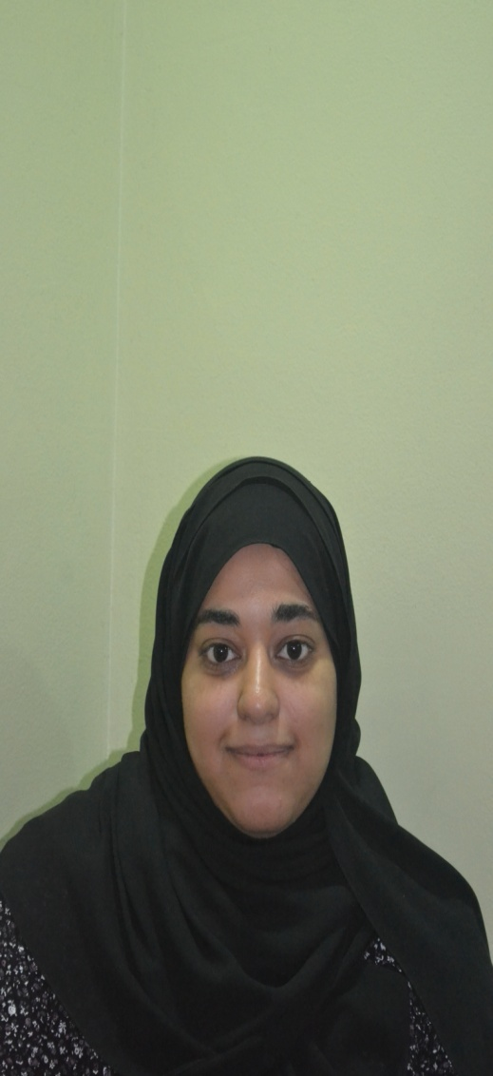

Name: Noof A.Alwahed Abdulla

Address: House 1767, Road 426, Block 1204

Hamad Town, Bahrain

Date of Birth: 29 MAY 1992

CPR No. 920501184

Nationality: Bahraini

Marital Status: Single

Mobile No: 33760707

E-mail: noofa.2014na@gmail.com

Education:

Qualification Received Institute/ School From To

Marketing Bahrain Training Institute 2011 2012

Secondary School Certificate ALWAFFAA Secondary School 2007 2010

Qualifications **:**

ICDL Certificate From AL-Mashreq Institute .

English Level 3 Course From AL-Mashreq Institute .

Mathematic Course From AL-Mashreq Institute.

Work Ethics Course AL-Mashreq Institute.

Skills:

Interpersonal skills:

* + Team Player
  + Hard – working
  + Good communication skills
  + Good communication with Kids

Computer Skills:

* + MS Office 2007 -2010
  + Computer programs

Languages:

* Good in both Arabic and English