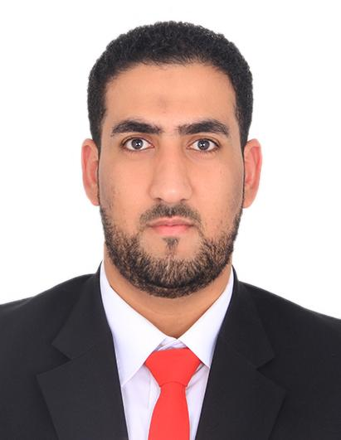**OSAMA ABDULHUSSAIN AHMED ALI**

**PERSONAL DETAILS:**

**DATE OF BIRTH:** May 06, 1996

**NATIONALITY:** BAHRAINI

**CPR NUMBER:** 960501428

**ADDRESS:** Building 101 – Flat No. 01 – Avenue No.75 – ABU SAIBA 475

**MOBILE:** 00973-33797689 -39299940

**EـMAIL:** osama.almahdi@hotmail.com

**OBJECTIVE:**

As a University student who is recently graduated with an Electrical Engineer degree looking for a better future life through a particular job that let me to achieve my goals through an atmosphere which is full of cooperation ,responsibility, quality and efficiency.

**EDUCATION:**

* Associated Diploma in Electrical Engineering 2014 – 2018 (G.P.A=3.31)
* Jidhafs Secondary Technical School 2011 - 2014

**EXPERIENCE & TRAINING :**

* working at sayed kadhem aldurazi's company (6 month)
* I have wire-man license 12/2018
* On job training at Almahroos 2018 (2 month)
* cashier at Al Jawhrya supermarket part time from March to June 2018
* Training at National Institute for industrial training 2014
* On job training at ASRY 2012 (1 month)
* First Aid & CPR Course On 7 Oct. 2017
* Secretary at Abu Saiba charity society. ( 2 years )

**SKILLS:**

* Good in Computer Microsoft Office (Excel , Word , Power Point)
* Communication skills (Good in Arabic & English )
* Graphic Designer ( Photoshop & premiere )
* Technician Audio and Video
* Swimming Coach

**INTERESTS:**

1. Swimming
2. Riding bikes
3. Fishing