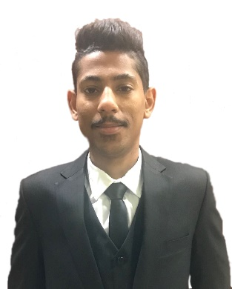

Curriculum Vitae (C.V.)

**Personal Information:**

**____________________________________________________________________________________________**

**Full Name:** Husain isa Mohammed

**Marital Status**: Single

Bahraini **:Nationality**

**Age**: 24

**Mobile No:** 36933761

**E-mail:** husainalmallah@gmail.com

**Address**: House: 704 Road: 3214 Block: 1032 City: Malikiya

**Job Objective:**

**____________________________________________________________________________________________**

Applying for a secretary job

**Education Levels:**

|  |  |  |  |
| --- | --- | --- | --- |
| **Name of School** | **Certificate** | **Period** | |
| **To** | **From** |
| AOU | University | Until Now | 2014 |
| Shik isa bin ali | High School | 2012 | 2008 |

**Languages:**

|  |  |  |
| --- | --- | --- |
| **Writing** | **Speaking** | **Languages** |
| Good | Excellent | English |
| Excellent | Excellent | Arabic |

**Work Experience:**

|  |  |
| --- | --- |
| **Organization Name of** | **Position** |
|
| Malkiya Construction Equipment Rental | Customer Service & office business |
| Middle East Trading & Contracting Center | Employee |
| Romano’s Macaroni grill | Customer Service |

**Activities / Skills**

**____________________________________________________________________________________________**

Computer Skill

Teamwork skill

Speaker

Communication

Motivation

Adaptability

**Hobbies (Interests) ____________________________________________________________________________________________**

Love cars

Playing football

Volleyball

Reading