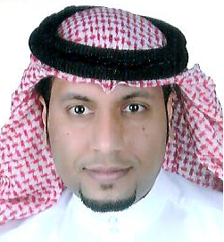**House: 3020**

**Road: 2252**

**Block: 522**

**Barbar, Bahrain**

Sayed Ali Shubber Almosawi

**Personal details:**

**Nationality: Bahraini**

**Date of birth: 13 may 1986**

**Marital status: Single**

**Mobile#:00937 39299889**,**00973 17695757**

**Email: mosawiali@outlook.com**

**Education:**

**2014-International H.R.D. Association: certified )NLP Diploma&PRACTITIONER).**

**2014-TrainingPlus: Autodesk 3DSMax certified professional.**

**2004-Modern institute: ICDL _GCC International Computer Driving Licence.**

**2004- Bahrain training institute: information technology.**

**Computer course:**

**Basic computer knowledge.**

**Using windows XP.**

**Using the MS office package.**

**Using the internet.**

**2003_2004 Jidhafs Technical secondary school.**

**2003_ Delmun academy**

**English course:**

**Communication skills.**

**Written and spoken English.**

**Other certification:**

**2013 workshop outdoor team building.**

**2011 Ethics and values of professional work.**

**2010 Art of dealing with people.**

**2008 comprehensive directions in merchandising, selling& stock control.**

**2008 work ethics customer care & communication skills.**

**2007 course in strategic customer care.**

**Experience:**

**Ibn al- nafaees Hospital:**

**Position:**

**Insurance Officer,**

**Finance and Accounts,**

**Receptions & Business officer.**

**Date of joining: 31-5-2011**

**Up to date**

**Jawed Group: jawed supermarket**

**Position: Customer Services and Supervisor**

**Date of joining: 8-1-2007**

**Last working date: 30-3-2011**

**AL Rashid Group:**

**Position: sales man**

**Date of joining 20-7-2006**

**Last working: 7-1-2007**

**References Are Available On Request.**