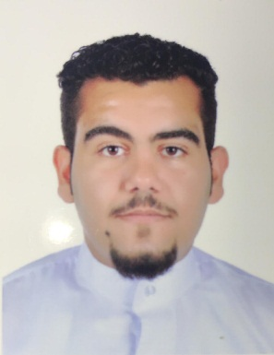**CV**

**Reryadh Ahmed A.Nabi A.Wahad**

**PERSONAL INFORMATION**

Marital status: Single

Nationality: Bahraini

Age: 19years old

Place of Birth: Jidhafs

Mobile phone: 33140203

**OBJECTIVE**

To get more experience

To improve my skills

**EDUCATION**

2015- 2018 Taawon Secandary Boys school

Public Secondary Certificate

2012-2015 Awal Intermediate Boys school

Public Intermediate Certificate

**SUMMARY OF QUALIFICATION**

Computer skills

writing Skills

Dealing with customer skills

**LANGUAGES**

Arabic: Mother Language, Good

English: Fluent in speaking

**INTERESTS AND ACTIVITES**

Reading books

Watching TV

Relaxing on the beach

HOBBIES

Play Games ,Drawing and Swimming

SIGNATURE

**Reyadh Ahmed**