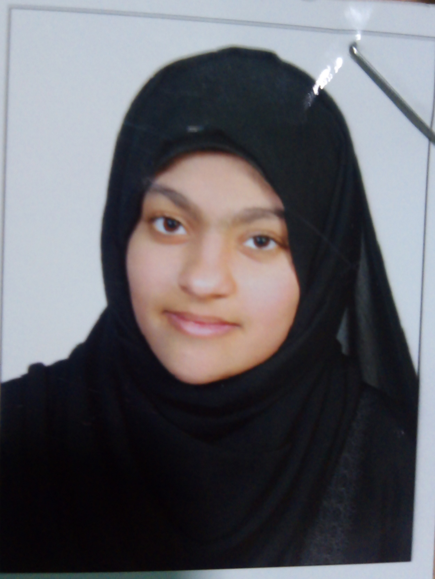

**Personal information :**

Name : zainab Hassan Juma Naser Radhi

C. P. R : 981001882

Date of Birth : 06/10/1998

Place of Birth : Manama

Passport No : 2499342

Address : Bldg:5050,Road:1234,Block:812

Isa Town

Nationality : Bahraini

Marital status : Married

Mobile Number : 37216746/33926609

Email : [zhjnr98@gmail.com](mailto:zhjnr98@gmail.com)

**Personality & Objective :**

I am looking to be a part of an Organization, which provides care growth opportunity and my professional skill in technical expertise, which contribute towards growth expansion of business.

**Education and Degrees :**

Omaima bint Al Nouman : Graduated 2016 Secondary School

**Work Experience:**

None

**Languages :**

Arabic :Native

English : Good

**Skills :**

**\***Computer Skills (Basic)

*Fast learner

*Capable of Working under pressure

*Leadership

*Team Worker.

**Interests :**

Reading & Writing