**Curriculm Vitea**

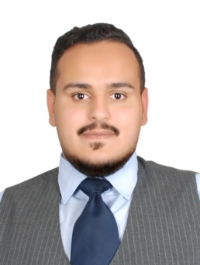**Personal infomation**

**Hussain Ali Habib Ebrahim Salman AlMarkhi**

date of birth: 4th Feb, 1993

**CPR:** 930204298

**Marital Status** **:** Married

**Address:** flat:12, Building:1200 Road: 3336, Jabalat Habshi: 433

**E-mail :**  [Almarkhi93@gmail.com](mailto:maysa.marhoon@gmail.com)

**Phone :** +973-36644152

**Objective**

I am seeking to become associated with a company in an environment that will challenge me further; while allowing me to utilize my skills and knowledge and gain further experience.

**Education**

**2008 – 2011 High school Diploma in Commercial -** Ahmed Al-Omran Secondary School

**work experience**

**Oct 2018 - July 2019 at Modern Jewelry** - (salesman) **:** dealing with the customers and marketing all jewelry in the showroom or via social media.

**June 2015 - Sep 2018 at THE PALACE HOTEL- Bahrain** - (driver) **:** *direct communication to the guests were you consider as big part to make them satisfied.*

**Feb 2015 - May 2015 at AMERICANA Company -** (Call Centre representatives) **:** *taking orders and dealing with all customers in Bahrain.*

**June 2013 - Feb 2014 at construction company -** (driver)

**Mar 2012 - Oct 2012 at construction company** - (receptionist)

**Qualification**

* Customer service skills.
* Computer Knowledge in Microsoft office programs and also in Photoshop.
* Quick learner, Teamwork skills, Time management and Self-motivation.

**Languages**

* **English (good) -** Understanding, Reading, Speaking and Writing.
* **Arabic (Excellent) -** Understanding, Reading, Speaking and Writing.

**Reference**

Available upon Request