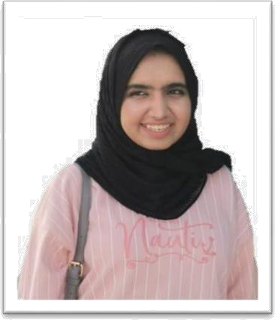SHAHEEN ANSARI



[EMAIL: SHAANSARI96@GMAIL.COM](mailto:SHAANSARI96@GMAIL.COM) PHONE: 33054118

AGE: 24 CITIZENSHIP: INDIAN

VALID DRIVING LICENCE

# OBJECTIVE:

To obtain a position that will help me develop my knowledge in commerce and office automation concurrently helping in the overall development of the organization.

# KEY SKILLS:

* **Communication**: Good listener, excellent English language handling skills with clarity and concision.
* **Team Player**: Enjoys sharing knowledge and encouraging development of others to achieve goals.
* **Systems Knowledge**: Working experience in Microsoft Tools, Computer software essentials.

# ACADEMIC EXPERIENCE:

* **HTML and VBScript Programming-on Perfumes:**

It was an individual project based on HTML and VB Script had to prepare web page and presentations on PowerPoint along.

# The World Bank

This was a Business research project on World Bank. I was given the task of collating information to give an overall picture of how it function. This gave

me enormous knowledge about how they managed finance and various transformations the Bank has gone through since their establishment in 1944. I worked on this single-handedly and took approx. two weeks for the project completion.

# EDUCATION EXPERIENCE:

* + Senior Higher Secondary School Certificate (CBSE) - 2015 **The Indian School, Bahrain**
  + All India Secondary School Examination – 2013 **IBN Al- Hytham Islamic School, Bahrain**
  + Bachelor in Banking and Finance-Minor in Marketing – 3rd Year.

# University of Bahrain, Sakheer

**WORK EXPERIENCE:**

1. Assistant accountant:

(2015-2016)

GHAZALA YASMEEN GROUP

* Can handle petty cash
* Companies Expense
* Maintain Proper Record of Invoices
* Filing and Report Making

1. Sales executives:

2018)

DAR AL TEEB PERFUMES (2017-

* Customer Dealing’s
* Reaching Target’s as per required

1. Accountant and Supervisor RAMEZ GROUP (2019-PRESENT)

* Knowledge of Pos System
* Credimx Knowledge and Report Making
* Overseeing salespeople, cashiers, shelf stockers, and other employees.
* Managing finances and preparing an annual budget.
* Keeping records of expenditure, sales figures, and employee performance.
* Overseeing salespeople, cashiers, shelf stockers, and other employees.
* Managing finances and preparing an annual budget.
* Keeping records of expenditure, sales figures, and employee performance.

References available upon request.