**Curriculum Vita**

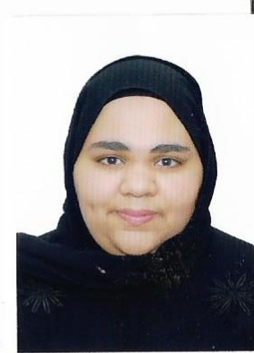

**Personal Information:**

**Name:** Duaa Mohsen Ali Abdali Hassan Ahmed

**Nationality:** Bahrain

**Marital status**: Single

**Sex:** Female

**CPR No.**991206142

**Date of Birth:** 16/12/1999

**Address:** House No.1993-Road No.931-Block No.609-Sitra- Kingdom of Bahrain

**E-mail:** [**duaamohsen99@gmail.com**](mailto:duaamohsen99@gmail.com)

**Education & Qualifications:**

* Sitra Secondary girls school (commercial), I have 3 subject don’t complete yet.

**Languages:**

* Arabic.
* English.

**Interests& skills:**

* Using the internet effectively.
* Have computer Skills, Using Microsoft Office.
* Reading.
* Good ability to communicate easily
* Good ability to lead groups of people.
* Honest.
* Flexible.
* Sociable.
* Hard working.
* Customer Service.

**Work Experience:**

* Experience in how to deal with customers.
* I have experience in using Microsoft Office.

**Reference:**

Duaa Mohsen Ali Abdali – Tel No.39205009-35176781