Personal details:

Name :khawla taha yaqoob yusuf taha Alshameri

Address: villa:3417 / /road 4561/block 0645 ,,,( Hawrat Sanad)

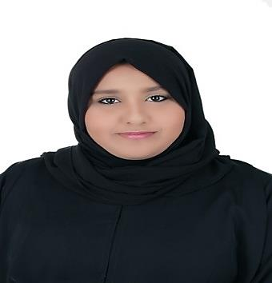Telephone : +973- 32302668 / 33026094

Email: [5wlh96@gmail.com](mailto:5wlh96@gmmail.com)

Date of birth 12/11/1996

Nationality : Bahrain

Marital status : single

Objective:

To develop and increase my abilities for being a useful member to help community to always grow and reach higher levels " the offers experience in a high standard of customer care.

Academic Background :

-High school graduated (maarefa high school

-study in Bahrain training institute Diploma travel and tourism

Training

ministry of labor: -

Training for two months in ( employers services section ) in customer service , increasing my language skills ,how to deal with customers and meet their need .

Through training i gained confidence and at the same incentive to work

Personal skills :

-well known in computer Microsoft packages

- Using (Galileo, Amadeus , Sabre) system

-ability to work hard pressure and meeting deadlines

- language : Arabic and English ( speaking , reading ,writing)