**Curriculum vitae**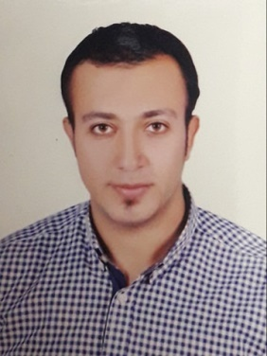

**Mahmoud Ahmed Ragab Ali**

Mobile : +9733509664

Email :[mahmoud24891@gmail.com](mailto:mahmoud24891@gmail.com)

**ــــــــــــــــــــــــــــــــــــــــــــــــــــــــــــــــــــــــــــــــــــــــــــــــــــــــــــــــــــــــــ**

**Personal information:**

**Birth date : 24-8-1991**

**Age : 27**

**Gender : Male**

**Nationality : Egyptian**

**CPR No : 910849498**

**Language : Arabic and English**

**Work In :** **- Security of the Meshal hotel in Bahrain**

* **Accountant**
* **Receptionist**
* **bodybuilding coach**

**Educational Qualification: Faculty of Commerce**

**Hobbies : Bodybuilding and Boxing games**

**Applicant Name**

**Mahmoud Ahmed Ragab Ali**