**Curriculum Vitae**

## Personal Details

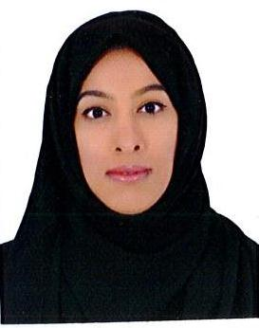

* **Name** Najla Mahmmod Hassan Alderazi

photo

* **Address**  Building 1298-Flat 21 -Road 4539**–** Sanad745
* **Cpr** 910901678
* **Date of Birth** 1/9/1991
* **Marital Status** Married
* **Telephone** 36358003
* **E-mail** Najla_400@hotmail.com

## Educational Qualification

* **2013-2014** Diploma in Commercial Studies
* **2010-2011** Orientation English
* **2009-2010** certificate of achievement

## working Experiences

* **2013-2014** **University of Bahrain**,
* **(**Professional internship)**.**
* **2013** **Bahrain institute of entrepreneurship technology**,
* (Microsoft’s Initiatives and unlimited potential)

## key skills

* Ability to perform under pressure and organized
* Good communication skills**,** willingness to learn and honest
* Numerate ,punctual, reliable
* Computer Skills: Application Microsoft office and success skills program
* Languages: Fluent in Arabic and Excellent in English