Curriculum vitae

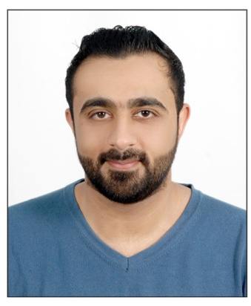

**Name: Hussain Abbas Saeed Nussaif**

**Personal No: 901006840**

**Birth Date: 5th October 1990**

**Address: tubli**

**Telephone: 33488558**

**E-mail: h101010@hotmail.com**

**Nationality: Bahraini**

**Educational Qualifications**

* **June 2012 till Dec. 2012**

**Certificate in Warehouse and Storage Management from Bahrain International Retail Development center (BIRD).**

* **September 2005 till June 2008**

**Secondary high School Certificate from Shaikh Abdulla Bin Isa AL Khalifa.**

**Work Experience**

* **Reef island**

**reception**

* **Four Seasons Hotel**

**Safety officer**

* **ASHRAF ( SONY)**

sales

* **Toyota**

**sales**

* **Home electronics**

**sales**

**Languages:**

* Arabic and English.

**Skills:**

* Computer skills.
* Hard Worker.
* Able to work under pressure and work in a team.
* Dealing with different nationalities.
* Decision making.
* Creating a nice work environment