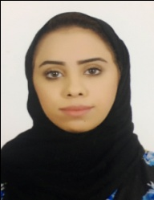**CURRICULUM VITAE**

**Hawraa jameel Abdulla Ahmad Sabt**

**Mob: 34098413**

**Kingdom of Bahrain**

**Email:hoorii.sabt7@gmail.com**

**PERSONAL DETAILS**

Date of Birth : 07.10.1995

Nationality : Bahraini

Sex : Female

Marital Status : Single

Address : H-939-R-914-B-1209

Hamad town - Bahrain

CPR No. : 951001868

Languages : English, Arabic

Driving license : Valid Bahrain license (car)

**EDUCATIONAL QUALIFICATION**

* Hamad Town Secondary School -2013

**WORK EXPERIENCE**

* I study at the impact institute course in the art sales and customers service
* Work at Twenty four as sales staff and casher
* Work at Arg group as sales staff and cashier sometimes
* Training with Mr.john at customer Service
* Work at Middle East Hospital as reception

**DECLARATION**

I hereby declare that the above said information are true and correct to the best of my knowledge and belief.

**HAWRAA JAMEEL ABDULLA AHMAD SABT**