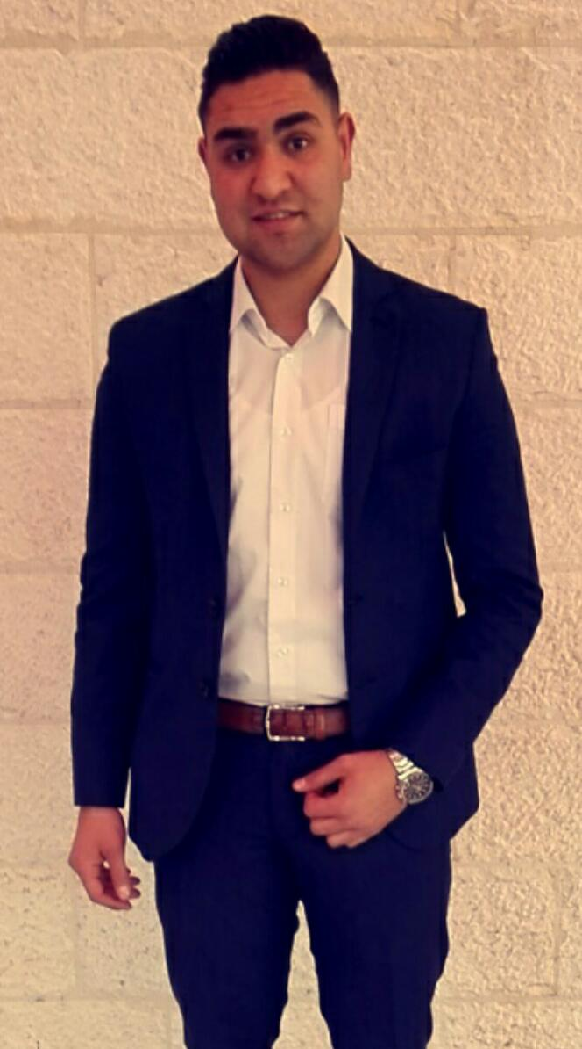

**Haitham Al Rajabi**

**Date and place of birth:** Jul 22nd 1994 Amman –Jordan

**Marital status:**  Single

**Mobile number:** 00973 38190536

**Email:** [haitham.alrajbi@yahoo.com](mailto:haitham.alrajbi@yahoo.com)

**Practical Experience:**

* November 2019 captain at florence restaurant _ADLIYA _BAHRAIN
* January 2019 Supervisor at Seafood Island Restaurant-Salmiya-Kuwait
* April 2018 Supervisor at Kempinski Hotel-Amman
* April 2017 Captain at Kempinski Hotel - Amman
* May 2014 Waiter at Kempinski Hotel-Amman

**Languages:**

* Arabic: Mother language
* English: Very good Written, spoken & understanding**.**
* **Skills:**
* Computer (Microsoft Word, Excel and power point, Micros, Material control).
* Quick Learning, Ability to appropriate.
* Excellent organizational skills.
* I'm dedicated to hard work, I have enough experience.
* I believe in team spirit.
* Have good communication skills to build good relations with
* customers and mangers, with excellent analytical skills.
* Able to work under the high pressure.
* High sense of responsibility, good judgment and initiative.

**Certificates Training:**

* LQA
* BBI.
* DNA
* Giving & Receiving Feedback.
* The 7 Levels of Change.
* Behavioral based interviews.
* Complaint handling.
* Developing open channel communication.
* E-mail etiquette.
* Employee of the month January 2016

**REFERENCES :**

* Available upon request