**Curriculum Vitae**

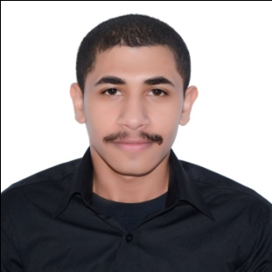

**Objective:**

* Bahraini citizen I have a year experience in the field of sales man and I have a year experience in the field of entrepreneurship and I bear the work under pressure

**Contact:**

* Phone number: 33277934
* Email: [ha7221san@gmail.com](mailto:ha7221san@gmail.com)

**Personal information:**

* **Name:** Hasan abdali hasan
* **Gender:** Male
* **Nationality:** Bahraini
* **Date of birth:** 27/12/1999
* **Marital status:** Single
* **Address:** karbabad, Bahrain

**Education:**

* Jidhafs secondary boys industrial school Sept 2014 - June2017 (Electrical specialization)

**Training experience:**

Training in Aluminium Bahrain Sept 2016 - Nov 2016

**Qualifications:**

**>Languages:**

* Native Arabic
* Good English

**>skills:**

**Soft skills:**

* Ability to work under pressure
* Solving problems
* Leader ship
* Responsibility
* Teamwork

**Interests:**

* Sport in the gym
* Decoration the cars

**References:**

References available upon request