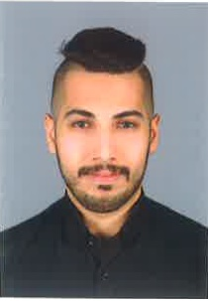Ahmed Ismaeel

* **Contact**:

Date of birth: 10-3-1992

* **Phone**: 33915835

17691996

* **Email:**Ahmed_fayeq@hotmail.com
* **Profile**

A highly motivated and result oriented individual looking for a position in a

well-established organization that allow me to utilize my organization skills and knowledge efficiently, thus giving me the opportunity to achieve career and

personal development.

**EXPERIENCE**

* **2016 ( Marketing )**

Marketing health and safety and management courses in IPTS . (3 Months)

* **2016 -2018 : ( Operator )**

Telephone Operator at Lagoona Beach Luxury Resort & Spa MAY 2016- Present

• Answer incoming calls, greeting callers, providing information, transferring calls and/or taking messages as necessary.

• Relay and route written and verbal messages.

• Perform clerical duties, such as typing, proofreading, accepting orders, scheduling appointments, and sorting mail.

• Assists in reporting telephone equipment or service complaints and problems.

• Answers incoming calls.

• Directs call to guest rooms, staff, or departments through the switchboard or PBX system.

• Places outgoing calls.

• Receives guest messages and deliver the same to the guest.

• Logs all wake-up call requests and performs wake-up call services.

• Provides information about hotel services to guests.

* **2018 and still currently : ( Reservation Agent )**
* Handling reservation on calls, walk in guest and travel agency.

**EDUCATION**

* Bahrain University (UOB) 2010-2015
* Bachelor’s degree in physical education
* Ahmed Alomran secondary school (2007-2010)
* High school certificate in finance
* **SKILLS:**
* Able to work with Team and individually.
* Pro – Active.
* Excellent in Microsoft.
* Excellent Leadership.
* Have the ability to adapt.
* **LANGUAGES**
* Arabic (Mother language)
* English