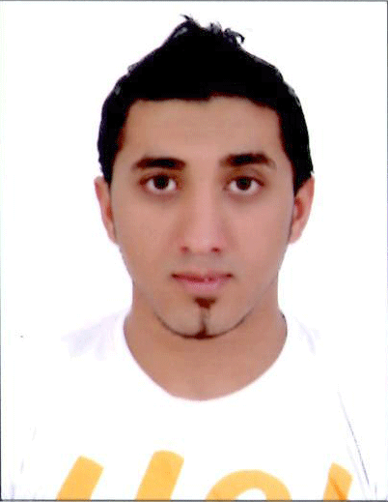Work seeker

2016-2017

**ID information**

* Name: Mohammed Yousif Salman Hassan.
* Sex: Male.
* Nationality: Bahraini.
* Date of Birth: October 11th ,1990
* Place of Birth: Al-riffa.
* CPR:901003026.
* Social status: Single.
* Mobile Number: 37743032.
* Address: Hamad Town, Bahrain
* Availability of driver's license and my own car.

**Objective:**

Seeking a position to utilize my skills and abilities in your organization that offers professional growth while being resourceful innovative and flexible willing to learn new innovative ideas with hard work, leadership, team work, quality, excellent interpersonal and communication skills and ability to handle a challenging situations.

**Qualifications:**

* Excellent in computer, internet and programs.
* FIREDIRECT, Fire & Safety Consultant License, Second Industrial City, Dammam, Sudia Arabia.
* Basic Plus; CPR, AED, and First Aid for Adults.
* Basic H2S & SCBA Training from
* NABORS DRILLING INTERNATIONAL LIMITED.
* Certificate of the world's largest swimming lessons - official team member as a swimming rescuer in the lost paradise of delmon, Bahrain.
* Assistant in Bahrain International Circuit F1.
* Certificate of achievement in cross selling & cashiering – batch 33.

**Education**

* High School Graduation.
* Fire Team Member Training.
* CPR, AED, and First Aid Training.
* H2S & SCBA Training.

**Work Experiences:**

* I worked in organization of NABORS DRILLING in Second Industrial City, Dammam, Sudia Arabia. with one year of professional experience in oil exploration and installation.
* Played a big role as assistance in Formula-one for two months.
* Marketing in several shopping malls. skilled casher worker, seller and customer service.
* Life guardian in the lost paradise of Delmon for more than one year.
* Official team member in water park.

**Professional Skills**

* Life’s Rescuer.
* Computer user.

**Personal Skills**

* Creativity.
* Leadership.
* Organization.
* Excellent. Driver.

**Languages:**

* Arabic: excellent in speaking reading writing and typing.
* English: good in speaking reading writing and typing.