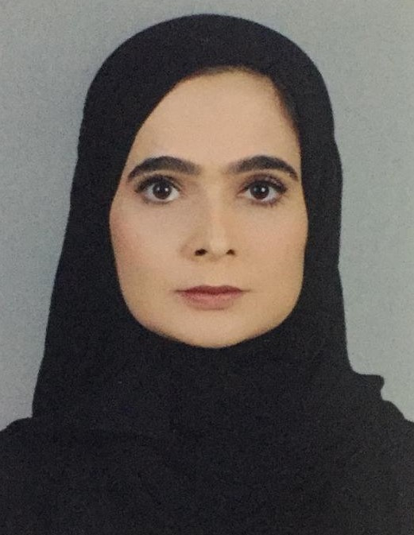

**Name:** Jehan hafizallah habib waleed mohammed

**ID Number:** 851011144

**Date of Birth:** 01/October,1985

**Tel: 35052585 / 39158645**

**Address :** House No 2071 Road 2728 Block 927 Riffa

**Email:** [amori-girl@hotmail.com](mailto:amori-girl@hotmail.com)

**EDUCATION**

* Secondary School Certificate in Scientific , West Riffa Secondary School

**SKILLS**

* Using The Computer
* Internet, Outlook
* Typing Arabic, English
* Time Management
* A good team work
* Work Under Pressure

**LANGUAGES**

* Arabic Native spoken, written
* English Good spoken, written

**HOBBIES AND INTERESTS**

* Work volunteer
* Reading
* fashoin