karim ibrahim Elmarakby 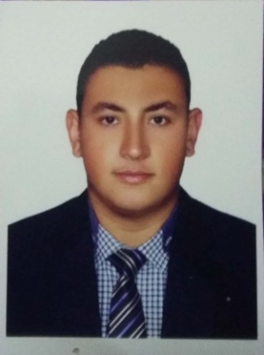

Kingdom of Bahrain, east riffa , block 907, Road 741, Building. 3296

 Telephone  : +937 36866436

 Email : [elmarakby1998@gmail.com](mailto:ahmedmohmmed25@icloud.com)

cpr num : 980517559

# Objective

Being a useful part of well – reputed organization to enhance my skills in order to accept the challenges, through my professional experience.

# Education

* . 2016- High School (East Riffa Secondary school for Boys)
* Scientific Section
* 2016- study (Electrical Engineering)

Bahrain University.

. 2019- ongoing (information Technology )

Arabic Open University.

# Skills & Abilities

## Management

## . Foster an efficient, innovation and team -oriented work environment

## . Contribute to the audit teams and engage in sharing team members' views

## . Use technology to continually learn, share knowledge, and enhance service delivery

## mARKETING

* Develop and understanding of the client’s needs and adopt the audit approach to the client’s changing environment
* Build and maintain effective working relationship with client.

**Technical**

**.** using Mathematics to solve problems

**.** Using logic and reasoning to identify the strengths and weakness of alternative solutions, conclusions or approaches to problems

**.** monitoring/ assessing performance of myself, other individuals, or organizations to make improvements or take corrective action.

**.** Understandingwritten sentences and paragraphs in work related documents

## Communication

* Good working with the team
* Cooperating with colleagues

## Computer

* Office Package Namely (Word, Excel, Access, Publisher, Outlook, PowerPoint and InfoPath)
* Internet Browsing
* Photoshop

## Language

. Arabic (Mother Tongue)

. English (Very good, verbal and written)