**Curriculum Vitae**

**Personal Information**

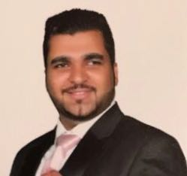

**Name:** **Mahmood Fadhel Abbas Abdulla.**

**Date of Birth:** **21 December 1992.**

**Gender: Male.**

**Marital Status: Married.**

**Nationality:**  **Bahraini.**

**CPR Number:** **921207310.**

**Address:** **House 2843, Road 3469, Block 234, Samaheej-Muharraq, Kingdom of Bahrain.**

**Tel: 33711878.**

**E-mail:** **Mahmoodfadhel1@gmail.com**

**Education**

**Secondary/Scientific. Al Hedaya Secondary School. 2006 - 2009.**

**Air Craft Engineering**

**(EASA147.0072) , B1 AFAQ Institute of Aviation Technology. 2011 - 2013**.

**Courses**   **Courses**

- **English and Computer Courses at Al Ahli Institute.**

**Skills**

**Computer Skills :**

* Windows, MS Office.

**Language:**

* Arabic and English.

**Experience**

**-Work at Limousina for 2 years (2012-2014).**

**References**

1. Mr. Mahmood Albalooshi, Mananger Training & Examination System, Tel.69990102.
2. Mrs. Khulood, Tel.69990102.

