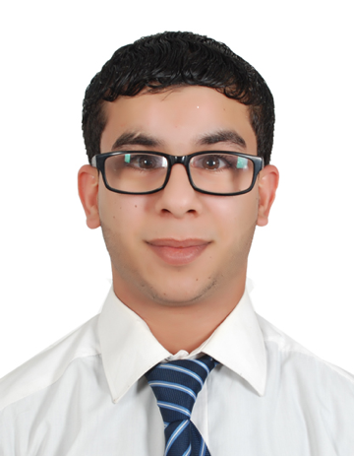

**mustafa Hasan Makki**

|  |
| --- |
| **Name** : Mustafa Hassan Makki Khalaf  **Nationality** : Bahraini  **Passport No.** : 2315254  **CPR No.** : 950904848  **Date of Birth** : 10 Sept 1995  **Contact No.** : 36115208 – 17600409  **Email** : mustafakh1995@gmail.com  **Address** : H. 1442 – R.D. 2242 – Dumistan 1022  **Marital Status** : Single |
| **work Experience** | |
| May 2016 – Dec 2017 Work as government clearance in Alandlus company |

|  |  |
| --- | --- |
| **OBJECTIVE** | |
|  | I would like to be considered for any suitable vacancy, which may arise in your organization in support of my candidature …. Below are the details you may require. |
| **EDUCATION AND CERTIFICATE** | |
|  | **Al Jabriya Secondary Technical School Manama, BHR**  Secondary Technical in Welding (2010-2013) |
| **SKILLS** | |
|  | **Interpersonal: -**   * Ability to work individually and within a team. * Time Management. * Quick learner. * Flexible, I can work until any time under any atmosphere.   **Computer Skills: -**   * Good in using the Office Microsoft. |
| **LANGUAGES** | |
|  | Arabic (Reading – Writing – Speaking)  English (Reading – Writing – Speaking |
| **INTERESTS AND ACTIVITIES** | |
|  | Reading Books.  Playing Football.  Internet & Watching TV. |
|  | |
|  |  |
|  |  |