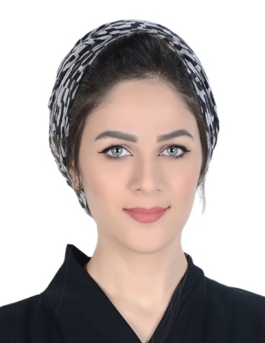**Curriculum Vitae**

**Asmaa Ali A.Wahab**

Villa 1410, Road 4152, Blok 441, North Sehla

Mobile : 66999433

Email : [asoomz.a@hotmail.com](mailto:asoomz.a@hotmail.com)

------------------------------------------------------------------------------------

**Personal Details**

Date of Birth : 15/05/1991

National : Bahraini, Valid a Driving License

Marital Status : Married

C.P.R Number : 910115370

**Objective**

Looking for an experience in all areas of practical life for developing my self and gaining more experience in all type of business .

**Experience**

* **Azadia Group at Prenatal as ( Sales Women, Cashier ) from 1 Jun, 2009 Until 1 Jan 2010.**

Include :-

* Receiving Goods
* Storing
* Stock Inventory.
* Public Relation.
* Handling the customer.
* Open and close the cash and updating every day.
* Checking the cashier after closing.
* Handled large amount of cash and related document.

**Also :-**

* Listening to customer requirement and presenting appropriately to make a sale .
* Maintaining and developing relationship with existing customer in person.
* Challenging any objections with a view to getting the customer to buy.
* Checking quantity of goods on display and in stock.
* **Al Wadad Constriction Company ( Accounting Manager )**

**From 1 Jan, 2010 Until 1 Oct, 2012**

Responsibility including :-

* Maintaining Files.
* General Correspondence.
* Receiving and sending E-mails.
* Preparing the invoices.
* Updating and reporting of the job details.
* Handled large amount of cash and related document.
* Develop, create and manage all kinds of professionals reports such as ( the company account like the costs, sales and budget ).
* **Ceram Dental Center**

As a Receptionist staff **from 1 Jan, 2013 Until 1 March, 2015 .**

Responsibility:

* Answering or referring the inquiries.
* Taking appointment to the doctors.
* Open and closing the cash.
* Incharge for the clink products such as receiving and sending product.
* Maintaining files.
* Preparing the invoices and insurance.

**Nail House Spa**

**Accountant at Nail Spa** From 1, April 2016 Until 1, Jun 2018.

Responsibility:

* Handled salon’s products.
* Organizing customers appointments.
* Schedule staff timing.
* Open and close petty cash and handling the income and outcome.

**Education**

Graduated from **AMA International University – Bahrain** ( Business Informatics )

**From First of September Until April 2016.**

**Additional Skills & Qualities**

* Very good in computer skills and computer applications ( MS Window, MS Office ).
* Good Commutation skills, interpersonal skills and strong writing & speaking in English & Arabic.
* Working in new environment and befriend.
* Ability to work under pressure, flexible working hours and long time.

**Interested**

Reading magazine, using internet, football, traveling, and making new friends.