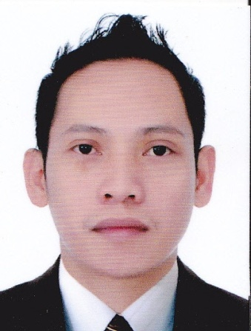**EDUARDO H. OLARVE**

**ADDRESS:** Flat Villa 11, building 117, road 4104, block 941, Al Buhair East Riffa Kingdom of Bahrain

**Mobile #:** +973 39058033

**E-mail:*olarve.eduardo@gmail.com/ eduardo.olarve@yahoo.com***

**Career aim:**  Looking for a position that will build on my knowledge and skills.

**OBJECTIVE:**

To be an asset of the company by acquiring the knowledge which will be able me to utilize and enhance my skills thereby allowing me to use my fullest potentials.

**PERSONAL INFORMATION:**

Gender: male

Date of Birth: July 8, 1985

Height: 5’4”

Weight: 127 lbs.

Civil Status: Single

Language Capability: English / Filipino

**EDUCATIONAL BACKGROUND:**

College STI College, Fairview Quezon City

2003-2005

Diploma in Computer and Electronics Technology

Vocational ELECTRON Technical Training Center

Sept 2008 – Dec 2008

Computer Technician

**SKILLS:**

Knowledge in MS Word, Excel, Power point and basic Trouble Shooting.

Innovative, hard working, and honest

Self motivated and can work under minimum supervision.

**WORKING EXPERIENCE:**

**STOP AND GO SUPERMARKET**

Salesman

December 15, 2019 – Present

**LULU HYPERMARKET**

SalesStaff

February2017 **–** December 12, 2019

**ROCKY MOUNTAIN CAFE’ INC**.

Supermarket Coordinator

February 24, 2015 – January 2016

**SAN MIGUEL INTEGRATED SALES INC. (PUREFOODS)**

Merchandiser

July 14, 2010 to January 30, 2014

**MARKETVENTURES DISTRIBUTOR SALES INC.**

Merchandiser

February 2008 – June 2009

**PROFOOD INTERNATIONAL CORPORATION**

Merchandiser

July 2006 – January 2007

**CHARACTER REFERENCES:**

**Available upon request**