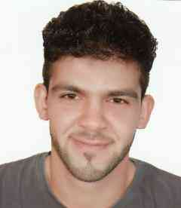**CURRICULUM VITAE**

**S.AhmedS.Mahdi S.Mohammed**

H. No: 416, R. No: 1211, B. No: 1106

Hamed Town - Kingdom of Bahrain

**Mobile: +973 36433086**

E-mail:ahmmdahmmad333@gmail.com

**_____________________________________________________________________**

**SUMMARY:**

* Profile: Male, single
* Nationality: Bahraini
* Date of Birth: 17April 1996
* CPR Number: 960404210
* Last Company: Carriage

_____________________________________________________________________

**OBJECTIVE:**

Seeking for a job that suits my educational qualifications and experience.

_____________________________________________________________________

**WORK EXPERIENCE:**

* **Rami grand hotel(maintenance)**
* **Lulu hyper market as sales**
* **Carriage as driver**

**___________________________________________________________________________________**

Eduction:

**Alghazzali Intermediate Boys School**

**( Hamed Town , Bahrain)**

**_________________________________________________________________**

**LANGUAGES:**

* Arabic Native
* English good

**_____________________________________________________________________**

**Additional:**

* Valid driving license

**_____________________________________________________________________**

**SKILLS:**

* Working in group.
* Hard Worker
* Quick to Learn.
* Willingness to listen and learn.

**____________________________________________________________**

**Reference**

Upon your request