Personal Details:

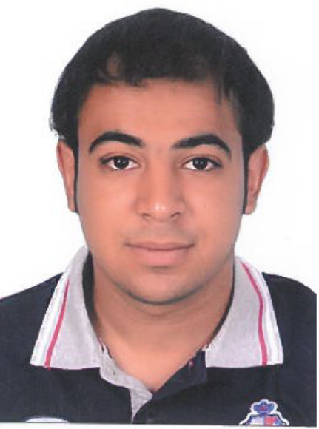

Nationality: Bahraini

D.O.B.: 13 June 1998

C.P.R. No.: 980603820

Passport No: 2373082

Sex: Male

Marital status: Single

Contact No.: 66952291 / 38939919

Address: Villa 1428 Road 3342 Block 630

Ma'ameer

#### Education and Qualifications

|  |  |  |
| --- | --- | --- |
| Year | Qualification | College / School |
| 2016 | Passed the examination of the secondary commercial school. | Al Tawon Secondary School |

#### Experience

|  |  |  |
| --- | --- | --- |
| Year | Experience | Years of Experience |
| 2017 | Cashier in Lulu Hypermarket | 2 Year |

###### Languages

Good in Written and spoken Arabic and English.

Other Information

Interests and Hobbies:

Reading, Traveling, connecting with people, surfing the internet