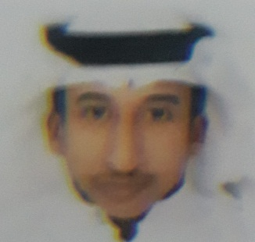**Curriculum vitae(CV)**

**\*PERSONAL INFORMATION:**

**NAME: Khalifa Sameer Khalifa DATE of BIRTH:24/5/1998**

**GENDER: female MARTIAL STATUS: Single**

**CPR NO: 980510651**

**NATIONALITY: Bahraini**

**\*contact information:**

**HOME ADDRESS: Villa 4051, Road 4568, BLOCK 645, Sanad -Bahrain.**

**Mobile:35159621-36578025**

**E-mail: khalifa_8_@hotmail.com**

**\*Educational Qualification:**

**2014-2016 school: Sheikh Abdullah bin Isa tech.sec**

**Secondary certificate: computer mantenace**

**GPA:82.8%**

**\*WORK Experience &Achievements:**

**-Ministry of Electricity and Water |work 1month**

**-Bahrain Aluminum |work 2month**

**-Degree PF.CHANGS Best Employee(hero) |work 1year**

**Bas boy-server**

**\*language Arabic: good 100%**

**\*language English: weak 25%**