

**COMSATS UNIVERSITY ISLAMABAD, ATTOCK CAMPUS**

**PREPARED BY:**

Muhammad Sufyan (SP22-BSE-045)

**SUBJECT:**

Mobile Application Development

**SUBMITTED TO:**

MR Muhammad Kamran

**DATE:**

26thSeptember,2024

**ASSIGNMENT #01**

**Introduction**

The objective of this assignment is to create a simple shopping cart system that allows users to add, remove, and update items in their cart, as well as calculate the total cost of the items. The system consists of five main operations:

1. Add items to the cart
2. Remove items from the cart
3. Update the quantity of items in the cart
4. Calculate the total cost of the items in the cart
5. Display a summary of the cart contents

These operations are implemented using JavaScript functions which are explained

**Code Explanation**

1. **Add Items to the Cart:**

Four parameters are required by the addItem function: productId, productName, quantity, and price. Using these parameters, a new product object is created and added to the cart array with the push method. To verify that the item has been put to the cart, it finally sends a message to the console.

1. **Remove Items from the Cart:**

The **removeItem** function takes one parameter: **productId**. It uses the **findIndex** method to find the index of the product with the specified **productId** in the **cart** array. If the product is found, it removes it from the array using the **splice** method and logs a message to the console to confirm that the item has been removed. If the product is not found, it sends a message to the console indicating that the product was not found.

1. **Update the Quantity of Items in the Cart:**

The updateItemQuantity function takes two parameters: productId and newQuantity. It uses the find method to find the product with the specified productId in the cart array. If the product is found, it updates its quantity to the specified newQuantity and logs a message to the console to confirm that the quantity has been updated. If the product is not found, it logs a message to the console indicating that the product was not found.

1. **Calculate the Total Cost of the Items in the Cart:**

The calculateTotalCost function uses the reduce method to calculate the total cost of the items in the cart array. It initializes the accumulator to 0 and then iterates over each product in the array, adding the product's quantity multiplied by its price to the accumulator. Finally, it returns the total cost.

1. **Display a Summary of the Cart Contents:**

The displayCartSummary function uses the map method to create an array of strings representing the cart summary. Each string includes the product name, quantity, and total price for the product. It then uses the filter method to remove any items with a quantity of 0. Finally, it logs the cart summary to the console, including the total cost.

1. **Bonus: Apply Discount:**

The applyDiscount function takes one parameter: discountCode. If the discount code is 'SUMMER10', it calculates the total cost of the items in the cart, applies a 10% discount, and logs a message to the console with the new total cost. If the discount code is invalid, it logs a message to the console indicating that the discount code is invalid.

## **Output Screenshot:**

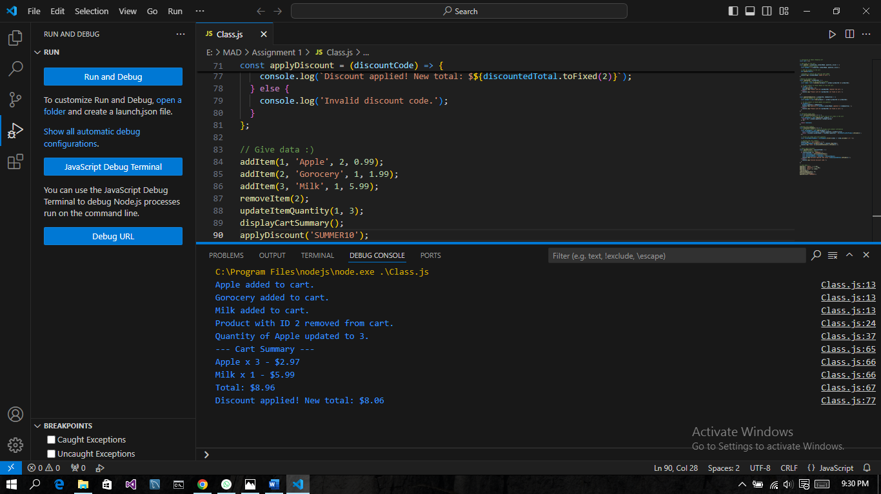

**Conclusion:**

in this assignment, I gained hands-on experience with JavaScript, specifically with array methods and functions. I learned how to:

1. **Create and manage a shopping cart**: I implemented functions to add, remove, and update items in the cart, which helped me understand how to manipulate arrays in JavaScript.
2. **Use array methods**: I applied various array methods, such as push, splice, map, findIndex, and filter, to perform different operations on the cart array.
3. **Implement a discount system**: I created a function to apply a discount to the total price, which introduced me to conditional statements and basic arithmetic operations in JavaScript.
4. **Organize code**: I structured the code into separate functions, each with a specific responsibility, which improved the code's readability and maintainability.

**Challenges Faced:**

1. **Understanding array methods**: Initially, I struggled to grasp the differences between various array methods, such as map and forEach. However, through practice and experimentation, I gained a deeper understanding of their usage and applications.
2. **Managing state**: I encountered issues with updating the cart state correctly, particularly when removing or updating items. I had to revisit the code and ensure that I was updating the correct references to the cart array.
3. **Debugging:** I encountered errors due to incorrect indexing or out-of-bounds access. I learned to use the browser's console and debugging tools to identify and resolve these issues.
4. **Code organization**: As the codebase grew, I had to reorganize the functions and variables to maintain a clean and readable structure. This helped me develop a better understanding of code organization and modularization