Virtual CLASSROOM / SkillSwap App (Peer-to-Peer Learning Platform)
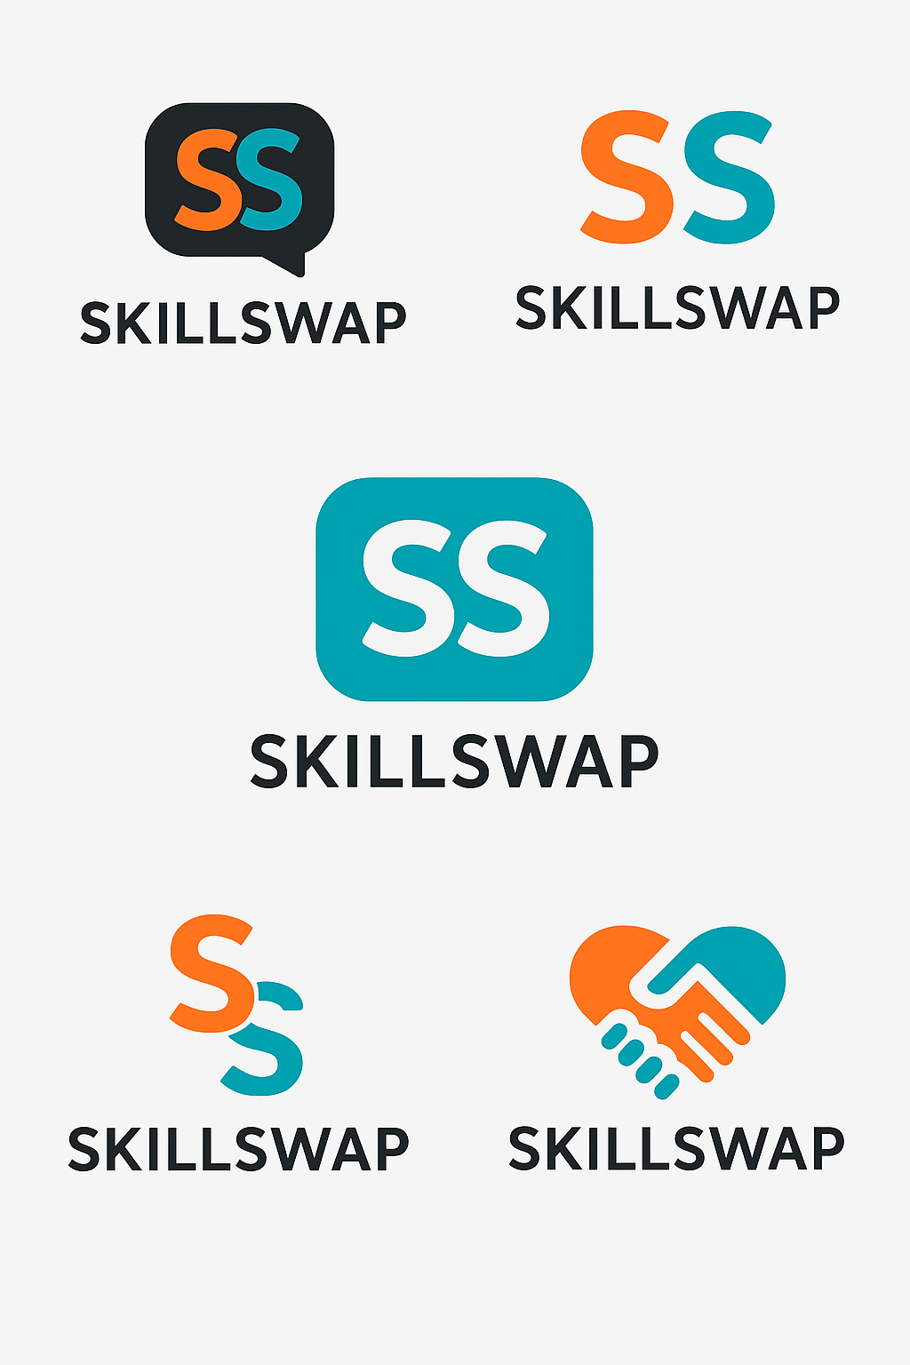

Overview
SkillSwap is a peer-to-peer learning platform that enables users to exchange skills directly. For instance, a person can teach guitar lessons in exchange for Excel tutorials. This approach eliminates financial barriers, builds communities, and promotes continuous learning.

Problem Solved
High costs of professional courses and limited access to affordable learning opportunities.

Revenue Model
The app generates revenue through ad-free premium memberships, offering advanced matching, exclusive mentor access, and an enhanced user experience.

Prototype
Web or mobile prototype using Firebase.

10 Major Benefits
- 1. Affordable Learning – Exchange knowledge instead of money.
- 2. Community Building – Build a friendly learning and teaching community.
- 3. Personalized Skill Growth – Find mentors and learners with shared goals.
- 4. Global Accessibility – Join from anywhere in the world.
- 5. Boosts Soft Skills – Enhance communication and leadership by teaching others.
- 6. Portfolio Creation – Showcase your expertise and learning journey.
- 7. Encourages Lifelong Learning – Promotes continuous personal development.
- 8. Equal Opportunity Platform – Open for everyone regardless of background.
- 9. Time Efficiency – Learn faster with flexible sessions.
- 10. Networking & Collaboration – Connect for projects and career growth.

10 Key Features / Functions
- 1. User Profiles – List teachable and learnable skills.
- 2. Skill Matching System – AI matches users for complementary skills.
- 3. Chat & Video Call System – Enables real-time lessons.
- 4. Rating & Review System – Builds trust through user feedback.
- 5. Scheduling & Calendar – Manage lesson times easily.
- 6. Skill Verification – Earn badges or certificates for verified teaching.
- 7. In-App Notifications – Stay updated on matches and sessions.
- 8. Learning Progress Tracker – Track milestones and learning history.
- 9. Community Forums – Exchange ideas and resources.
- 10. Premium Membership – Ad-free, advanced matching, and expert access.

10 Unique Elements That Make SkillSwap Stand Out
- 1. Barter-Based Learning Concept – No monetary exchange required.
- 2. Gamification – Reward points and badges for active participation.
- 3. Smart AI Matching – Connects users based on skills and availability.
- 4. Diversity in Skills – Academic and creative areas supported.
- 5. Offline + Online Mode – Offers local meetups and virtual options.
- 6. Safety Features – Verified profiles and secure communication.
- 7. Analytics Dashboard – Insights on user engagement and trends.
- 8. Localization – Multilingual support for global users.
- 9. Mentorship Mode – Paid or free mentoring options.
- 10. Integration with LinkedIn – Export verified skills directly.

Development Plan
1. Prototype Design – Create wireframes using Figma or Canva.
2. Backend Development – Use Firebase for data storage and real-time updates.
3. Frontend Development – Build the mobile app using Flutter or React Native.
4. Team Roles – Assign developer, designer, and business planner roles.
5. Presentation – Highlight problem, target market, business model, and demo flow.
New Major Feature: Global Communication System
Purpose:
To eliminate communication barriers among users worldwide and enable smooth, real-time global collaboration.
Description:
The Global Communication feature will allow users to connect and interact across borders with built-in real-time translation, multi-language chat, and voice/video call translation tools.
This promotes cultural exchange, enhances understanding, and allows learners and teachers from different regions to collaborate without the limitation of language.
Sub-Features:
- Instant Language Translation: Messages translated automatically into the user’s preferred language.
- Voice & Video Translation: Real-time subtitle or audio translation during lessons.
- Cultural Mode: Adds cultural context to translated phrases for better understanding.
- Global Time Synchronization: Smart scheduling based on time zones for international sessions.
- Language-Based Matchmaking: Helps connect users with complementary language preferences (e.g., English ↔ Spanish).
- International Community Boards: Global discussion threads filtered by language and skill category.
- Virtual “Global Classroom”: Live international workshops for skill sharing and discussions.
- Accent Neutralization Mode: Optional voice feature that converts accents for easier comprehension.
- AI Moderation: Prevents miscommunication or inappropriate content across languages.
- Cross-Cultural Learning Analytics: Tracks global engagement and participation metrics.
Impact:
This feature turns SkillSwap into not just a skill-sharing app — but a global learning bridge that connects people through knowledge and communication. It directly addresses the global issue of language barriers in education and collaboration

SkillSwap App – Project Cost Breakdown Report
The SkillSwap App is an innovative peer-to-peer learning platform where individuals barter skills — for example, one person teaches guitar in exchange for learning Excel. The project aims to make learning accessible, affordable, and globally connected. Below is the minimum estimated cost required to develop a real, working prototype of the SkillSwap App in today’s market conditions (2025).

💰 Estimated Minimum Total Project Cost
Category | Description | Estimated Minimum Cost (USD) | Notes / Alternatives
App Design (UI/UX) | Figma / Canva design for screens, color theme, and logo. | $100 – $200 | You can do this yourself using Figma (free).
Frontend Development | Flutter or React Native app (Android + iOS) | $400 – $700 | Hire part-time developer or use open-source template.
Backend Development (Firebase) | Authentication, chat, database, file storage, notifications | $200 – $400 | Firebase has free tier; pay later if needed.
AI Matching / Translation APIs | Basic AI for matching and translation | $50 – $150 | Optional — can simulate in early version.
Server / Hosting | Firebase Hosting or VPS | $0 – $50 / month | Free tier covers small projects.
App Testing & Debugging | QA testing on Android/iOS devices | $50 – $100 | Can test yourself with Android Studio.
Logo & Branding | Professional logo set (you already have) | $0 – $50 | Already completed.
Marketing & Promotion | Social media page setup, small ad campaign | $100 – $200 | Optional; good for demo or investors.
Domain & Website | Domain (skillswapapp.com) + hosting | $30 – $60 / year | Basic domain for branding.
Miscellaneous / Contingency | Unplanned costs, API charges | $50 – $100 | Always reserve a small buffer.
💵 Total Estimated Cost: 👉 $900 – $1,600 USD (Approx. PKR 250,000 – 450,000

- except of the codding and some other skills
Total Minimum Estimated Cost
| If you use all free tools and handle development yourself |
👉 $25 – 50 (≈ Rs. 7,000 – 14,000 PKR)

