ECSE 443 – ASSIGNMENT 3

MUHAMMAD TAHA – 260505597

# Chapter 5

## Exercises

### 5.3

1. As $\frac{df(x)}{x}=2x$, the Newton iteration is given as follows, when f(x) = 0 needs to be solved.
$$x_{k+1}=x_{k}-\frac{x_{k}^{2}-y}{2x_{k}}$$

2. Given an initial guess of 4-bit accuracy, to obtain 24-bit accuracy, the number of iterations required is $k=\log_{2}\left(\frac{24}{4}\right)=3$. For 53-bit accuracy $k=\log_{2}\left(\frac{53}{4}\right)=4$.

### 5.4

Let $f\left(x\right)=x-1-y$. Then, $\frac{df(x)}{dx}=-x-2$. Hence, to solve f(x) = 0 the Newton iteration is as follows:

$$x_{k+1}=x_{k}-\frac{x_{k}^{-1}-y}{{-x}_{k}^{-2}}=x_{k}+{x_{k}}^{2}\left(x_{k}^{-1}-y\right)=2x_{k}-{x_{k}}^{2}y$$

### 5.6

1. As $g_{1}^{'}\left(x\right)=1-2x$ and $g_{1}^{'}\left(\sqrt{3}\right)=\left|1-2\sqrt{3}\right|=2.46>1$, the iterative scheme is not convergent.
2. As $g_{2}^{'}\left(x\right)=1-\frac{2x}{y}$ and $g_{1}^{'}\left(\sqrt{3}\right)=\left|1-\frac{2\sqrt{3}}{3}\right|=0.155<1$, the iterative scheme is locally convergent.
3. $f^{'}\left(x\right)=2x$, the fixed-point iteration function given by Newton’s method is $g\left(x\right)=x-\frac{x^{2}-y}{2x}$.

### 5.9

This first iteration given by Newton’s method is $x_{0}+s_{0}$, where $s_{0}$ can be found via:

$$J_{f}{(x}_{0})s_{0}=\left[\begin{matrix}{2x}_{1} & {-2x}_{2} \\ {2x}_{2} & {2x}_{1}\end{matrix}\right]\left[\begin{matrix}s_{1} \\ s_{2}\end{matrix}\right]=\left[\begin{matrix}{-x}_{1}^{2} \\ 1-2x_{1}x_{2}\end{matrix}\right]=-f{(x}_{0})$$

For $x_{0}=[\begin{matrix}0 & 1\end{matrix}]^{T}$

$$J_{f}{(x}_{0})s_{0}=\left[\begin{matrix}0 & -2 \\ 2 & 0\end{matrix}\right]\left[\begin{matrix}s_{1} \\ s_{2}\end{matrix}\right]=\left[\begin{matrix}1 \\ 1\end{matrix}\right]$$

$$\left[\begin{matrix}{-2s}_{2} \\ {2s}_{1}\end{matrix}\right]=\left[\begin{matrix}1 \\ 1\end{matrix}\right]$$

Hence s1 = 0.5 and s2 = -0.5.

Therefore, the first iteration is = x0 + s0 =

### 5.10

If

Hence, $x_{k+1}=x_{k}-f{(x}_{k})\frac{x_{k}{-x}_{k-1}}{f{(x}_{k})-f{(x}_{k-1})}=x^{*}-0=x^{*}$

If $x_{k-1}=x^{*},$ then $f{(x}_{k-1})=f{(x}^{*})=0$

Therefore,

$$x_{k+1}=x_{k}-f{(x}_{k})\frac{x_{k}{-x}_{k-1}}{f{(x}_{k})-f{(x}_{k-1})}$$

$$x_{k+1}=x_{k}-f{(x}_{k})\frac{x_{k}{-x}^{*}}{f{(x}_{k})}$$

$$x_{k+1}=x_{k}-\left(x_{k}{-x}^{*}\right)$$

$$x_{k+1}=x^{*}$$

## Computer Problems

### 5.1

$\left|g_{1}^{'}\left(x\right)\right|=\left|\frac{2x}{3}\right|=|\frac{4}{3}|$

Therefore, the gradient is divergent.

$\left|g_{2}^{'}\left(x\right)\right|=\left|\frac{3}{2\sqrt{3x-2}}\right|=|\frac{3}{4}|$

Therefore, the gradient is convergent at 0.75.

$\left|g_{3}^{'}\left(x\right)\right|=\left|\frac{2}{x^{2}}\right|=|\frac{1}{2}|$

Therefore, the gradient is convergent at 0.5.

$\left|g_{4}^{'}\left(x\right)\right|=\left|\frac{-2(x^{2}-2)}{{(2x-3)}^{2}}+\frac{2x}{2x-3}\right|=\left|-4+4\right|=0$

Therefore, the gradient is quadratically convergent.

1. The MATLAB output for the functions above is given below:

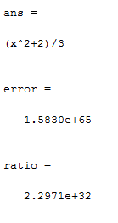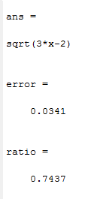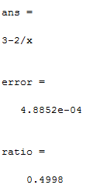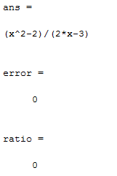

### 5.2

The termination criteria used for each function was that the computation for each function was repeated a maximum of ten times per method and the tolerance of error was set as 10-10.

The output obtained for each function with all 3 methods is shown below.

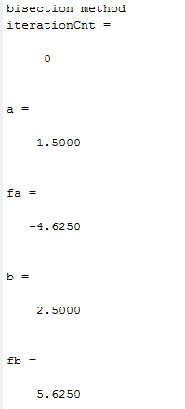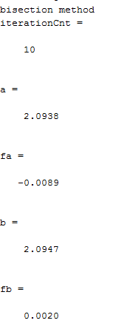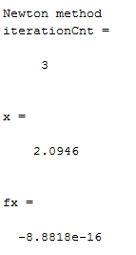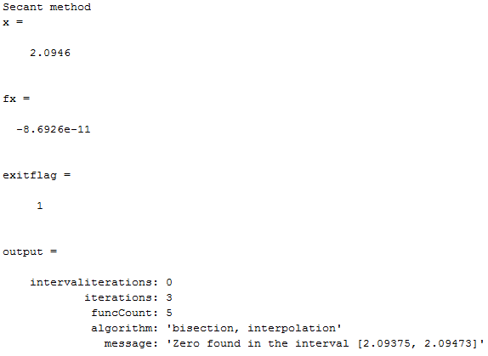

Figure : Part a

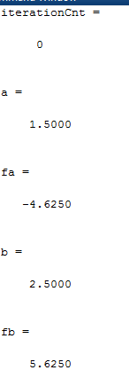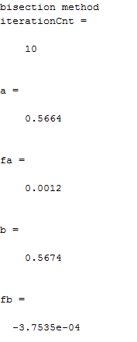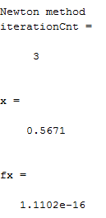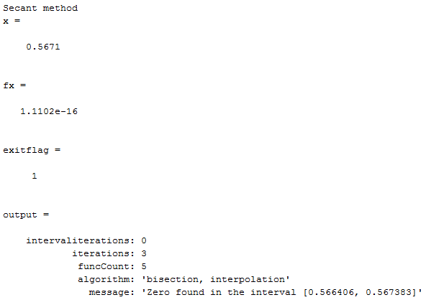

Figure : Part b

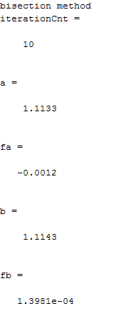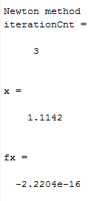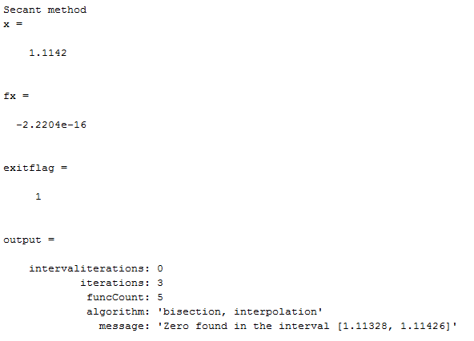

Figure : Part c

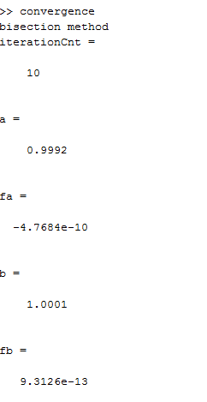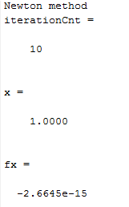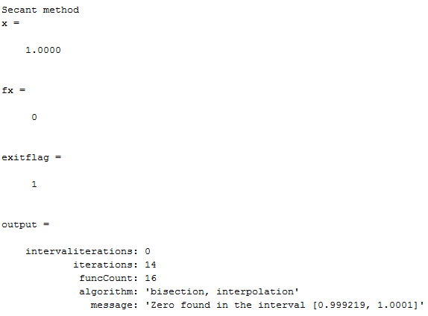

Figure : Part d

### 5.13

The following screenshots shows the result obtained by the implementation in MATLAB compared with the built-in MATLAB solver.

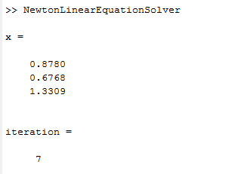

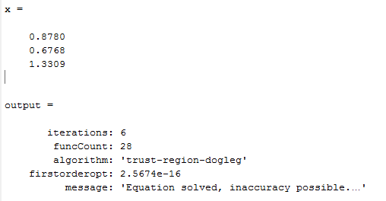

### 5.17

$$R_{k+1}=I-AX_{k+1}$$

$$R_{k+1}=I-A(X_{k}+X_{k}\left(I-AX_{k}\right))$$

$$R_{k+1}=I-A(X_{k}+X_{k}R_{k})$$

$$R_{k+1}=I-AX_{k}(I+R_{k})$$

$$R_{k+1}=I-AX_{k}-{AX_{k}R}_{k}$$

$$R_{k+1}=R_{k}-{AX_{k}R}_{k}$$

$$R_{k+1}=R_{k}(I- AX_{k})$$

$$R_{k+1}=R_{k}^{2}$$

$$E_{k+1}=A^{-1}-X_{k+1}$$

$$E_{k+1}=A^{-1}-X_{k}+X_{k}\left(I-AX_{k}\right)$$

$$E_{k+1}=A^{-1}-X_{k}+X_{k}-AX_{k}^{2}$$

$$E_{k+1}=A^{-1}-AX_{k}^{2}$$

$${A^{-1}E}_{k+1}={A^{-1}A}^{-1}-X_{k}X_{k}$$

$${A^{-1}E}_{k+1}=E_{k}(A^{-1}-X_{k})$$

$$E_{k+1}=E_{k}A(A^{-1}-X_{k})$$

$$E_{k+1}=E_{k}AE_{k}$$

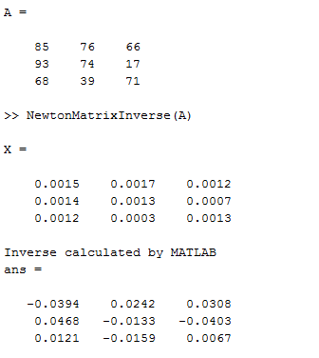

# Chapter 6

## Exercises

### 6.1

$f\left(x\right)=\frac{1}{2}(x_{1}^{2}-x_{2})^{2}+\frac{1}{2}(1-x_{1})^{2}$

$$∇f\left(x\right)=\left[\begin{matrix}2x_{1}^{3}-2x_{1}x_{2}+x_{1}-1 \\ -x_{1}^{2}+x_{2}\end{matrix}\right]$$

$$H_{f}\left(x\right)=\left[\begin{matrix}6x_{1}-2x_{2}+1 & -2x_{1} \\ -2x_{1} & 1\end{matrix}\right]$$

f has a minimum, critical point at $x^{*}=\left[\begin{matrix}1 & 1\end{matrix}\right]$ as $H_{f}\left(x\right)$ is positive definite at $x^{*}$.

1. The matrix inverse is given by:

$$H^{-1}=\frac{1}{5}\left[\begin{matrix}1 & 4 \\ 21 & 4\end{matrix}\right]$$

Hence,

${Δx}_{2}=\left[\begin{matrix}1 & 4 \\ 21 & 4\end{matrix}\right]\left[\begin{matrix}-9 \\ 2\end{matrix}\right]=\frac{1}{5}\left[\begin{matrix}-1 \\ 6\end{matrix}\right]$

Therefore,

$$x_{2}={Δx}_{2}+ x_{1}=\frac{1}{5}\left[\begin{matrix}9 \\ 16\end{matrix}\right]$$

1. The derivative is close to zero with this step as shown below

${||f}^{'}\left(x_{0}\right)||=|\left|f^{'}\left(2,2\right)\right||^{2}=||($ 9, -2)|| = 9.2 and ${||f}^{'}\left(x_{1}\right)\left|\left|= {||f}^{'}\left(\frac{9}{5},\frac{16}{5}\right)\right|\right|=0.94$

1. The new iteration deviates from the solution so the chosen step is not good

|| ||= ||(1, 1)|| = 1.41

|| ||= ||)||= 2.34

### 6.2

1. When A $x^{*}=b$:

$$∇f\left(x\right)=Ax-b$$

$$Hf\left(x\right)=A$$

The system for Newton’s method step from an arbitrary $x_{0}$ is given below

$$H_{f}{(x}_{0})s_{0}=As_{0}=b-Ax_{0}= -∇f(x_{0})$$

Which gives the result $x_{1}=x_{0}+s_{0}$. Hence, we get:

$${Ax}_{1}=A\left(x_{0}+s_{0}\right)= {Ax}_{0}+As_{0}=\left(b-Ax_{0}\right)+As_{0}=b$$

Implying that $x_{1}=x^{*}$. Thus, it can be observed that Newton’s method converges to the solution in one iteration from any $x_{0}$.

1. For the steepest descent method, we need to find the minimum of α ${f(x}_{0}+αs_{0})$**,** where ${ s}_{0}=-∇f\left(x\right)=b-Ax$. The minimizing value for α is:

$$α=s_{k}^{T}s_{k}/s_{k}^{T}As_{k}$$

If, $x_{0}-x^{*}$ is an eigenvector of A, then

$$λ(x_{0}-x)=A(x_{0}-x)=Ax_{0}-Ax=Ax_{0}-b.$$

The following equations proves that $s_{0}$ is A’s eigenvector:

$${ As}_{0}= λA\left(x^{*}{-x}_{0}\right)= λA\left(x^{*}-Ax\right)=λ\left(b-Ax_{0}\right)=λs_{0}$$

Therefore, $λ=\frac{s_{0}^{T}As_{0}}{s_{0}^{T}s_{0}}$

As $α=\frac{1}{λ}$,

$$x_{1}=x_{0}-α∇f\left(x_{0}\right)$$

$$x_{1}=x_{0}+\left(\frac{1}{λ}\right)\left(b-Ax_{0}\right)$$

$$x_{1}=x_{0}+\left(\frac{1}{λ}\right)\left(Ax^{*}-Ax_{0}\right)$$

$$x_{1}=x_{0}+\left(\frac{1}{λ}\right)\left(A{(x}^{*}-x_{0}\right))$$

$$x_{1}=x_{0}+\left(\frac{1}{λ}\right)\left(λ(x^{*}-x_{0}\right))=x^{*}$$

Showing that the steepest method converges to the solution in one iteration from the starting point.

### 6.3

If y is a non-zero vector, then

$${\left[\begin{matrix}0 \\ y\end{matrix}\right]}^{T}\left[\begin{matrix}B & J^{T} \\ J & O\end{matrix}\right]\left[\begin{matrix}0 \\ y\end{matrix}\right]={\left[\begin{matrix}0 \\ y\end{matrix}\right]}^{T}\left[\begin{matrix}J^{T}y \\ 0\end{matrix}\right]=0$$

Hence, a 2x2 Hessian matrix of the Lagrange function for constrained optimization cannot be positive definite.

### 6.4

1. The following vertices are contained in the feasible region:

{(0,0), (0, 1.5), (0.857, 0.857), (1.09, 0.545), (1.2, 0)}

1. The values of the objective function at each vertex are: 0, -3, -4.29, -4.37 and -3.6 respectively.

The lowest cost is found at: (1.09, 0.545)

## Computer Problems

### 6.9

The plot of the path taken in plane by the solutions for each method is given below

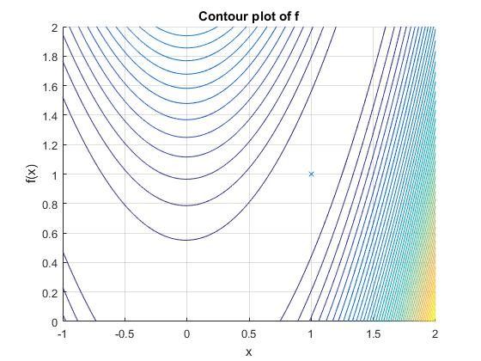

Final solutions obtained from each method after a suitable number of iterations is provided below

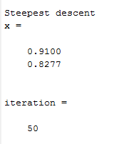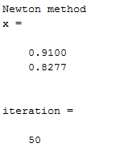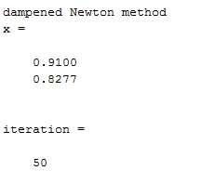

### 6.11

The following figures shows the solutions obtained from MATLAB

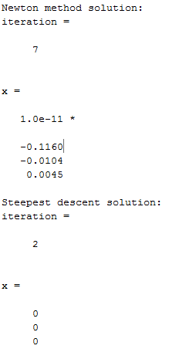

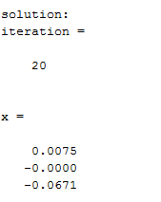

### 6.12

The solution below is obtained for the Fletcher Reeves algorithm.

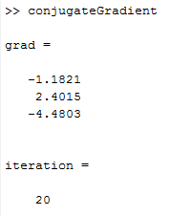

The solution below is obtained for Polak Ribiere algorithm.

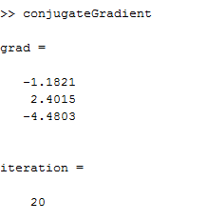

The tolerance was set as 10­-5 and the function successfully converged to the solution in n steps for an arbitrary quadratic function of n variables.

### 6.13

1. The solution obtained from MATLAB is given below

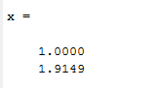

1. The solution obtained from MATLAB is given below

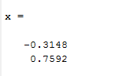

### 6.19 (a)

The solution obtained from MATLAB for all unknown x is shown below

