# Chapter 5

## Exercises

### 5.3

1. As , the Newton iteration is given as follows, when f(x) = 0 needs to be solved.
2. Given an initial guess of 4-bit accuracy, to obtain 24-bit accuracy, the number of iterations required is . For 53-bit accuracy .

### 5.4

Let . Then, . Hence, to solve f(x) = 0 the Newton iteration is as follows:

### 5.6

1. As and , the iterative scheme is not convergent.
2. As and , the iterative scheme is locally convergent.
3. , the fixed-point iteration function given by Newton’s method is .

### 5.9

## Computer Problems

### 5.1

Therefore, the gradient is divergent.

Therefore, the gradient is convergent at 0.75.

Therefore, the gradient is convergent at 0.5.

Therefore, the gradient is quadratically convergent.

1. The MATLAB output for the functions above is given below:

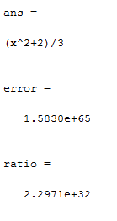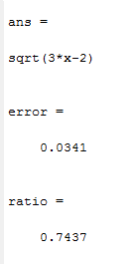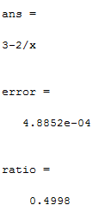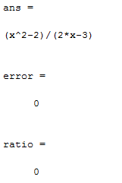

### 5.2

The termination criteria used for each function was that the computation for each function was repeated a maximum of ten times per method and the tolerance of error was set as 10-10.

The output obtained for each function with all 3 methods is shown below.

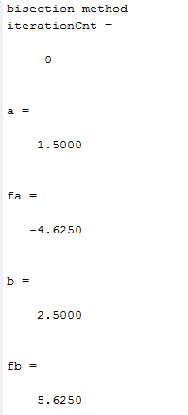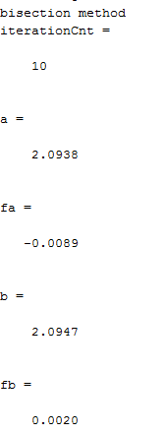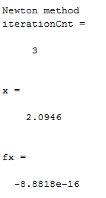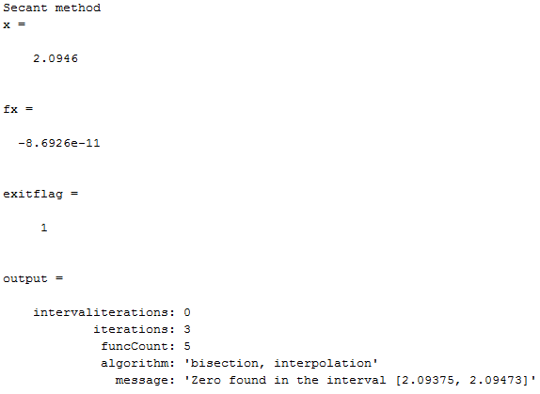

Figure 1: Part a

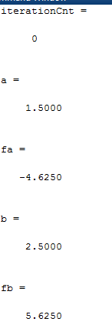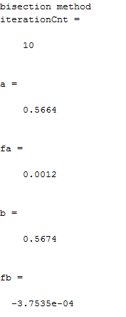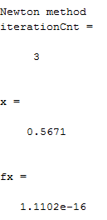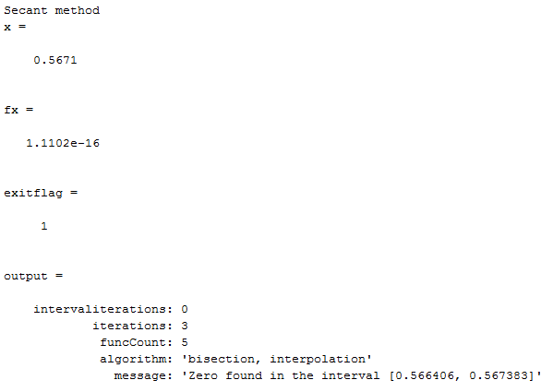

Figure 2: Part b

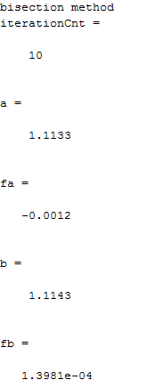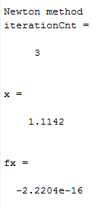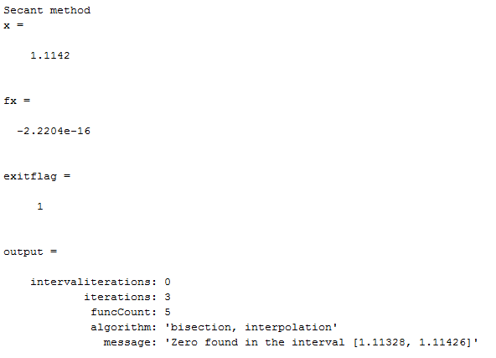

Figure 3: Part c

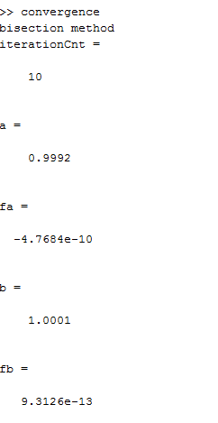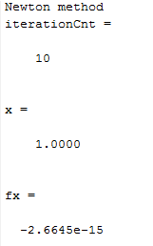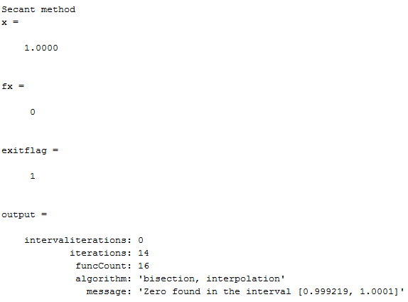

Figure 4: Part d

### 5.13

The following screenshots shows the result obtained by the implementation in MATLAB compared with the built-in MATLAB solver.

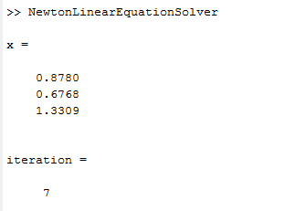

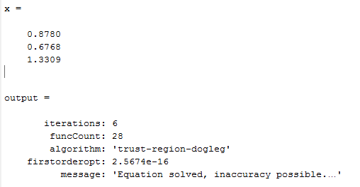

### 5.17

CHECK THIS

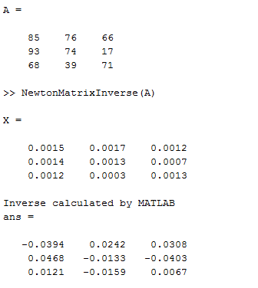

# Chapter 6

## Computer Problems

### 6.9

The plot of the path taken in plane by the solutions for each method is given below

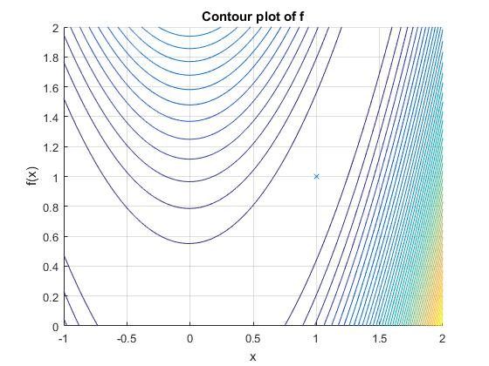

Final solutions obtained from each method after a suitable number of iterations is provided below

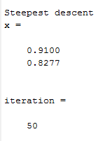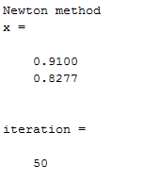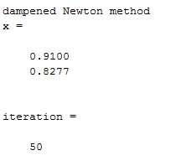

### 6.11

// incomplete code

### 6.12

The solution below is obtained for the Fletcher Reeves algorithm.

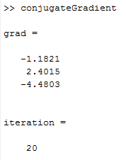

The solution below is obtained for Polak Ribiere algorithm.

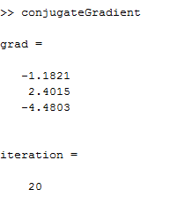

The tolerance was set as 10­-5 and the function successfully converged to the solution in n steps for an arbitrary quadratic function of n variables.

### 6.13

1. The solution obtained from MATLAB is given below

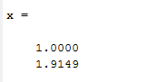

1. The solution obtained from MATLAB is given below

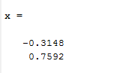

### 6.19 (a)

The solution obtained from MATLAB for all unknown x is shown below

