## Question 3

1. Plot below shows the discrete plot of impulse response (h[n]).



Result was confirmed with MATLAB as well, by looping over the impulse vector and finding the index where the first non-zero value occurs.

Frequency is 16000 Hz, so the delay = 149/16000 = 0.0093 seconds. Speed of sound = 340 m/s, so distance between microphone and the person is d = 340*0.0093 = 3.1662 m.

1. Sound still audible after convolution, although there is some noise noticeable. A background noise can be heard which seems to have degraded the sound quality of the original audio. SHOROUQ!! Can you listen to both and give a better description?
2. An delayed version of the sound can be heard along with the original, therefore creating the impression of an echo.
3. The sound is played backwards by reversing the original sound vector. This is achieved by using the flipud function in MATLAB. Playing the backwards signal resulted in speech which could not be understood.

|  |  |
| --- | --- |
| Frequency | Comments |
| 13000 | The sound seems slower and the voice is now thick, low-pitched voice |
| 14500 | The sound is quite like the original but still slow, quite thick, low-pitched voice |
| 17000 | The sound is quite similar but is a faster, higher pitched version of the original |
| 18500 | The sound is much faster and higher pitched version of the original, and seems much higher than the previous frequency |
| 20000 | At this frequency, the sound is way high pitched and much faster than the original |

1. The plot below shows the Fast Fourier Transform (FFT) plot, comparing the original signal, with the sub-sampling signals

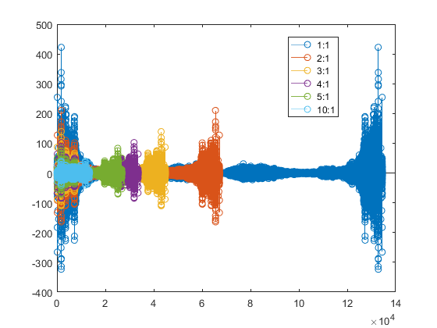

|  |  |
| --- | --- |
| Sub-Sample ratio | Ratio |
| 2:1 | The sound is like the original with some minor losses in the audio |
| 3:1 | This sound is also like the original, but the signal seems more lossy now |
| 4:1 | This sound is more lossy than before, with the sound almost resembling a muffled voice |
| 5:1 | This sound is more muffled than before with the audio almost not hearable in low volume |
| 10:1 | This sound has the most losses, having the greatest muffled audio. Only a little bit of the audio could be understood |

1. The following results were obtained after quantization:

**1-bit quantization:**

The graph below shows the discrete plot of the 1-bit quantized signal. In this case, nothing could be heard apart from a slight noise at the at a specific time, which corresponds to the plot

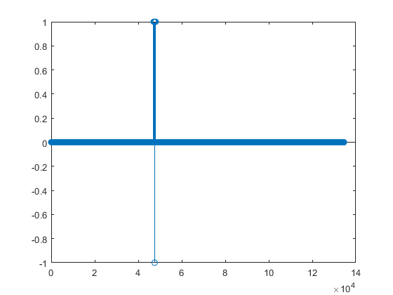

**2-bit quantization:**

The graph below shows the plot for the 2-bit quantized signal. In this case, most of the signal was cut-off (could not be heard) with background noise, severely hampering the quality. However, some parts of the original could be heard, albeit with the noise

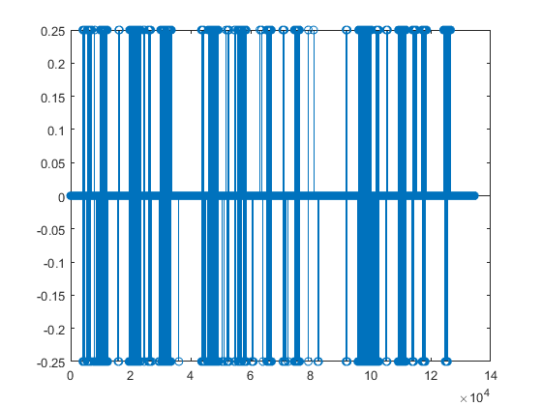

**4-bit quantization:**

The graph for 4-bit quantization is as shown below. In this case, the original signal could be heard without any cut-offs, however there was noticeable background noise.

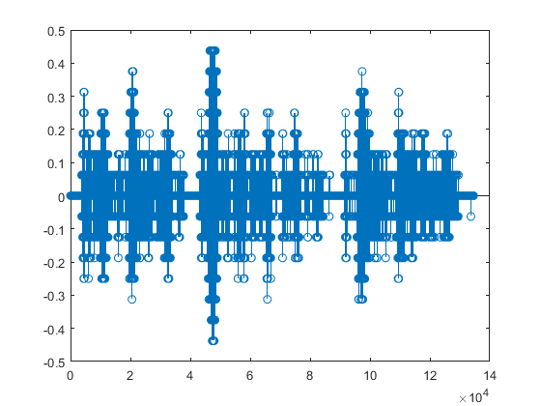

**8-bit quantization:**

In this case the sound was very clear, almost close to the original. Some low and minor noise could be heard with the signal at very specific points and not throughout the audio playback, as was the case with 4-bit quantization. The discrete plot is shown below, which is almost the same as the discrete of the original signal.

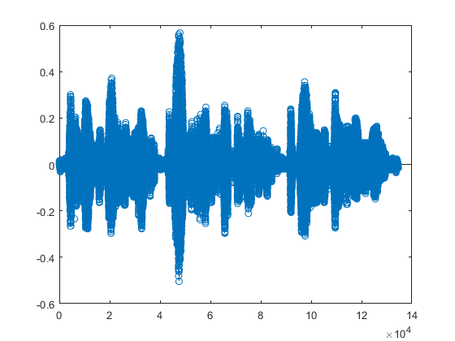

**16-bit quantization:**

In this case the sound quality was the same as the original and no noise could be heard. The plot is shown below, which is now more closer and better in shape compared to the original signal’s plot.

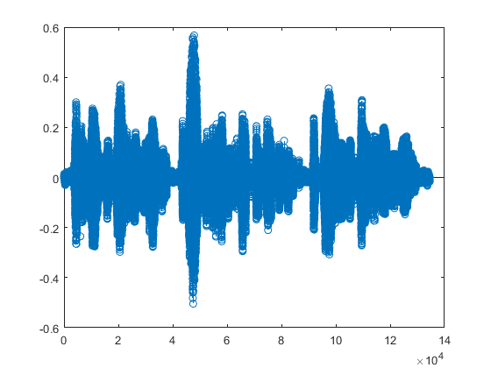

## Question 4

e) In MATLAB, the rand function can be used to generate uniformly distributed numbers such as:

a + rand(n, 1) * (b – a)

where a is the minimum, b is the maximum and n is the number of random number generated in vector.

In our case, where the interval is [-1 1] and we are adding 6 uniform generators, a is -1, b is 1 and n is 6, Matlab script to show the noise generated is in fact close to being Gaussian distributed is shown in **Fig ..**:

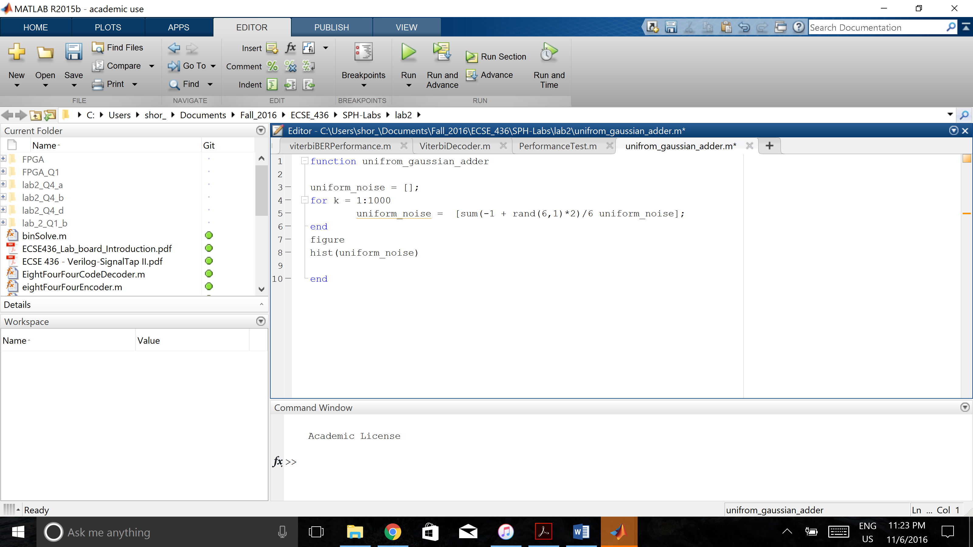

The plot of this script in **Fig 1** shows that the noise generated with six uniform number generators has a Gaussian distribution.



f) The mean of noise in part (d) is 0 while the variance is 0.2.

g) The noise power was adjusted by masking most significant bits in noise. Estimating the each masked bit corresponds to 6dB and that SNR of 0dB is such that the most significant 4 bits of noise are shifted to the right. The different SNR values were obtained as shown in **Table**:

|  |  |
| --- | --- |
| **SNR /dB** | **Right Shift in Added Gaussian Noise** |
| -10 | Shifted two bits |
| 0 | Shifted four bits |
| 10 | Shifted six bits |
| 20 | Shifted seven bits |
| 30 | Shifted nine bits |
| 40 | Shifted eleven bits |

## Question 5

1. Here is an example of 4 equations with 4 unknowns where the real and mod2 solutions differ

Solving the above four equations yields the following results in base-10: a = -1, b = -1, c = 2 and d = 0. Solving the equations in mod-2 gives the following: a = 1, b = 1, c = 0 and d = 0.

## Question 6

1. A system is said to be causal if its output depends only on present and past input values, and not future inputs. For discrete LTI systems, all outputs are defined via the convolutional theorem:

For non-zero h[n] when n < 0, the summation would expand as such:

It can be noticed from the last two terms of the summation that when h[n] is negative the output depends on future values of x (x[n+1], x[n+2] and so on). This goes against the definition of causality and hence the LTI system is not causal if impulse response is non-zero for n < 0.

1. For BIBO stability, any bounded input, i.e. |x[n]| < ∞, should give a bounded output, i.e. |y[n]| < ∞. For LTI systems a system is not BIBO stable if |h[n]| is not stable. This can be proved via the convolutional theorem, where assume that summation of |x[n]| = A, a finite constant:

= ∞

Therefore, the system is not stable.

1. For a system to be invertible, there should exist an impulse response such that when the output signal of the system is multiplied (or convoluted) with the inverse, the original input is recovered:

h[n]

h`[n]

x[n]

y[n]

x[n]

The following equation shows the output for the echo system used in Question 1. The echo is generated by delayed response of the input signal, modelled by the term x[n – A], where A is a real, positive constant.

Converting this equation discrete time Fourier transform:

The invertible system is defined by:

= 1/

Hence the system is only invertible when the term 1 + e­-jwA is non-zero, thus making H`(ejw) real. Due to this condition, the system is not strictly invertible.

1. In this case, the impulse response of the system will be 1 for certain frequencies only. Assume that the impulse response is given as follows:

The z-transform for this impulse response is the following:

//complete

1. The convolution theorem states the following for LTI systems:

It is also known that an LTI system has h[n] as its output when the input is . This can be stated as:

Due to time-invariance we can say:

Due to linearity:

Again, due to linearity:

Hence, the above states and proves the convolution theroem:

1. The Fourier transform for any signal x[n] is defined by the following equality:

The convolutional property states the following:

Therefore, Y(ejw) is given as such:

It can be observed that the two summations above correspond to the definition of discrete Fourier transform. Thus:

1. Aliasing refers to the sub-sampling of a signal. With the aid of aliasing, a continuous signal can be sampled at different frequencies to arrive at its close approximation in discrete time. A sample taken at every other interval will be a closer approximation to a sample taken at every 3rd interval. The plots below show the effect of aliasing by sampling a sine waveform from continuous time domain to discrete time domain. In **Fig2** the sample is taken at every 0.1 seconds. In **Fig3** the sample is taken at every 0.3 seconds. In both figures, some points from the original waveform are missing due to aliasing.



Figure : Sine plot in continuous time domain



Figure : Sine function in discrete time domain, sample taken at every 0.1 seconds



Figure : Sine function in discrete time domain, sample taken at every 0.3 seconds