University Of Engineering and Technology, Lahore
Computer Engineering Department

Course Name: Object Oriented Programming | Course Code: CMPE-252L
Assignment Type: Lab | Dated: Spring 2026
Semester: 2nd | Session: Spring 2026
Lab/Project/Assignment #: 1 | CLOs to be covered: CLO1
Lab Title: Conditional & Loop Structures in Java | Teacher Name: Hafiz Muhammad Mubashar
Student Name: Muhammad Zaid | Reg No: 2025-CYS-154
Section: C | Spring 2026
Lab Evaluation:

CLO1 | Apply appropriate programming techniques to create executable programs to solve well defined problems
 | Level1 | Level2 | Level3 | Level4 | Level5 | Level6
(5)
Total |  |  |  |  |  | /5
Rubrics for Current Lab Evaluation
Scale | Marks | Level | Rubric
Excellent | 5 | L1 | Submitted all lab tasks, BONUS task, have good understanding.
Very Good | 4 | L2 | Submitted the lab tasks but have good understanding
Good | 3 | L3 | Submitted the lab tasks but have weak understanding.
Basic | 2 | L4 | Submitted the lab tasks but have no understanding.
Barely Acceptable | 1 | L5 | Submitted at least one lab task.
Unacceptable | 0 | L6 | Did not submit the lab tasks.

University Of Engineering and Technology, Lahore
Computer Engineering Department

Course Name: Object Oriented Programming | Course Code: CMPE-252L
Assignment Type: Lab | Dated: Spring 2026
Semester: 2nd | Session: Spring 2026
Lab/Project/Assignment #: 1 | CLOs to be covered: CLO1
Lab Title: Conditional & Loop Structures in Java | Teacher Name: Hafiz Muhammad Mubashar
Student Name: Muhammad Zaid | Reg No: 2025-CYS-154
Section: C | Spring 2026

Objective
To practice conditional statements and loops in Java for mathematical and logical problem solving.
Theory
Java provides if-else and switch for branching, and for/while/do-while for iteration. These constructs allow programs to make decisions and repeat actions based on conditions.
Task 1 — Factorial Calculator
Strategy: Read integer input. If negative, print undefined. Otherwise loop from 1 to n multiplying into a long accumulator and print the result.

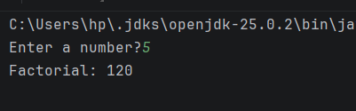
Task 2 — Number Range Printer
Strategy: Read start and end. Compare to determine direction (ascending or descending), then loop printing each number from start to end.

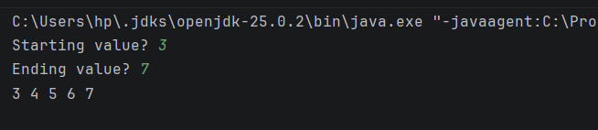

Task 3 — Leap Year Checker
Strategy: Read a year. Apply rule: (divisible by 4 AND NOT 100) OR (divisible by 400). Print result.

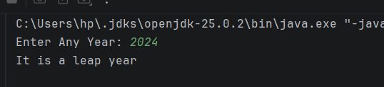
Task 4 — Electricity Bill Calculator
Strategy: Read units. Apply tiered billing: ≤100 units @Rs.5, next 100 @Rs.7, remainder @Rs.15. Sum slabs and print total bill.

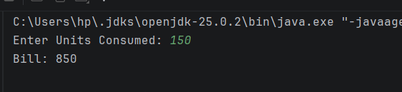
Task 5 — Count Binary Divisions
Strategy: Read positive integer. While value > 1, divide by 2 and increment counter. Print final count.

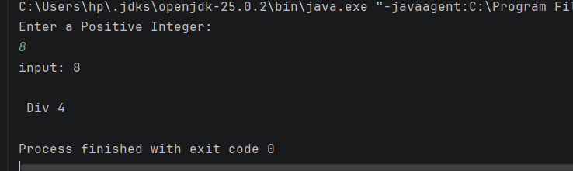

Task 6 — Number Reversal
Strategy: Extract digits using modulo 10, build reversed number by multiplying accumulator by 10 then adding each digit. Continue until original becomes 0.

