University Of Engineering and Technology, Lahore
Computer Engineering Department

Course Name: Object Oriented Programming | Course Code: CMPE-252L
Assignment Type: Lab | Dated: Spring 2026
Semester: 2nd | Session: Spring 2026
Lab/Project/Assignment #: 10 | CLOs to be covered: CLO1
Lab Title: Abstract Classes in Java | Teacher Name: Hafiz Muhammad Mubashar
Student Name: Muhammad Zaid | Reg No: 2025-CYS-154
Section: C | Spring 2026
Lab Evaluation:

CLO1 | Apply appropriate programming techniques to create executable programs to solve well defined problems
 | Level1 | Level2 | Level3 | Level4 | Level5 | Level6
(5)
Total |  |  |  |  |  | /5
Rubrics for Current Lab Evaluation
Scale | Marks | Level | Rubric
Excellent | 5 | L1 | Submitted all lab tasks, BONUS task, have good understanding.
Very Good | 4 | L2 | Submitted the lab tasks but have good understanding
Good | 3 | L3 | Submitted the lab tasks but have weak understanding.
Basic | 2 | L4 | Submitted the lab tasks but have no understanding.
Barely Acceptable | 1 | L5 | Submitted at least one lab task.
Unacceptable | 0 | L6 | Did not submit the lab tasks.

University Of Engineering and Technology, Lahore
Computer Engineering Department

Course Name: Object Oriented Programming | Course Code: CMPE-252L
Assignment Type: Lab | Dated: Spring 2026
Semester: 2nd | Session: Spring 2026
Lab/Project/Assignment #: 10 | CLOs to be covered: CLO1
Lab Title: Abstract Classes in Java | Teacher Name: Hafiz Muhammad Mubashar
Student Name: Muhammad Zaid | Reg No: 2025-CYS-154
Section: C | Spring 2026

Objective
To understand abstract classes, how they define contracts through abstract methods, and how subclasses fulfill them.
Theory
Abstract class: declared with 'abstract', cannot be instantiated. Abstract methods have no body — subclasses must @Override them. Can contain concrete methods and fields.
Task 1 — Abstract Creatures and Tiger
Strategy: abstract Creatures with abstract displayInfo(). Tiger extends Creatures, constructor sets creatureName and habitat, overrides displayInfo() printing both fields.

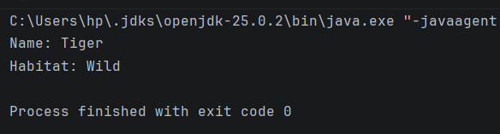
Task 2 — Abstract PaymentService
Strategy: abstract PaymentService with abstract makePayment(int). EasyPaisa extends it, overrides makePayment() printing confirmation and storing amount. SadaPay has stub.

