University Of Engineering and Technology, Lahore
Computer Engineering Department

Course Name: Object Oriented Programming | Course Code: CMPE-252L
Assignment Type: Lab | Dated: Spring 2026
Semester: 2nd | Session: Spring 2026
Lab/Project/Assignment #: 11 | CLOs to be covered: CLO1
Lab Title: Interfaces in Java | Teacher Name: Hafiz Muhammad Mubashar
Student Name: Muhammad Zaid | Reg No: 2025-CYS-154
Section: C | Spring 2026
Lab Evaluation:

CLO1 | Apply appropriate programming techniques to create executable programs to solve well defined problems
 | Level1 | Level2 | Level3 | Level4 | Level5 | Level6
(5)
Total |  |  |  |  |  | /5
Rubrics for Current Lab Evaluation
Scale | Marks | Level | Rubric
Excellent | 5 | L1 | Submitted all lab tasks, BONUS task, have good understanding.
Very Good | 4 | L2 | Submitted the lab tasks but have good understanding
Good | 3 | L3 | Submitted the lab tasks but have weak understanding.
Basic | 2 | L4 | Submitted the lab tasks but have no understanding.
Barely Acceptable | 1 | L5 | Submitted at least one lab task.
Unacceptable | 0 | L6 | Did not submit the lab tasks.

University Of Engineering and Technology, Lahore
Computer Engineering Department

Course Name: Object Oriented Programming | Course Code: CMPE-252L
Assignment Type: Lab | Dated: Spring 2026
Semester: 2nd | Session: Spring 2026
Lab/Project/Assignment #: 11 | CLOs to be covered: CLO1
Lab Title: Interfaces in Java | Teacher Name: Hafiz Muhammad Mubashar
Student Name: Muhammad Zaid | Reg No: 2025-CYS-154
Section: C | Spring 2026

Objective
To understand Java interfaces — defining them, implementing them, comparing with abstract classes, and implementing multiple interfaces.
Theory
Interface: all methods implicitly public+abstract. 'implements' keyword. A class can implement multiple interfaces but extend only one class. Abstract class can have concrete methods and state; interfaces cannot (pre-Java 8).
Task 1 — Interface: Single Implementation
Strategy: Learner interface with showName() and showRoll(). Static inner class Myself implements Learner overriding both. Create Myself in main and call both methods.

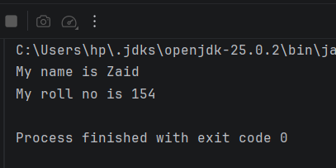

Task 2 — Abstract Class vs Interface
Strategy: Abstract Enrolled has abstract showName()/showRoll() + concrete showSection(). Myself extends Enrolled. Reference type is Enrolled — shows abstract class can have concrete methods unlike pure interfaces.

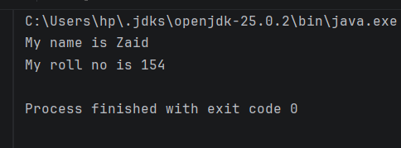
Task 3 — Multiple Interface Implementation
Strategy: Pupilz interface (showName, showRoll). Faculty interface (showReg). Member implements both, overriding all three. Call all methods from main.

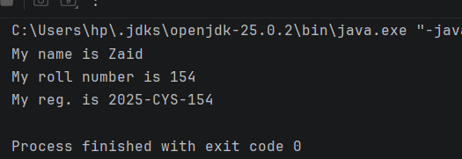
Task 4 — Abstract Class Chain
Strategy: Abstract Batchmate with abstract showRegistration(). Participant extends Batchmate implementing it. Variable type is Batchmate — only showRegistration() accessible.

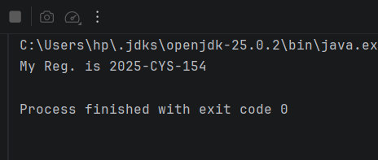

Task 5 — Abstract Class + Interface Combined
Strategy: Peer interface (showName, showRoll). Abstract Instructor (showReg). Candidate extends Instructor AND implements Peer — overrides all three. Combines inheritance with interface.

