University Of Engineering and Technology, Lahore
Computer Engineering Department

Course Name: Object Oriented Programming | Course Code: CMPE-252L
Assignment Type: Lab | Dated: Spring 2026
Semester: 2nd | Session: Spring 2026
Lab/Project/Assignment #: 13 | CLOs to be covered: CLO1
Lab Title: Associations, Composition & GUI Introduction | Teacher Name: Hafiz Muhammad Mubashar
Student Name: Muhammad Zaid | Reg No: 2025-CYS-154
Section: C | Spring 2026
Lab Evaluation:

CLO1 | Apply appropriate programming techniques to create executable programs to solve well defined problems
 | Level1 | Level2 | Level3 | Level4 | Level5 | Level6
(5)
Total |  |  |  |  |  | /5
Rubrics for Current Lab Evaluation
Scale | Marks | Level | Rubric
Excellent | 5 | L1 | Submitted all lab tasks, BONUS task, have good understanding.
Very Good | 4 | L2 | Submitted the lab tasks but have good understanding
Good | 3 | L3 | Submitted the lab tasks but have weak understanding.
Basic | 2 | L4 | Submitted the lab tasks but have no understanding.
Barely Acceptable | 1 | L5 | Submitted at least one lab task.
Unacceptable | 0 | L6 | Did not submit the lab tasks.

University Of Engineering and Technology, Lahore
Computer Engineering Department

Course Name: Object Oriented Programming | Course Code: CMPE-252L
Assignment Type: Lab | Dated: Spring 2026
Semester: 2nd | Session: Spring 2026
Lab/Project/Assignment #: 13 | CLOs to be covered: CLO1
Lab Title: Associations, Composition & GUI Introduction | Teacher Name: Hafiz Muhammad Mubashar
Student Name: Muhammad Zaid | Reg No: 2025-CYS-154
Section: C | Spring 2026

Objective
To understand object associations (has-a), distinguish association from composition, use super(), and introduce Java Swing GUI.
Theory
Association: A holds reference to B (injected externally). Composition: A creates B internally (owns it). super() calls parent constructor. Swing: JFrame=window, JLabel=text, JTextField=input. setBounds(x,y,w,h) positions with null layout.
Task 1 — Association & Composition: Caretaker and Pet
Strategy: Caretaker injected into Pet via assignPet() (association). Pet creates its own Caretaker internally (composition). makeSound() prints message + pet name. display() uses internal caretaker fields.

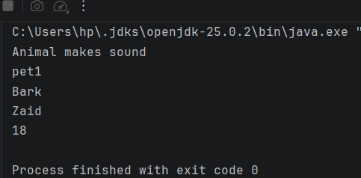

Task 2 — Inheritance with super()
Strategy: Creaturer has name field and makeSound(). Puppy extends Creaturer, has own name field, calls super(). Inherits makeSound(), adds display(). Puppy.name shadows Creaturer.name.

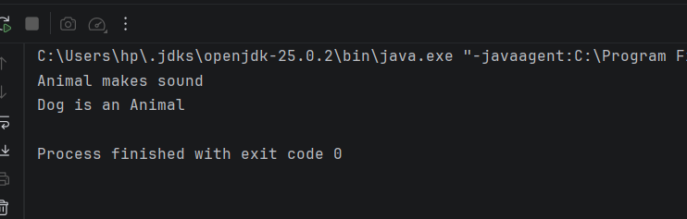

Task 3 — Java Swing GUI Introduction
Strategy: JFrame + setSize(600,600) + setLayout(null). JLabel and JTextField with setBounds(). Add both to frame. Shows first GUI window with a labeled input field.

