University Of Engineering and Technology, Lahore
Computer Engineering Department

Course Name: Object Oriented Programming | Course Code: CMPE-252L
Assignment Type: Lab | Dated: Spring 2026
Semester: 2nd | Session: Spring 2026
Lab/Project/Assignment #: 2 | CLOs to be covered: CLO1
Lab Title: Built-in Java Classes: Math & String | Teacher Name: Hafiz Muhammad Mubashar
Student Name: Muhammad Zaid | Reg No: 2025-CYS-154
Section: C | Spring 2026
Lab Evaluation:

CLO1 | Apply appropriate programming techniques to create executable programs to solve well defined problems
 | Level1 | Level2 | Level3 | Level4 | Level5 | Level6
(5)
Total |  |  |  |  |  | /5
Rubrics for Current Lab Evaluation
Scale | Marks | Level | Rubric
Excellent | 5 | L1 | Submitted all lab tasks, BONUS task, have good understanding.
Very Good | 4 | L2 | Submitted the lab tasks but have good understanding
Good | 3 | L3 | Submitted the lab tasks but have weak understanding.
Basic | 2 | L4 | Submitted the lab tasks but have no understanding.
Barely Acceptable | 1 | L5 | Submitted at least one lab task.
Unacceptable | 0 | L6 | Did not submit the lab tasks.

University Of Engineering and Technology, Lahore
Computer Engineering Department

Course Name: Object Oriented Programming | Course Code: CMPE-252L
Assignment Type: Lab | Dated: Spring 2026
Semester: 2nd | Session: Spring 2026
Lab/Project/Assignment #: 2 | CLOs to be covered: CLO1
Lab Title: Built-in Java Classes: Math & String | Teacher Name: Hafiz Muhammad Mubashar
Student Name: Muhammad Zaid | Reg No: 2025-CYS-154
Section: C | Spring 2026

Objective
To explore Java's built-in Math and String classes along with type casting and Java operators.
Theory
Math class: Math.pow(), Math.PI, Math.random(). String: length(), toUpperCase(), indexOf(). Type casting: (int) truncates doubles. Operators include arithmetic, relational, logical, and bitwise.
Task 1 — Circle Area using Math
Strategy: radius = 13.8. Use Math.pow(radius,2) × Math.PI. Print double result then cast to int.

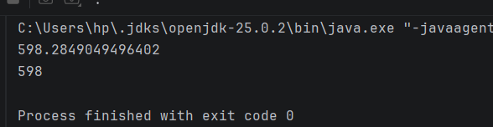
Task 2 — String Manipulation
Strategy: Declare name string. Use .length(), .toUpperCase(), .indexOf(' ') and print each result.

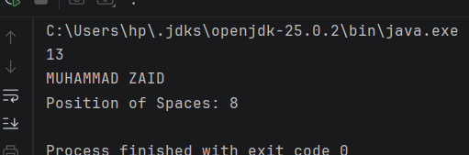
Task 3 — Type Casting
Strategy: Declare percentage = 85.99. Cast to int to truncate decimal. Print both values showing the difference.

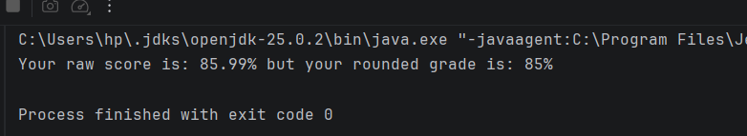
Tasks 4, 6, 7, 8 — Arithmetic & Bitwise Operators
Strategy: Demonstrate operator precedence, char arithmetic, bitwise AND/OR, and compound assignment in focused snippets.

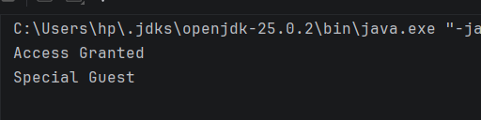
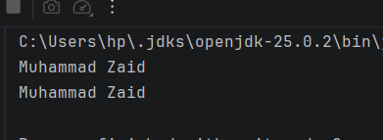
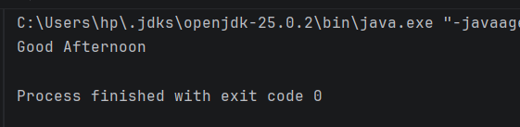
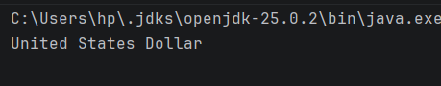

Task 5 — Random Number Guess
Strategy: Generate random int in [0,10] using (int)(Math.random()*11). Compare with fixed guess and print boolean result.

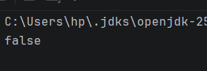
Task 9 — Relational Operators & Increment
Strategy: Compare two ints with !=, print message if unequal. Demonstrate pre-increment (++a1) and print value.

