University Of Engineering and Technology, Lahore
Computer Engineering Department

Course Name: Object Oriented Programming | Course Code: CMPE-252L
Assignment Type: Lab | Dated: Spring 2026
Semester: 2nd | Session: Spring 2026
Lab/Project/Assignment #: 3 | CLOs to be covered: CLO1
Lab Title: Classes & Objects — Encapsulation Basics | Teacher Name: Hafiz Muhammad Mubashar
Student Name: Muhammad Zaid | Reg No: 2025-CYS-154
Section: C | Spring 2026
Lab Evaluation:

CLO1 | Apply appropriate programming techniques to create executable programs to solve well defined problems
 | Level1 | Level2 | Level3 | Level4 | Level5 | Level6
(5)
Total |  |  |  |  |  | /5
Rubrics for Current Lab Evaluation
Scale | Marks | Level | Rubric
Excellent | 5 | L1 | Submitted all lab tasks, BONUS task, have good understanding.
Very Good | 4 | L2 | Submitted the lab tasks but have good understanding
Good | 3 | L3 | Submitted the lab tasks but have weak understanding.
Basic | 2 | L4 | Submitted the lab tasks but have no understanding.
Barely Acceptable | 1 | L5 | Submitted at least one lab task.
Unacceptable | 0 | L6 | Did not submit the lab tasks.

University Of Engineering and Technology, Lahore
Computer Engineering Department

Course Name: Object Oriented Programming | Course Code: CMPE-252L
Assignment Type: Lab | Dated: Spring 2026
Semester: 2nd | Session: Spring 2026
Lab/Project/Assignment #: 3 | CLOs to be covered: CLO1
Lab Title: Classes & Objects — Encapsulation Basics | Teacher Name: Hafiz Muhammad Mubashar
Student Name: Muhammad Zaid | Reg No: 2025-CYS-154
Section: C | Spring 2026

Objective
To understand Java class design, object creation, private field encapsulation, and getter/setter methods.
Theory
A class bundles data (fields) and behavior (methods). Private fields enforce encapsulation. Getters return values; setters modify them. 'this.x = x' resolves parameter/field name conflicts.
Task 1 — 3D Point Class
Strategy: Point class with private int x, y, z. setPoint(x,y,z) assigns all using 'this'. getPoint() returns formatted string. Main reads 3 values via Scanner.

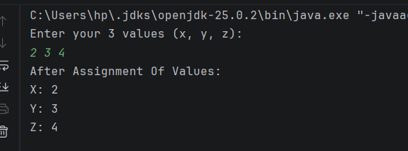

Task 2 — Time Conversion Class
Strategy: Time class. Conversion(sec): hours=sec/3600; if hours>23 extract days; rem=sec%3600; mins=rem/60; rem_secs=rem%60. Display with printf %02d.

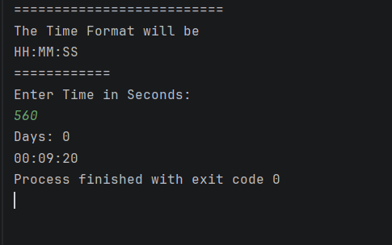
Task 3 — Asset Down Payment Calculator
Strategy: total_cost() = 25% of input. Total_months(): loop adding monthly 4%/12 return + salary portion until savings reach down payment. Return month count.

