University Of Engineering and Technology, Lahore
Computer Engineering Department

Course Name: Object Oriented Programming | Course Code: CMPE-252L
Assignment Type: Lab | Dated: Spring 2026
Semester: 2nd | Session: Spring 2026
Lab/Project/Assignment #: 4 | CLOs to be covered: CLO1
Lab Title: Constructors, Method Overloading & ArrayList | Teacher Name: Hafiz Muhammad Mubashar
Student Name: Muhammad Zaid | Reg No: 2025-CYS-154
Section: C | Spring 2026
Lab Evaluation:

CLO1 | Apply appropriate programming techniques to create executable programs to solve well defined problems
 | Level1 | Level2 | Level3 | Level4 | Level5 | Level6
(5)
Total |  |  |  |  |  | /5
Rubrics for Current Lab Evaluation
Scale | Marks | Level | Rubric
Excellent | 5 | L1 | Submitted all lab tasks, BONUS task, have good understanding.
Very Good | 4 | L2 | Submitted the lab tasks but have good understanding
Good | 3 | L3 | Submitted the lab tasks but have weak understanding.
Basic | 2 | L4 | Submitted the lab tasks but have no understanding.
Barely Acceptable | 1 | L5 | Submitted at least one lab task.
Unacceptable | 0 | L6 | Did not submit the lab tasks.

University Of Engineering and Technology, Lahore
Computer Engineering Department

Course Name: Object Oriented Programming | Course Code: CMPE-252L
Assignment Type: Lab | Dated: Spring 2026
Semester: 2nd | Session: Spring 2026
Lab/Project/Assignment #: 4 | CLOs to be covered: CLO1
Lab Title: Constructors, Method Overloading & ArrayList | Teacher Name: Hafiz Muhammad Mubashar
Student Name: Muhammad Zaid | Reg No: 2025-CYS-154
Section: C | Spring 2026

Objective
To practice parameterized constructors, method overloading, ArrayList for dynamic storage, and menu-driven applications.
Theory
Constructors initialize objects at creation. ArrayList<T> grows dynamically. Switch-case in a while loop drives menus. Math.abs() handles negative differences. Static methods are class-level.
Task 1 — Enhanced Time Comparison
Strategy: Constructor calls Conversion(sec). seconds() converts back to total. Difference_in_seconds() = Math.abs(t1.seconds()-t2.seconds()). Difference_in_timestamp() wraps result as new Time. Display_in_12hour_format() computes hour%12 and AM/PM.
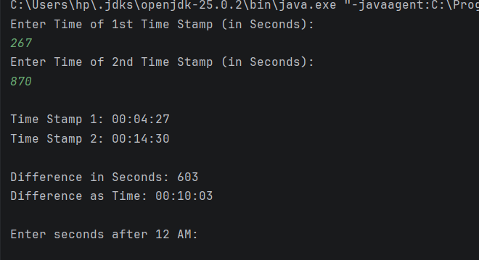

Task 2 — Bank Management System
Strategy: accounts class with name/accNo/balance. Deposit validates ≤50000, Withdrawal validates ≤20000 and ≤balance. Static find_account() searches ArrayList. Menu: create, deposit, withdraw, display, exit.

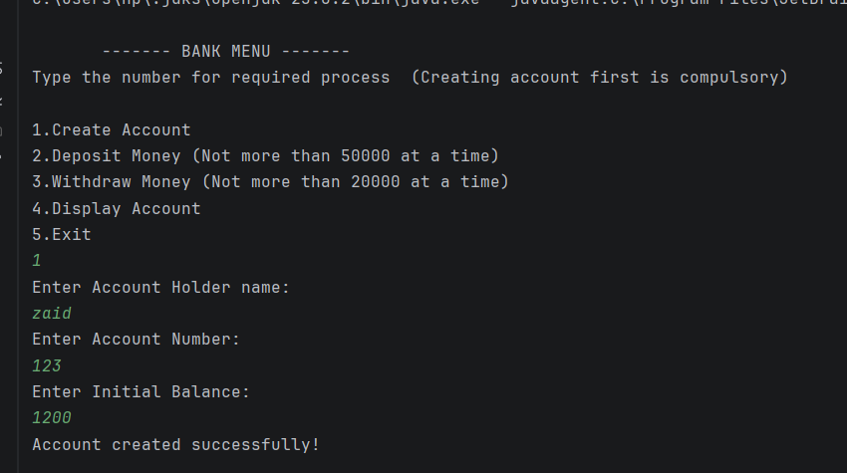
Task 3 — 2D Movement Game
Strategy: Person at (0,0). W/S/A/D move by 3 units. Boundary check [-10,10]. Hurdle collision warning. Hasan moves randomly. Loop ends on 'Q' or boundary hit.

