University Of Engineering and Technology, Lahore
Computer Engineering Department

Course Name: Object Oriented Programming | Course Code: CMPE-252L
Assignment Type: Lab | Dated: Spring 2026
Semester: 2nd | Session: Spring 2026
Lab/Project/Assignment #: 6 | CLOs to be covered: CLO1
Lab Title: Encapsulation, Getters/Setters & Inheritance Intro | Teacher Name: Hafiz Muhammad Mubashar
Student Name: Muhammad Zaid | Reg No: 2025-CYS-154
Section: C | Spring 2026
Lab Evaluation:

CLO1 | Apply appropriate programming techniques to create executable programs to solve well defined problems
 | Level1 | Level2 | Level3 | Level4 | Level5 | Level6
(5)
Total |  |  |  |  |  | /5
Rubrics for Current Lab Evaluation
Scale | Marks | Level | Rubric
Excellent | 5 | L1 | Submitted all lab tasks, BONUS task, have good understanding.
Very Good | 4 | L2 | Submitted the lab tasks but have good understanding
Good | 3 | L3 | Submitted the lab tasks but have weak understanding.
Basic | 2 | L4 | Submitted the lab tasks but have no understanding.
Barely Acceptable | 1 | L5 | Submitted at least one lab task.
Unacceptable | 0 | L6 | Did not submit the lab tasks.

University Of Engineering and Technology, Lahore
Computer Engineering Department

Course Name: Object Oriented Programming | Course Code: CMPE-252L
Assignment Type: Lab | Dated: Spring 2026
Semester: 2nd | Session: Spring 2026
Lab/Project/Assignment #: 6 | CLOs to be covered: CLO1
Lab Title: Encapsulation, Getters/Setters & Inheritance Intro | Teacher Name: Hafiz Muhammad Mubashar
Student Name: Muhammad Zaid | Reg No: 2025-CYS-154
Section: C | Spring 2026

Objective
To reinforce encapsulation through getters/setters and introduce inheritance using the 'extends' keyword.
Theory
Encapsulation: hide data with private, expose via public get/set. Inheritance: child uses 'extends' to reuse parent members. Child can call inherited and its own methods.
Task 1 — StudentInfo: Full Encapsulation
Strategy: Private studentName and enrollmentId. Constructor sets both. Setters update fields. Main creates object, prints initial info, updates via setters, prints again.

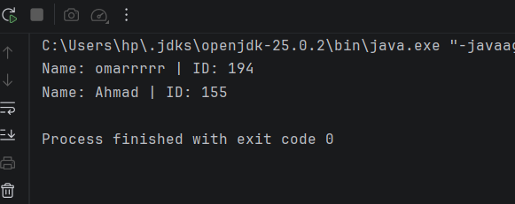

Task 2 — Grade Calculator
Strategy: Constructor computes percentage=(scored×100)/total. displayGrade() maps percentage to grade A through F using if-else chain. Read inputs from Scanner.

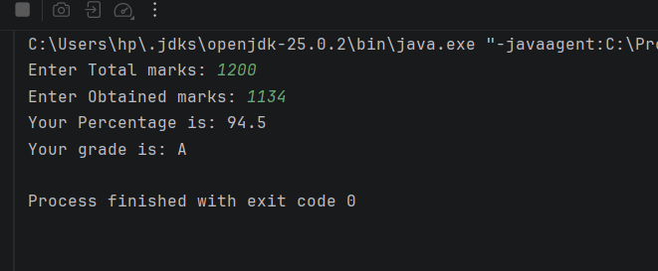
Task 3 — Inheritance: Creature and Cow
Strategy: Creature has eat(). Cow extends Creature, adds moo() and graze(). Main creates Cow and calls all three methods — eat() is inherited.

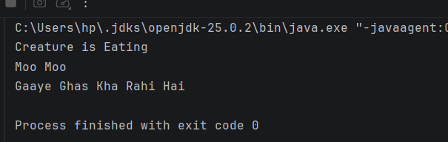

Task 4 — ScoreCalculator
Strategy: Constructor computes score=(achieved×100)/full. computedResult() returns stored value. Demonstrates constructor-based computation.

