University Of Engineering and Technology, Lahore
Computer Engineering Department

Course Name: Object Oriented Programming | Course Code: CMPE-252L
Assignment Type: Lab | Dated: Spring 2026
Semester: 2nd | Session: Spring 2026
Lab/Project/Assignment #: 7 | CLOs to be covered: CLO1
Lab Title: Constructors & the 'this' Keyword | Teacher Name: Hafiz Muhammad Mubashar
Student Name: Muhammad Zaid | Reg No: 2025-CYS-154
Section: C | Spring 2026
Lab Evaluation:

CLO1 | Apply appropriate programming techniques to create executable programs to solve well defined problems
 | Level1 | Level2 | Level3 | Level4 | Level5 | Level6
(5)
Total |  |  |  |  |  | /5
Rubrics for Current Lab Evaluation
Scale | Marks | Level | Rubric
Excellent | 5 | L1 | Submitted all lab tasks, BONUS task, have good understanding.
Very Good | 4 | L2 | Submitted the lab tasks but have good understanding
Good | 3 | L3 | Submitted the lab tasks but have weak understanding.
Basic | 2 | L4 | Submitted the lab tasks but have no understanding.
Barely Acceptable | 1 | L5 | Submitted at least one lab task.
Unacceptable | 0 | L6 | Did not submit the lab tasks.

University Of Engineering and Technology, Lahore
Computer Engineering Department

Course Name: Object Oriented Programming | Course Code: CMPE-252L
Assignment Type: Lab | Dated: Spring 2026
Semester: 2nd | Session: Spring 2026
Lab/Project/Assignment #: 7 | CLOs to be covered: CLO1
Lab Title: Constructors & the 'this' Keyword | Teacher Name: Hafiz Muhammad Mubashar
Student Name: Muhammad Zaid | Reg No: 2025-CYS-154
Section: C | Spring 2026

Objective
To understand constructor side effects, the 'this' reference, method overloading, and private helper methods.
Theory
'this' refers to current object. Private buildInfo() can be shared internally. Method overloading: same name, different parameters. Constructor can trigger logic at object creation.
Task 1 — Learner with Private buildInfo()
Strategy: private buildInfo() returns info string. Constructor calls System.out.println(buildInfo()). showInfo() also calls buildInfo(). Info prints twice: once at construction, once via showInfo().

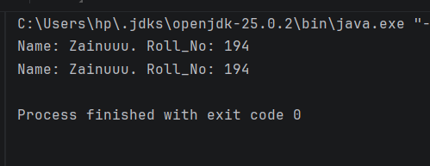

Task 2 — Pupil with Interactive Name Update
Strategy: Constructor prints info then asks to change name. If 'yes', calls overloaded updateName() reading new name from Scanner. showInfo() prints final state.

