University Of Engineering and Technology, Lahore
Computer Engineering Department

Course Name: Object Oriented Programming | Course Code: CMPE-252L
Assignment Type: Lab | Dated: Spring 2026
Semester: 2nd | Session: Spring 2026
Lab/Project/Assignment #: 8 | CLOs to be covered: CLO1
Lab Title: File I/O Operations in Java | Teacher Name: Hafiz Muhammad Mubashar
Student Name: Muhammad Zaid | Reg No: 2025-CYS-154
Section: C | Spring 2026
Lab Evaluation:

CLO1 | Apply appropriate programming techniques to create executable programs to solve well defined problems
 | Level1 | Level2 | Level3 | Level4 | Level5 | Level6
(5)
Total |  |  |  |  |  | /5
Rubrics for Current Lab Evaluation
Scale | Marks | Level | Rubric
Excellent | 5 | L1 | Submitted all lab tasks, BONUS task, have good understanding.
Very Good | 4 | L2 | Submitted the lab tasks but have good understanding
Good | 3 | L3 | Submitted the lab tasks but have weak understanding.
Basic | 2 | L4 | Submitted the lab tasks but have no understanding.
Barely Acceptable | 1 | L5 | Submitted at least one lab task.
Unacceptable | 0 | L6 | Did not submit the lab tasks.

University Of Engineering and Technology, Lahore
Computer Engineering Department

Course Name: Object Oriented Programming | Course Code: CMPE-252L
Assignment Type: Lab | Dated: Spring 2026
Semester: 2nd | Session: Spring 2026
Lab/Project/Assignment #: 8 | CLOs to be covered: CLO1
Lab Title: File I/O Operations in Java | Teacher Name: Hafiz Muhammad Mubashar
Student Name: Muhammad Zaid | Reg No: 2025-CYS-154
Section: C | Spring 2026

Objective
To perform file operations: creating, writing, reading, renaming, and appending using java.io and java.nio.file.
Theory
File class represents a path. PrintWriter writes text and must be closed. Files.readString(Path) reads entire file. FileWriter(name, true) appends. Files.readAllLines() returns List<String>.
Task 1 — Create, Write & Read File
Strategy: createFile() checks exists() before createNewFile(). writeToFile() uses PrintWriter then close(). readFromFile() uses Files.readString(Path.of(...)). renameFile() creates new File object with new name.

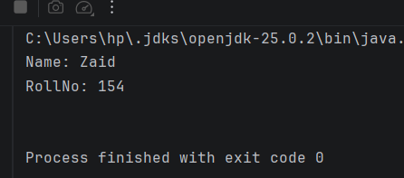

Task 2 — Append & Display Lines
Strategy: FileWriter(name, true) opens in append mode. displayLines() calls Files.readAllLines() and iterates printing each line. Multiple runs accumulate lines.

