University Of Engineering and Technology, Lahore
Computer Engineering Department

Course Name: Object Oriented Programming | Course Code: CMPE-252L
Assignment Type: Lab | Dated: Spring 2026
Semester: 2nd | Session: Spring 2026
Lab/Project/Assignment #: 9 | CLOs to be covered: CLO1
Lab Title: CSV File Processing & Multi-Class Design | Teacher Name: Hafiz Muhammad Mubashar
Student Name: Muhammad Zaid | Reg No: 2025-CYS-154
Section: C | Spring 2026
Lab Evaluation:

CLO1 | Apply appropriate programming techniques to create executable programs to solve well defined problems
 | Level1 | Level2 | Level3 | Level4 | Level5 | Level6
(5)
Total |  |  |  |  |  | /5
Rubrics for Current Lab Evaluation
Scale | Marks | Level | Rubric
Excellent | 5 | L1 | Submitted all lab tasks, BONUS task, have good understanding.
Very Good | 4 | L2 | Submitted the lab tasks but have good understanding
Good | 3 | L3 | Submitted the lab tasks but have weak understanding.
Basic | 2 | L4 | Submitted the lab tasks but have no understanding.
Barely Acceptable | 1 | L5 | Submitted at least one lab task.
Unacceptable | 0 | L6 | Did not submit the lab tasks.

University Of Engineering and Technology, Lahore
Computer Engineering Department

Course Name: Object Oriented Programming | Course Code: CMPE-252L
Assignment Type: Lab | Dated: Spring 2026
Semester: 2nd | Session: Spring 2026
Lab/Project/Assignment #: 9 | CLOs to be covered: CLO1
Lab Title: CSV File Processing & Multi-Class Design | Teacher Name: Hafiz Muhammad Mubashar
Student Name: Muhammad Zaid | Reg No: 2025-CYS-154
Section: C | Spring 2026

Objective
To read and process CSV data across multiple cooperating classes: loading, field extraction, calculation, and display.
Theory
CSV: comma-separated values read line by line. split(',') tokenizes. Integer.parseInt() converts strings. Static public lists share data across classes. Percentage = (marks/max)×100.
Task 1 — Load CSV Records (Lab9_task1)
Strategy: Scanner on StudentData.csv, loop hasNextLine() adding each line to static recordList. Main prints all records to verify loading.

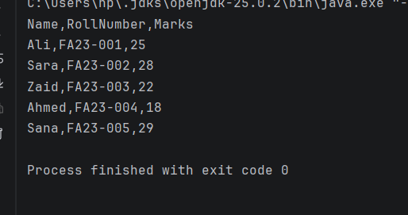

Task 2 — Extract Fields (Lab9_task2)
Strategy: Call Lab9_task1.loadRecords(). extractMarks() parses column[2] as int; extractNames() takes column[0]; extractRolls() takes column[1]. Skip header (index 0).

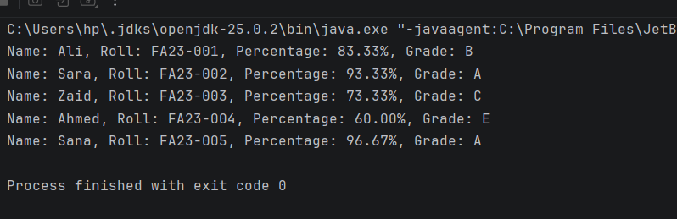

Task 3 — Result Calculation (ResultCalc)
Strategy: calculatePercentage() = mark/30.0×100. printResults() combines name+roll+percentage+grade. evaluateGrade() maps: A≥90, B≥80, C≥70, E≥60, F otherwise. Throws exception if >100.
JUST CODEEE:
