## **Sentiment Analysis Report: Product Review Insights**

### **1. Objective**

This analysis aims to extract insights from customer reviews to understand sentiment trends, common themes, and pain points. The results support product improvement and marketing strategy decisions.

### **2. Sentiment Distribution**

Using VADER sentiment analysis, each review was classified as **Positive**, **Negative**, or **Neutral**.

**Results:**

* **Positive:** 51%
* **Negative:** 45%
* **Neutral:** 4%

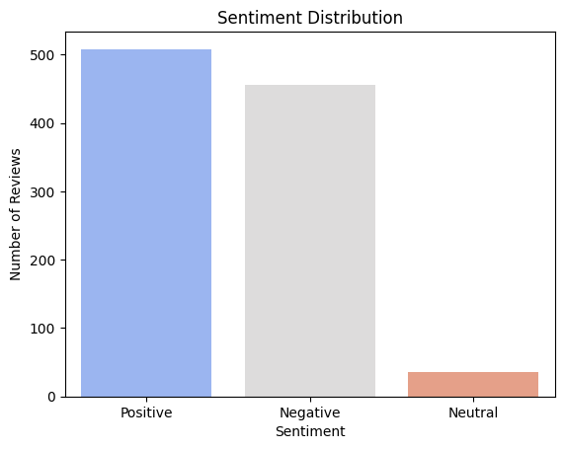

### **3. Sentiment vs. Review Ratings**

A strong correlation exists between **positive sentiment** and **higher star ratings**, and between **negative sentiment** and **low ratings**.

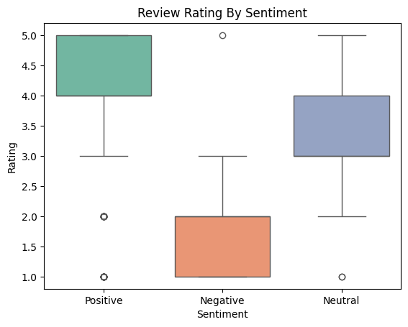

### **4. Sentiment Trends Over Time**

Sentiment trends were analyzed monthly to detect fluctuations.

**Findings:**

* Spikes in negative sentiment were observed in mid-2023.
* Positive sentiment was consistent for some products over time.

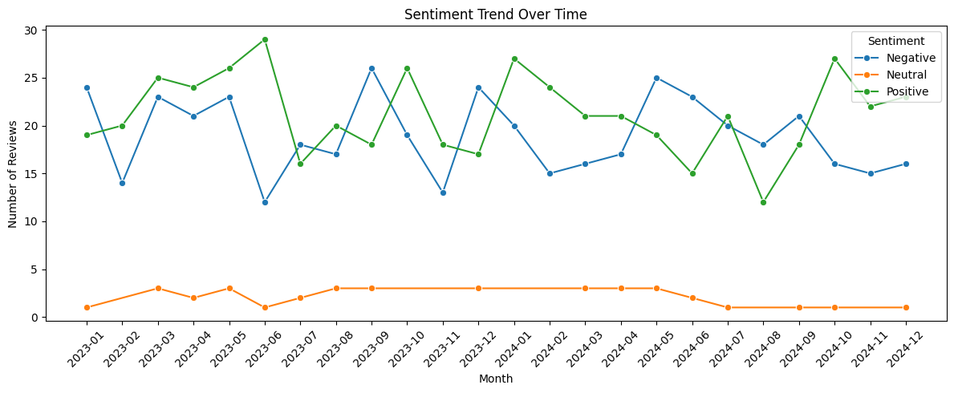

### **5. Sentiment by Product**

Different products received varying sentiment profiles:

* **Product_A** and **Product_C** had the most positive reviews.
* **Product_B** received disproportionately negative sentiment.

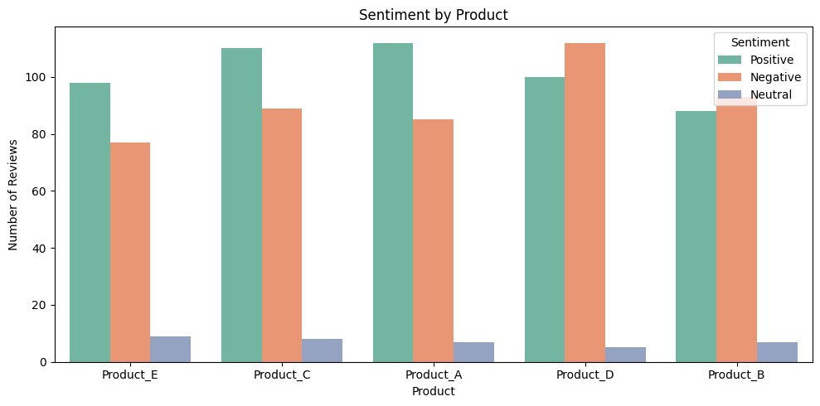

### **6. Word Clouds for Each Sentiment**

To better understand customer language, word clouds were generated:

* *Positive Sentiment Word Cloud*

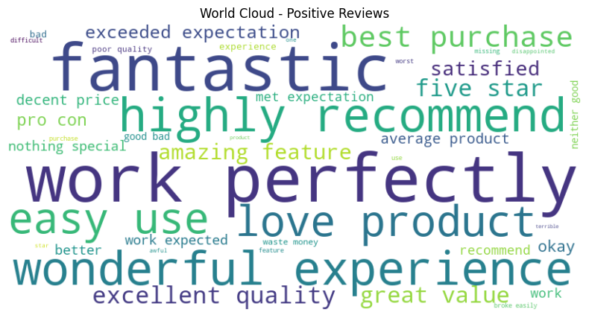

* *Negative Sentiment Word Cloud*

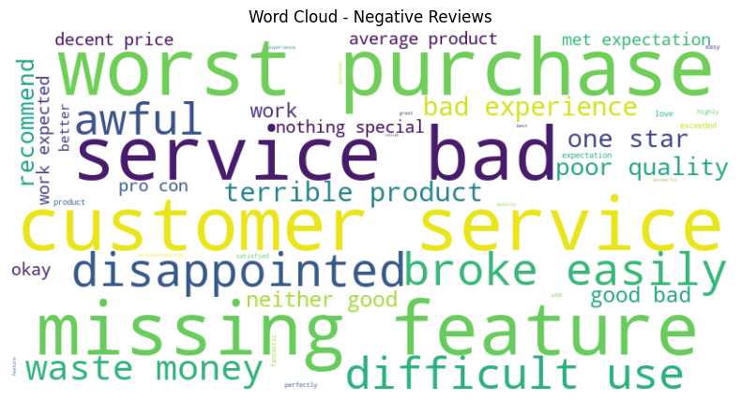

* *Neutral Sentiment Word Cloud*

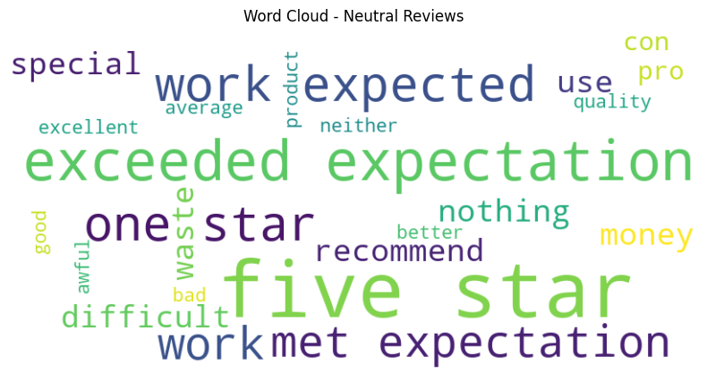

**Positive Themes:** "love", "excellent", "recommend", "fantastic", "easy to use"

**Negative Themes:** "poor quality", "broken", "worst", "bad experience", "missing"

### 

### **7. Topic Modeling of Negative Reviews**

Using LDA, we discovered common themes within negative reviews:

| **Topic** | **Top Keywords** | **Theme** |
| --- | --- | --- |
| 1 | broken, quality, worst, refund | Product defects |
| 2 | missing, packaging, delivery, issue | Delivery problems |
| 3 | customer, service, support, help | Support dissatisfaction |

These themes reflect consistent pain points and customer dissatisfaction drivers.

### 

### **8. Actionable Insights**

#### **Product Team:**

* Investigate top topics from negative reviews (e.g., poor quality, missing parts).
* Re-evaluate Product_B’s build or packaging process.

#### **Customer Support:**

* Address dissatisfaction with support experience.
* Create an FAQ or help desk improvements around top complaint areas.

#### **Marketing:**

* Promote **Product_C** (highest positive feedback) in campaigns.
* Use language from positive reviews ("love this", "best ever") in ads.

#### **Business Strategy:**

* Monitor sentiment monthly to detect quality drops early.
* Tag new reviews by sentiment to route feedback faster.