Project Name

Students : Muhammad Biadsy, Omar Sharafy
Supervisor : Amnon Stanislavsky
Semester : Winter 2025

Project Description:
This project aims to prepare a pipelined RISC-V processor for potential fabrication by modifying and optimizing its design. Key tasks include replacing non-synthesizable memory loading methods with an external interface, improving memory efficiency with compiled memories, adding debug features for post-fabrication testing, and optimizing the Verilog code to achieve the highest possible operating frequency. after the modifications, we will perform a full backend design flow, including synthesis, floor planning, power analysis, placement, routing, and timing analysis, to ensure the processor is ready for physical implementation.

Project Requirements:
- Change memory interface to be synthesizable.
- Compiled memories.
- debug capabilities to the processor.
- trying to raise the highest possible frequency.
- Synthesis.
- Physical design (layout) of the processor.
- complete backend flow of the RISC-V.
Project Specifications:
- synthesizable memories.
- Rise the processor frequency.
- Compiled memories.
- Technology: Tower 0.18u CMOS .
- Debug features.
Development Stages / Design Flow | Tools
RISC-V code Implementation | System Verilog
Functional simulation | XMSIM/VCS/ NCSIM
Synthesis | Design Vision
Layout Design | First Encounter

Literature
Provide a brief summary of the literature used for the project.

Alternative solutions
Describe very briefly which solutions were evaluated.

Selected solution
Describe why you decided to implement your particular solution.

Top Level Interface
Example:

Top Level Architecture
Example:

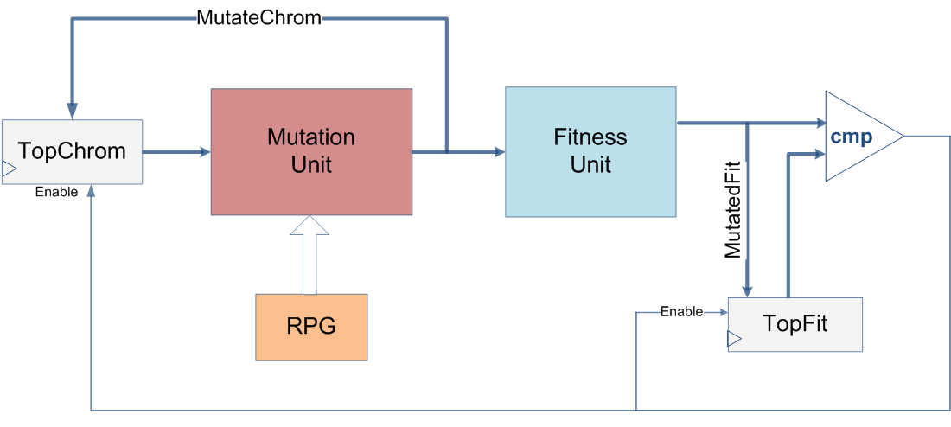

Project Schedule :
Try and estimate as accurately as possible the schedule for your project. For example:

Provisional/Preliminary Schedule  Architectural and Logic Design  HDL Implementation  Functional simulation  Synthesis  Layout Design  Report | Week  1-3  3-5  6-9  9-12  13  14

Please prepare a Gantt chart as follows: Gantt Chart Example:
Week 1 2 3 4 5 6 7 8 9 10 11 12 13 14 15
Software Simulation

Architectural and Logic Design

HDL Implementation

Functional simulation

Synthesis

Layout Design

Report

