Project Name

Students :
Supervisor :
Semester : Winter 2022

Project Description:
Prepare a short description of the goals of the project as you understand them. For example:

Modern flash-based solid-state drives contain aggressive 19nm scaling of floating-gate transistors. As a result, data is often stored with errors due to inter-cell interference, coupling, random-telegraph noise and more. The signal-to-noise ratio becomes even worse as density increases. To provide reliable data storage, system controller employs error-correcting algorithms.

The goal of this project is to design and implement an advanced error-correction soft-decision Reed-Solomon encoder and decoder.
Project Requirements:
- Pipelined architecture
- Minimal on chip memory
- Real time performance
- Maximum area efficiency
- Synthesis
- Physical design (layout)
Project Specifications:
- Clock Frequency: 150 MHz
- Area: 5x5 sq. mm
- Maximum number of IOs: 120
- Technology: Tower 0.18u CMOS
Development Stages / Design Flow | Tools
Software Simulation | C/Matlab
Architectural and Logic Design
HDL Implementation | VHDL/SystemVerilog
Functional simulation | Ncsim/VCS
Synthesis | Design Compiler
Layout Design | First Encounter

Literature
Provide a brief summary of the literature used for the project.

Alternative solutions
Describe very briefly which solutions were evaluated.

Selected solution
Describe why you decided to implement your particular solution.

Top Level Interface
Example:

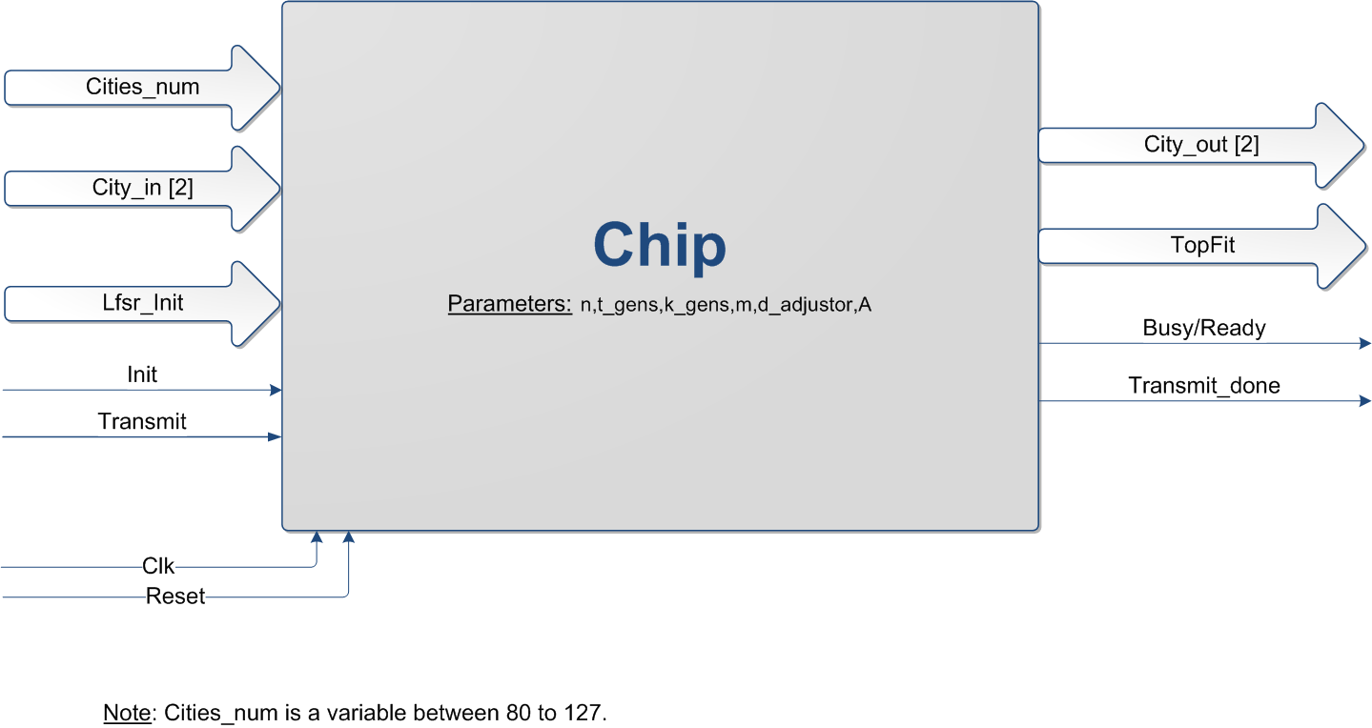

Top Level Architecture
Example:

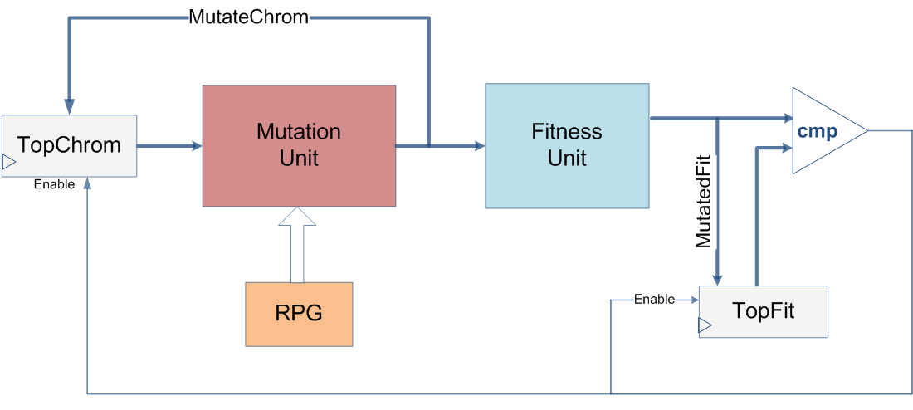

Project Schedule :
Try and estimate as accurately as possible the schedule for your project. For example:

Provisional/Preliminary Schedule  Architectural and Logic Design  HDL Implementation  Functional simulation  Synthesis  Layout Design  Report | Week  1-3  3-5  6-9  9-12  13  14

Please prepare a Gantt chart as follows: Gantt Chart Example:
Week 1 2 3 4 5 6 7 8 9 10 11 12 13 14 15
Software Simulation

Architectural and Logic Design

HDL Implementation

Functional simulation

Synthesis

Layout Design

Report

