MOHD ALI SIDDIQUI
CSE2006-PROGRAMMING IN JAVA
PROJECT REPORT
Advanced Calculator

Table of Contents
- 1. Problem Statement
- 2. Objectives
- 3. Scope & Requirements
- 4. System Architecture
- 5. Process Workflow
- 6. UML Diagrams (Overview)
- 7. Implementation Highlights
- 8. Testing
- 9. How to Build and Run
- 10. Conclusion & Future Enhancements

1. Problem Statement
Everyday computational tasks — arithmetic, scientific calculations, and short-term value retention — are often handled through scattered, single-purpose scripts that lack structure, validation, or reusability. There is a need for a single, reliable command-line tool that consolidates basic arithmetic, scientific functions, and memory operations into one well-structured, testable, and maintainable application that runs in any terminal environment without GUI dependencies.

2. Objectives
- Provide a single command-line application covering basic arithmetic, scientific functions, and memory management.
- Apply a layered software architecture (UI → Core Engine → Functional Modules) so responsibilities are clearly separated.
- Validate all user input and handle error conditions gracefully, without the application crashing or producing undefined behaviour.
- Record application activity and errors through a lightweight logging mechanism for traceability.
- Achieve meaningful automated test coverage of the computational modules using JUnit 5.
- Ensure the project builds and runs from a plain terminal using standard tooling (Maven), with no IDE-specific configuration required.

3. Scope & Requirements

3.1 Functional Requirements
The system is organized into three major functional modules, each implemented as its own class:
# | Module | Responsibility | Class
1 | Basic Arithmetic | Addition, subtraction, multiplication, division, modulus, power | BasicOperations
2 | Scientific Operations | Square root, factorial, sin/cos/tan, natural log, log10 | ScientificOperations
3 | Memory Management | Store, recall, clear, and accumulate a value across operations | MemoryModule

Input/Output structure: the user selects a numbered menu option, then types the required numeric operand(s) when prompted. The computed result is printed to the console; invalid input or invalid operations (e.g. divide by zero) print a clear error message instead of a raw stack trace.
Logical workflow: Application starts → ConsoleUI displays the menu → user selects an operation → input is validated → CalculatorEngine routes the request to the relevant module → the result (or error) is displayed and logged → the loop repeats until Exit is chosen.

3.2 Non-Functional Requirements
NFR | How it is addressed
Performance | All operations are O(1) except factorial (O(n)); no blocking I/O beyond console read/write.
Reliability | Every module validates its own inputs; the UI layer wraps all operations in exception handling.
Usability | A numbered, grouped menu (Basic / Scientific / Memory) with explicit prompts — no command syntax to memorise.
Maintainability | Layered package structure (core, modules, ui, util, exception) isolates concerns.
Error Handling Strategy | A single custom checked exception, CalculatorException, is used consistently across all modules.
Logging / Monitoring | CalculatorLogger timestamps and records every operation and error to console and calculator.log.
Resource Efficiency | Scanner and file writers are opened/closed correctly; no unnecessary allocation per loop iteration.
Scalability (design-level) | New operations can be added by extending a module without modifying existing modules.

4. System Architecture
The application follows a layered architecture with four distinct layers: UI, Core/Orchestration, Functional Modules, and shared Utilities/Exception handling. The UI never calls a module directly — every request passes through the CalculatorEngine, which keeps the design open for future front-ends (e.g. a web or GUI layer) without touching business logic.
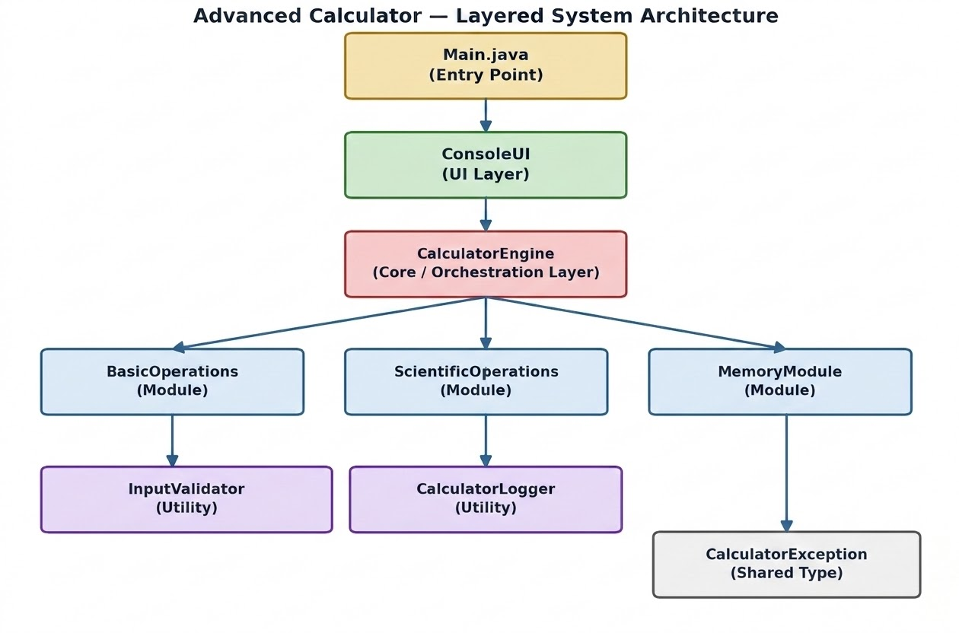

4.1 Package Structure
com.calculator
- Main.java
- core/CalculatorEngine.java
- modules/BasicOperations.java, ScientificOperations.java, MemoryModule.java
- ui/ConsoleUI.java
- util/InputValidator.java, CalculatorLogger.java
- exception/CalculatorException.java

5. Process Workflow
The diagram below traces a single user interaction from menu display through validation, computation, logging, and result display, including both success and error paths.

6. UML Diagrams (Overview)
Full Mermaid-format UML diagrams (Use Case, Class, and Sequence) are included in the project's docs/ folder and render automatically in GitHub. A summary is provided below.

6.1 Use Case Summary
Use Case | Actor | Description
Perform Basic Arithmetic | User | Add, subtract, multiply, divide, modulus, or raise to a power
Perform Scientific Calculation | User | Square root, factorial, trig functions, logarithms
Store / Recall / Clear Memory | User | Save, retrieve, or reset a numeric value across operations
Exit Application | User | Terminate the program
Validate Input (include) | System | Every numeric-entry use case validates input before computing
Log Operation (include) | System | Every use case logs its outcome for auditing

6.2 Key Classes
Class | Key Responsibility
ConsoleUI | Menu display, input collection, output/error presentation
CalculatorEngine | Orchestrates calls to modules; logs every operation
BasicOperations / ScientificOperations | Pure computational logic with validation
MemoryModule | Holds and mutates a single stored value
InputValidator | Centralised parsing and validation rules
CalculatorLogger | Timestamped logging to console and file
CalculatorException | Single checked exception type for all predictable errors

7. Implementation Highlights
- Custom checked exception (CalculatorException) instead of letting raw RuntimeExceptions surface to the user.
- Centralised InputValidator so every numeric-entry point shares identical validation rules.
- CalculatorLogger writes to both stdout/stderr and a persistent calculator.log file with ISO-style timestamps.
- CalculatorEngine acts as a facade, so ConsoleUI has zero direct dependency on any computational module.
- Each module (BasicOperations, ScientificOperations, MemoryModule) is independently unit-testable with no dependency on the UI or engine.

8. Testing
Four JUnit 5 test classes cover the computational and validation logic:
Test Class | Coverage
BasicOperationsTest | Add, subtract, multiply, divide, modulus, power, and divide/modulus-by-zero error cases
ScientificOperationsTest | Square root, factorial (including 0 and negative/non-integer errors), trig, logarithms
MemoryModuleTest | Initial state, store/recall, clear, and accumulate
InputValidatorTest | Valid/invalid numeric parsing, zero/negative/positive constraints

Compilation and runtime behaviour were manually verified: the main source set compiles cleanly with javac, and the console application was exercised end-to-end (e.g. 5 + 7 = 12, √16 = 4, 5! = 120) with correct results and correct log output.

9. How to Build and Run

9.1 Using Maven (recommended)
mvn compile # Compile
mvn test # Run unit tests
mvn exec:java # Run the application

9.2 Build a runnable JAR
mvn package
java -jar target/advanced-calculator.jar

9.3 Plain javac/java (no Maven)
mkdir -p out
find src/main/java -name "*.java" > sources.txt
javac -d out @sources.txt
java -cp out com.calculator.Main

10. Conclusion & Future Enhancements
The Advanced Calculator project demonstrates a small but complete application of layered architecture, input validation, centralised error handling, logging, and automated testing within a fully terminal-executable Java program. The modular structure means new functional modules (e.g. unit conversion, statistics) or a different front-end (e.g. a REST API or GUI) can be added without modifying existing, tested code.
Possible future enhancements:
- Persist calculation history to a file or database.
- Add an expression parser to support full infix expressions (e.g. "3 + 4 * 2").
- Expose the CalculatorEngine through a REST API using Spring Boot.
- Add code coverage reporting (e.g. JaCoCo) to the Maven build.

