1) What is Jenkins pipeline?

is a group of tasks that uses automated techniques to get software from version control into the hands of end users. Continuous delivery should be incorporated into our software development process.

2) What scripting language is Jenkins pipeline syntax based on?

Groovy programming language

3) what are the different ways to trigger pipeline ?

Employing a scheduled event listener, cron allows for the scheduling of worker execution. perfect for recurring jobs

A webhook is a device that enables a Jenkins project to be built automatically in response to a commit that is submitted to a git repository.

URL: to track changes in the response sent after a URL request.

Upstream: is a project that is configured to start another project as part of its execution.

4) what is different between parameter and jenkins env variable?

An environment variable in Jenkins is a variable that is set in the Jenkins environment and can be used to configure the job, as opposed to a parameter, which is an input that can be created by the user and supplied to a Jenkins job. Environment variables are used to send configuration information to the task, whereas parameters are often used to customise the job at runtime.

5) what is organization folder job and what is used for ?

Allow Jenkins to track a github organisation as a whole.

6) Create jenkins pipeline for your repo and use script file (jenkinsfile) to write pipeline syntax, include parameter functions and env variable in it ?

My GitHub repo

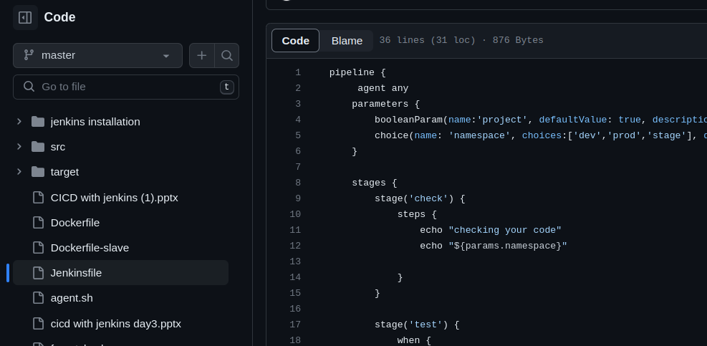

The configuration of pipeline

Configuration of git rpo

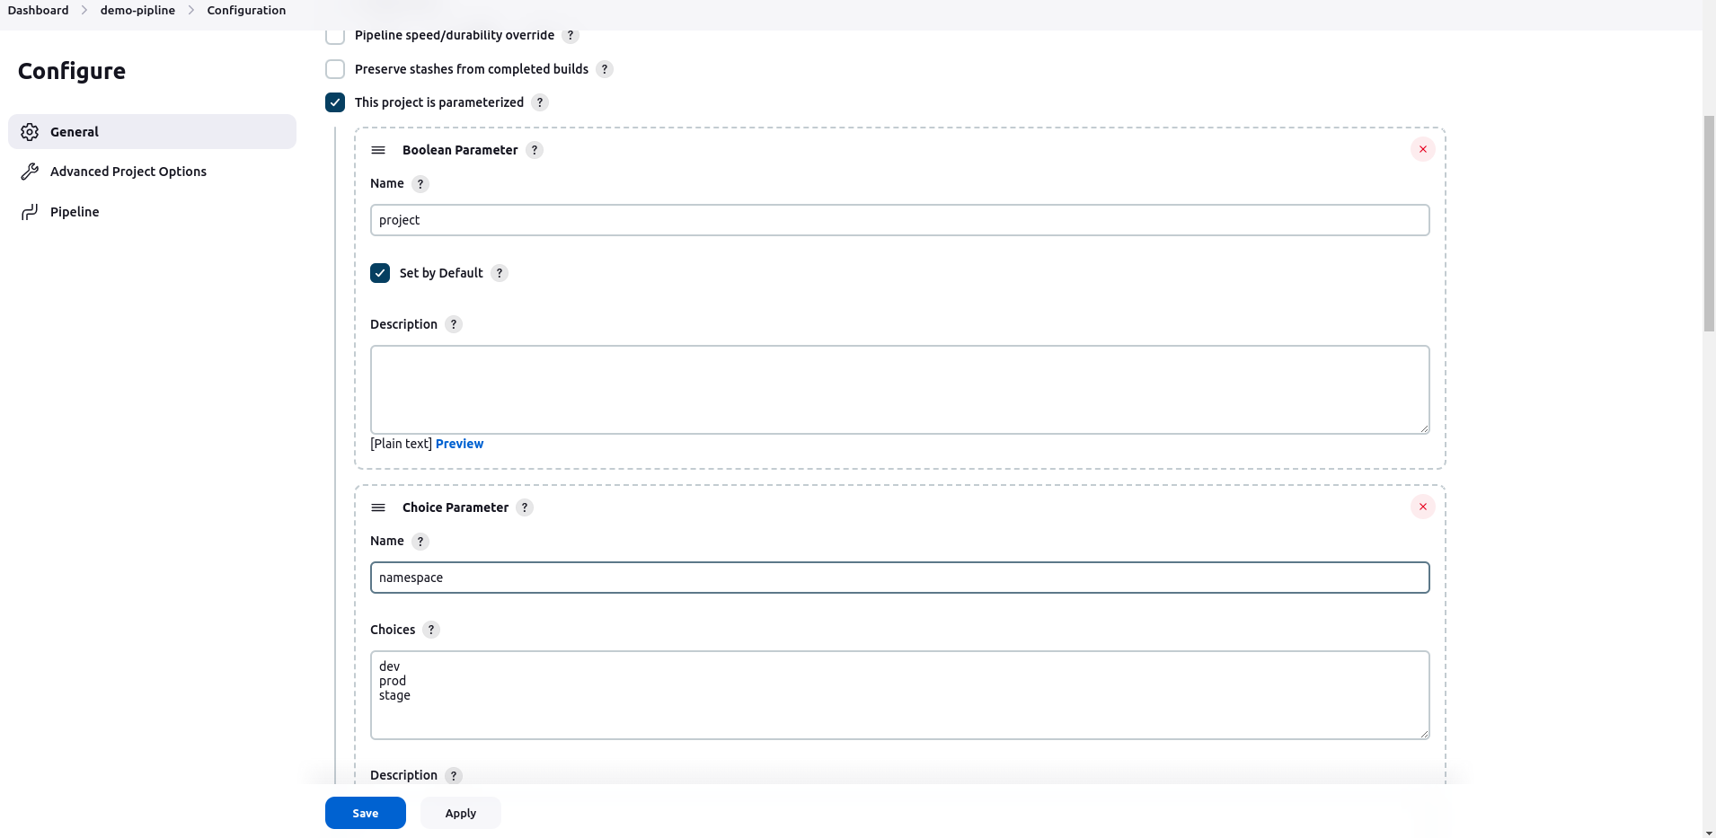

Build succeeded

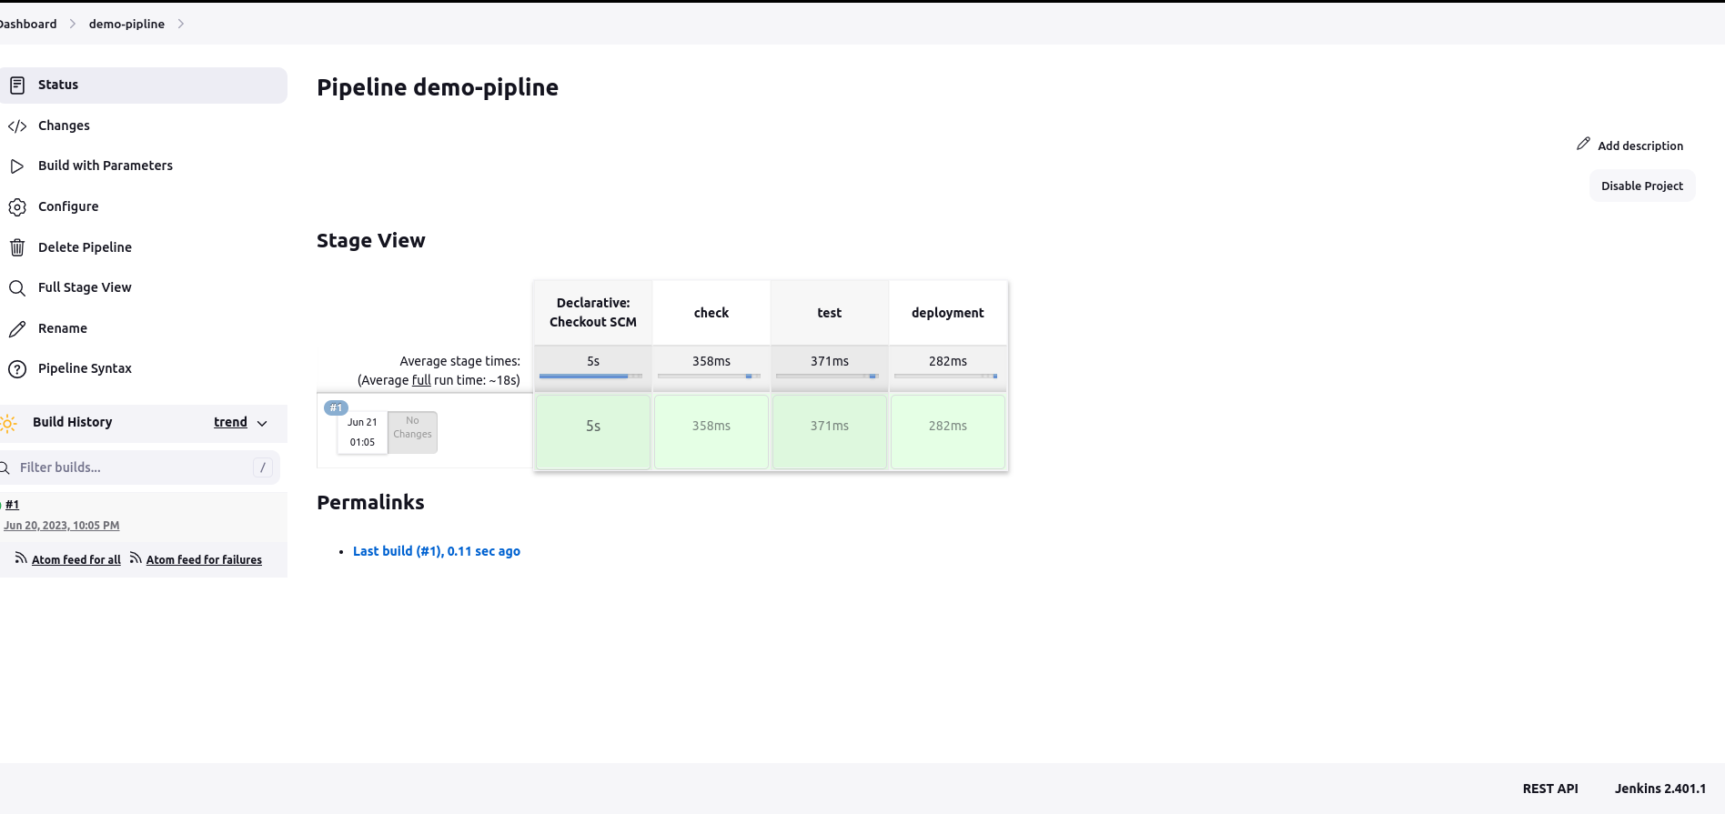

7) Create another multibranch pipeline and filter branches to contain only (master , dev , test ) ?

