

University of the Punjab

Gujranwala Campus

First Deliverable

Project ID

Table of Contents

First Deliverable Guide 3
1 Introduction 3
1.1 Project/Product Feasibility Report 3
1.1.1 Technical Feasibility 4
1.1.2 Operational Feasibility 4
1.1.3 Economic Feasibility 4
1.1.4 Schedule Feasibility 4
1.1.5 Specification Feasibility 5
1.1.6 Information Feasibility 5
1.1.7 Motivational Feasibility 5
1.1.8 Legal & Ethical Feasibility 5
1.2 Project/Product Scope 5
1.3 Project/Product Costing 5
1.3.1 Project Cost Estimation By Function Point Analysis 6
1.3.2 Project Cost Estimation by using COCOMO’81 (Constructive Cost Model) 8
1.4 CPM - Critical Path Method 9
1.5 Gantt chart 12
1.6 Introduction to Team member and their skill set 13
1.7 Tools and Technology with reasoning 13
1.8 Vision Document 13
1.9 Risk List 14
1 Introduction 15
1.1 Systems Specifications 16
1.2 Identifying External Entities 17
1.3 Context Level Data Flow Diagram 17
1.4 Capture "shall" Statements 17
1.5 Allocate Requirements 18
1.6 Prioritize Requirements 18
1.7 Requirements Trace-ability Matrix 18
1.8 Example 18
1.8.1 Introduction 18
1.8.2 Existing System Business Organization 18
1.8.4Scope of the System 19
1.8.5 Summary of Requirements:(Initial Requirements) 20
1.8.6 Identifying External Entities 22
1.8.9 Capture "shall" Statements and External Entities 23
1.8.10 Allocate Requirements 23
1.8.11 Priorities Requirements 25
1.8.12 Requirements Traceability Matrix 28
1.9 High Level Usecase Diagram 30

First Deliverable Guide

1 Introduction
First part of this deliverable is all about planning and scheduling of project. This deliverable must contain following artifacts:

- Project Feasibility
- Project Scope
- Project Costing
- Critical Path Method Analysis (CPM Analysis)
- Gantt Chart
- Introduction to team members
- Tools and Technologies
- Vision Document
- Risk List

1.1 Project/Product Feasibility Report
When a project is started the first matter to establish is to assess the feasibility of a project or product. Feasibility means the extent to which appropriate data and information are readily available or can be obtained with available resources such as staff, expertise, time, and equipment. It is basically used as a measure of how practical or beneficial the development of a software system will be to you (or organization). This activity recurs throughout the life cycle.
There are many types of feasibilities:

- Technical
- Operational
- Economic
- Schedule
- Specification
- Information
- Motivational
- Legal and Ethical

1.1.1 Technical Feasibility
Technical Feasibility deals with asking the question as to whether the system can be developed or not. It is one of the most important questions before starting the project because it is assessing the limits of theory or technology applicable to the project. Another important query to be answered is to evaluate whether you (the project members or organization) possess the technology and technical expertise.

1.1.2 Operational Feasibility
Evaluation of technical ability of the staff to operate the project is the main aim of operational feasibility. In this area the question arises as to whether the problem is worth solving and if the solution provided for the problem works or not. How do end users and managers feel about the problem or solution is another query to be answered.

1.1.3 Economic Feasibility
Justification for the benefit/cost analysis relative to the project is to be measured in economic feasibility. Therefore, economic feasibility can be divided into two parts; cost estimates and benefit estimates. Cost estimates can further be alienated into development or acquisition costs (one time) and maintenance and operation costs (ongoing). In order to find development costs, break the project into tasks and use the lifecycle cost models. Experienced costs gained from similar projects should then be used to make estimates. The function point metric should be calculated.
Benefit estimates enclose tangible benefits and intangible benefits. Tangible benefits would include reduced costs and increased revenues. However, information quality, job satisfaction, and external standing are examples of intangible benefits.

1.1.4 Schedule Feasibility
Time is an important factor. The assessment and evaluation of the completion of a project with the available staff and resources within time is very essential. Meeting deadlines and milestones should always be kept in mind.

1.1.5 Specification Feasibility
Requirements are the features that the system must have or a constraint that must be accepted for the customer. The question arises as to whether the requirements are clear and definite. The scope boundaries must also be assessed.

1.1.6 Information Feasibility
The feasibility of information must be assessed regarding its completion, reliability, and meaningfulness.

1.1.7 Motivational Feasibility
Evaluation of the client staff regarding the motivation to perform the necessary steps correctly and promptly must occur.

1.1.8 Legal & Ethical Feasibility
”Do any infringements or liabilities arise from this project? “ is the main focus of this feasibility.

1.2 Project/Product Scope
Scope is a very dominant factor. Scope and context are both intertwined as both involve the boundaries of a system. Context would be referring to what holds outside the boundary the system. While scope would indicate whatever is inside the boundary of the system.
The scope of a project is defined by the set of requirements allocated to it. Managing project scope to fit the available resources (time, people, and money) is key to managing successful projects. Managing scope is a continuous activity that requires iterative or incremental development, which breaks project scope into smaller more manageable pieces.
Using requirement attributes, such as priority, effort, and risk, as the basis for negotiating the inclusion of a requirement is a particularly useful technique for managing scope. Focusing on the attributes rather than the requirements themselves helps desensitize negotiations that are otherwise contentious.

1.3 Project/Product Costing
A metric is some measurement we can make of a product or process in the overall development process. Metrics are split into two broad categories:
- Knowledge oriented metrics: these are oriented to tracking the process to evaluate, predict or monitor some part of the process.
- Achievement oriented metrics: these are often oriented to measuring some product aspect, often related to some overall measure of quality of the product.
Most of the work in the cost estimation field has focused on algorithmic cost modeling. In this process costs are analyzed using mathematical formulas linking costs or inputs with metrics to produce an estimated output. The formulae used in a formal model arise from the analysis of historical data. The accuracy of the model can be improved by calibrating the model to your specific development environment, which basically involves adjusting the weightings of the metrics.
Cost estimation can be done by just one methodology.

1.3.1 Project Cost Estimation By Function Point Analysis
Function-oriented software metrics use a measure of the functionality delivered by the application as a normalization value. Since ‘functionality’ cannot be measured directly, it must be derived indirectly using other direct measures. Function-oriented metrics were first proposed by Albrecht, who suggested a measure called the function point. Function points are derived using an empirical relationship based on countable (direct) measures of software’s information domain and assessments of software complexity.
Function Point Analysis can provide a mechanism to track and monitor scope creep. Function Point counts at the end of requirements; analysis, design, code, testing and implementation can be compared. The function point count at the end of requirements and/or designs can be compared to function points actually delivered. If the project has grown, there has been scope creep. The amount of growth is an indication of how well requirements were gathered by and/or communicated to the project team. If the amount of growth of projects declines over time it is a natural assumption that communication with the user has improved.
Function points are computed by completing the table shown in the figure below. Five information domain characteristics are determined and counts are provided in the appropriate table location.
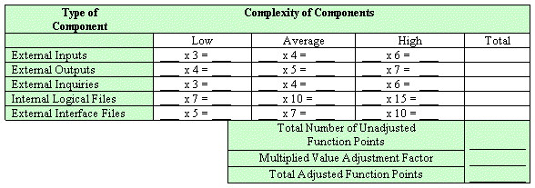

Information domain values are defined in the following manner:

Number of user inputs: Each user input that provides distinct application-oriented data to the software is counted. Inputs should be distinguished from inquiries, which are counted separately.

Number of user outputs: Each user output that provides application-oriented information to the user is counted. In this context output refers to reports, screens, error messages, etc. Individual data items within a report are not counted separately.

Number of user inquiries: An inquiry is defined ass an on-line input that results in the generation of some immediate software response in the form of an on-line output. Each distinct inquiry is counted.

Number of files: Each logical master file (i.e. a logical grouping of data that may be one part of a large database or a separate file) is counted.

Number of external interfaces: All the machine-readable interfaces (e.g., data files on storage media) that are used to transmit information to another system are counted.

Once these data have been collected, a complexity value is associated with each count. Organizations that use function point methods develop criteria for determining whether a particular entry is simple, average, or complex. Nonetheless, the determination of complexity is somewhat subjective.

To compute function points (FP), the following relationship is used:

FP est. = Count Total * [ 0.65 + 0.01 * (Fi)]

Where count total is the sum of all FP entries obtained from above figure and (Fi) is value adjustment factor (VAF) is based on 14 general system characteristics (GSC's) that rate the general functionality of the application being counted. Each characteristic has associated descriptions that help determine the degrees of influence of the characteristics. The degrees of influence range on a scale of zero to five, from no influence to strong influence.

1. Data communications
2. Distributed data processing
3. Performance
4. Heavily used configuration
5. Transaction rate
6. On-Line data entry
7. End-user efficiency
8. On-Line update
9. Complex processing
10. Reusability
11. Installation ease
12. Operational ease
13. Multiple sites
14. Facilitate change

Finally, Total Project Cost and Total Project Effort are calculated given the average productivity parameter for the system.

The formulae are given as follows:

Cost / FP = labor rate / productivity parameter

Total Project Cost = FP est. * (cost / FP)

Total Estimated Effort = FP est. / productivity parameter

1.3.2 Project Cost Estimation by using COCOMO’81 (Constructive Cost Model)
Boehm's COCOMO model is one of the mostly used models commercially. The first version of the model delivered in 1981 and COCOMO II is available now. COCOMO 81 is a model that allows one to estimate the cost, effort, and schedule when planning a new software development activity, according to software development practices that were commonly used in the 1970s through the 1980s. It exists in three forms, each one offering greater detail and accuracy the further along one is in the project planning and design process. Listed by increasing fidelity, these forms are called Basic, Intermediate, and Detailed COCOMO. However, only the Intermediate form has been implemented by USC in a calibrated software tool.
Three levels:

Basic: Is used mostly for rough, early estimates.
Intermediate: Is the most commonly used version, includes 15 different factors to account for the influence of various project attributes such as personnel capability, use of modern tools, hardware constraints, and so forth.
Detailed: Accounts for the influence of the different factors on individual project phases: design, coding/testing, and integration/testing. Detailed COCOMO is not used very often.

Each level includes three software development types:
- Organic: Relatively small software teams develop familiar types of software in an in-house environment. Most of the personnel have experience working with related systems.
- Embedded: The project may require new technology, unfamiliar algorithms, or an innovative new method
- Semi-detached: Is an intermediate stage between organic and embedded types.

Basic COCOMO
Type Effort Schedule
Organic PM= 2.4 (KLOC)1.05 TD= 2.5(PM)0.38
Semi-Detached PM= 3.0 (KLOC)1.12 TD= 2.5(PM)0.35
Embedded PM= 2.4 (KLOC)1.20 TD= 2.5(PM)0.32

PM= person-month (effort)
KLOC= lines of code, in thousands
TD= number of months estimated for software development (duration)

Intermediate COCOMO
Type Effort
Organic PM= 2.4 (KLOC)1.05 x M
Semi-Detached PM= 3.0 (KLOC)1.12 x M
Embedded PM= 2.4 (KLOC)1.20 x M

PM= person-month
KLOC= lines of code, in thousands
M.- reflects 15 predictor variables, called cost drivers

The schedule is determined using the Basic COCOMO schedule equations.

People Required = Effort / Duration

1.4 CPM - Critical Path Method
In 1957, DuPont developed a project management method designed to address the challenge of shutting down chemical plants for maintenance and then restarting the plants once the maintenance had been completed. Given the complexity of the process, they developed the Critical Path Method (CPM) for managing such projects.
CPM provides the following benefits:

- Provides a graphical view of the project.
- Predicts the time required to complete the project.
- Shows which activities are critical to maintaining the schedule and which are not.

CPM models the activities and events of a project as a network. Activities are depicted as nodes on the network and events that signify the beginning or ending of activities are depicted as arcs or lines between the nodes. The following is an example of a CPM network diagram:
Steps in CPM Project Planning

1. Specify the individual activities.
2. Determine the sequence of those activities.
3. Draw a network diagram.
4. Estimate the completion time for each activity.
5. Identify the critical path (longest path through the network)
6. Update the CPM diagram as the project progresses.
1. Specify the Individual Activities
From the work breakdown structure, a listing can be made of all the activities in the project. This listing can be used as the basis for adding sequence and duration information in later steps.

2. Determine the Sequence of the Activities
Some activities are dependent on the completion of others. A listing of the immediate predecessors of each activity is useful for constructing the CPM network diagram.

3. Draw the Network Diagram
Once the activities and their sequencing have been defined, the CPM diagram can be drawn. CPM originally was developed as an activity on node (AON) network, but some project planners prefer to specify the activities on the arcs.

4. Estimate Activity Completion Time
The time required to complete each activity can be estimated using past experience or the estimates of knowledgeable persons. CPM is a deterministic model that does not take into account variation in the completion time, so only one number is used for an activity's time estimate.

5. Identify the Critical Path
The critical path is the longest-duration path through the network. The significance of the critical path is that the activities that lie on it cannot be delayed without delaying the project. Because of its impact on the entire project, critical path analysis is an important aspect of project planning.

Determining the following six parameters for each activity which can identify the critical path:

ES: earliest start time: the earliest time at which the activity can start given that its precedent activities must be completed first.
ES (K)= max [EF(J) : J is an immediate predecessor of K]

EF: earliest finish time: equal to the earliest start time for the activity plus the time required to complete the activity.
EF (K)= ES (K) + Dur (K)

LF: latest finish time: the latest time at which the activity can be completed without delaying the project.
LF (K)= min [LS(J) : J is a successor of K]

LS: latest start time: equal to the latest finish time minus the time required to complete the activity.
LS (K)= LF(K) – Dur (K)

TS: Total Slack: the time that the completion of an activity can be delayed without delaying the end of the project
TS (K)= LS(K) – ES(K)

FS: Free Slack: the time that an activity can be delayed without delaying both the start of any succeeding activity and the end of the project.
FS (K)= min [ES(J) : J is successor of K] – EF(K)

The slack time for an activity is the time between its earliest and latest start time, or between its earliest and latest finish time. Slack is the amount of time that an activity can be delayed past its earliest start or earliest finish without delaying the project.
The critical path is the path through the project network in which none of the activities have slack, that is, the path for which ES=LS and EF=LF for all activities in the path. A delay in the critical path delays the project. Similarly, to accelerate the project it is necessary to reduce the total time required for the activities in the critical path.

6. Update CPM Diagram
As the project progresses, the actual task completion times will be known and the network diagram can be updated to include this information. A new critical path may emerge, and structural changes may be made in the network if project requirements change.

Example:

Activity | Immediate Predecessor | Duration (Weeks)
A | None | 5
B | None | 3
C | A | 8
D | A, B | 7
E | None | 7
F | C, D, E | 4
G | F | 5

D
E
B
A
C
F
G
End
Start

Network Diagram for the above-mentioned activities

Activity | Duration | ES | EF | LS | LF | TS | FS
A | 5 | 0 | 5 | 0 | 5 | 0 | 0
B | 3 | 0 | 3 | 3 | 6 | 3 | 2
C | 8 | 5 | 13 | 5 | 13 | 0 | 0
D | 7 | 5 | 12 | 6 | 13 | 1 | 1
E | 7 | 0 | 7 | 6 | 13 | 6 | 6
F | 4 | 13 | 17 | 13 | 17 | 0 | 0
G | 5 | 17 | 22 | 17 | 13 | 0 | 0

The parameters and slacks are calculated as follows:

The critical path is:
A-> C-> F-> G

1.5 Gantt chart
The Gantt chart enumerates the activities to be performed on the vertical axis and their corresponding duration on the horizontal axis. The tasks identified and enlisted are based on task dependency table. It is possible to schedule activities by either early start or late start logic. In the early start approach, each activity is initiated as early as possible without violating the precedence relations. In the late start approach, each activity is delayed as much as possible as long as the earliest finish time of the project is not compromised.
Based on the Work Breakdown Structure (WBS), a timeline or Gantt chart showing the allocation of time to the project phases or iterations should be developed. This Gantt chart would identify major milestones with their achievement criteria. It must contain duration estimation of all the necessary activities to be carried out during the project development along with the human resources responsible for the respective tasks. Activity dependencies are also required to be mentioned in it.
Use MS Project to develop gantt chart.

1.6 Introduction to Team member and their skill set
A brief but a concise introduction of the team members should be provided signifying their skill set. This skill set would especially be representative of the tasks and activities assigned to him.

1.7 Tools and Technology with reasoning
The application tools, which are to be used on front and back end of the system to be developed, should be listed. The reasons for these tools should also be described.
Identify what the needs for tool support are, and what the constraints are, by looking at the following:
- The development process. What tool support is required to effectively work? For example, if the organization decide to employ an iterative development process, it is necessary to automate the tests, since you will be testing several times during the project.
- Host (or development) platform(s).
- Target platform(s).
- The programming language(s) to be used.
- Existing tools. Evaluate any existing and proven tools and decide whether they can continue to be used.
- The distribution of the development organization. Is the organization physically distributed? Development tools generally support a physically distributed organization differently.
- The size of the development effort. Tools support large organizations more or less well.
- Budget and time constraints

1.8 Vision Document
The Vision defines the stockholder’s view of the product to be developed, specified in terms of the stockholder’s key needs and features. Containing an outline of the envisioned core requirements, it provides the contractual basis for the more detailed technical requirements.
A Vision Document is the starting point for most software projects. It is the primary deliverable and is therefore the first document produced in the planning process. The main purpose of this document is to move the project forward into detailed project planning and ultimately into development.
The Vision Document is designed to make sure that key decision makers on both sides have a clear, shared vision of the objectives and scope of the project. It identifies alternatives and risks associated with the project. Finally, it presents a budget for the detailed planning phase for the stakeholders to approve.
The Vision document provides a high-level for the more detailed technical requirements. There can also be a formal requirements specification. The Vision captures very high-level requirements and design constraints to give the reader an understanding of the system to be developed. It provides input to the project-approval process and is, therefore, intimately related to the Business Case. It communicates the fundamental "whys and what's" related to the project and is a gauge against which all future decisions should be validated.
A project vision is meant to be changeable as the understanding of requirements, architecture, plans, and technology evolves. However, it should be changing slowly and normally throughout the earlier portion of the lifecycle.
It is important to express the vision in terms of its use cases and primary scenarios as these are developed, so that you can see how the vision is realized by the use cases. The use cases also provide an effective basis for evolving a test case suite.
Another name used for this document is the Product Requirement Document. There are certain checkpoints that help to verify that the vision document is fulfilled.
Checkpoints:
- Have you fully explored what the "problem behind the problem" is?
- Is the problem statement correctly formulated?
- Is the list of stakeholders complete and correct?
- Does everyone agree on the definition of the system boundaries?
- If system boundaries have been expressed using actors, have all actors been defined and correctly described?
- Have you sufficiently explored constraints to be put on the system?
- Have you covered all kinds of constraints - for example political, economic, and environmental?
- Have all key features of the system been identified and defined?
- Will the features solve the problems that are identified?
- Are the features consistent with constraints that are identified?

1.9 Risk List
The possibility of suffering harm or loss in terms of danger is called risk. Regarding the importance of risks a list is to be maintained. Risk list is a sorted list of known, open risks to the project, sorted in decreasing order of importance, associated with specific mitigation or contingency actions.
Purpose
The Risk List is designed to capture the perceived risks to the success of the project. It identifies, in decreasing order of priority, the events that could lead to a significant negative outcome. It serves as a focal point for project activities and is the basis around which iterations are organized
The Risk List is maintained throughout the project. It is created early in the Inception phase, and is continually updated as new risks are uncovered and existing risks are mitigated or retired. At a minimum, it is revisited at the end of each iteration, as the iteration is assessed.

*********************REQUIREMENTS ENGINEERING*********************

1 Introduction
Requirements engineering process provides the appropriate mechanism for understanding what the customer wants, analyzing need, assessing feasibility, negotiating a reasonable solution, specifying the solution unambiguously, validating the specification and managing the requirements as they are transformed into an operational system. The task of capturing, structuring, and accurately representing the user's requirements so that they can be correctly embodied in systems which meet those requirements (i.e. are of good quality).

- Requirements elicitation
- Requirements analysis and negotiation
- Requirements specification
- System modeling
- Requirements validation
- Requirements management

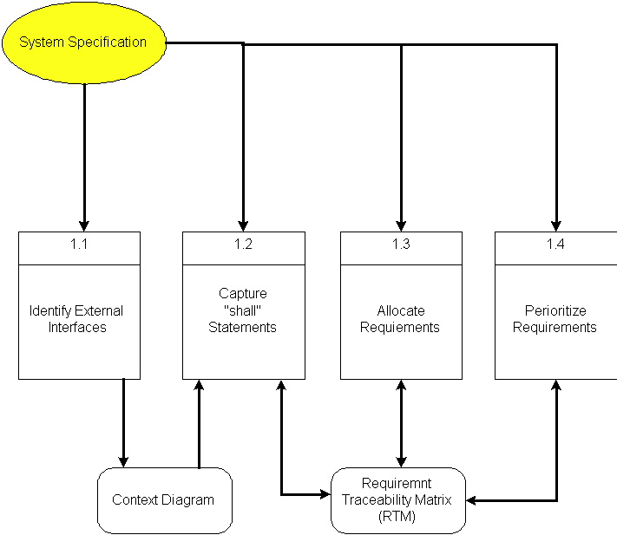

Here, requirements specification is to be discussed. Requirements specification would lead to the following four steps:
- Identify external interfaces
- Development of context diagram
- Capture “shall statements
- Allocate requirements
- Prioritize requirements
- Development of requirements traceability matrix

1.1 Systems Specifications
The following are the clauses that must be included while describing the system specifications.
Introduction
This clause should contain brief “Introduction” of the system under discussion domain knowledge. It can also contain company, its location, its historical background and its current status in the market. The most important part of this clause is to give an overview of the major business areas of the company. This overview must be very brief so that one can get a bird’s eye view of the organization under study.
Existing System
This clause must be focusing on providing a comprehensive detail of main business areas of the organizations that we have just mentioned in the previous clause. But here the discussion should be more elaborative.
Organizational Chart
Organizational chart will be very much supportive to get a better overview of the organization’s business areas and their decomposition into different departments.
Scope of the System
The Scope may include the boundaries of the system under study. To what domain you want to restrict your project must be clearly mentioned in this clause.
Summary of Requirements (Initial Requirements)
An abstract is necessary at this stage to give an understanding of the initial requirements of the system. This will show what high level requirements the proposed system must address. This abstract will act as a foundation for the future analysis of the system.

1.2 Identifying External Entities
The identification of the external entities will be based on the information contained in your Abstract. This identification is done after two phases. We will map the “Green wood” case study to make things more comprehensible.

The Identification of External Entities is done in two phases.

a. Over Specify Entities from Abstract
On the basis of the Abstract, one might identify the entities from the problem.

b. Perform Refinement
After over specifying the entities, you have to refine them on the basis of your business logic. For example, in this example we found the following entities more related to our business logic;

1.3 Context Level Data Flow Diagram
Context level data flow diagram contains only one process, representing the entire system. The process is given the number zero and all external entities are shown on the context diagram as well as major data flow to and from them. The diagram does not contain any data stores.

1.4 Capture "shall" Statements
Identify “shall” statements, as they would be all functional requirements.

1.5 Allocate Requirements
Allocate the requirements in the use cases.

1.6 Prioritize Requirements
Requirements must be prioritized as this will help achieve tasks easily. Rank them as “highest, medium, and lowest”.

1.7 Requirements Trace-ability Matrix
The requirements trace-ability matrix is a table used to trace project life cycle activities and work products to the project requirements. The matrix establishes a thread that traces requirements from identification through implementation.

1.8 Example
Here is an example to explain all the above. We are taking the system of Green Wood Company.

1.8.1 Introduction
Green Wood (GW) is a multinational company, which deals in manufacturing, delivery and selling of sports goods and sports ware throughput the world. GW deals in almost all types of support goods and has its manufacturing set-up in Sialkot, Pakistan. They have their own products selling outlets and showrooms throughout the world. They also supply their goods to other dealers on wholesale ordering basis. Currently GW is managing their operations manually. GW management has decided to completely automate the whole business processes of the company. Also in order to increase their sales, GW wants to have fully automated system, which can support online 24x7 electronic buying and selling.

1.8.2 Existing System Business Organization
GW deals in following three main business areas:

- Sport goods manufacturing
- Sport goods ordering and supply
- Consumer Outlets & Showrooms

Following departments/offices facilitates above mentioned business services:

1.8.2.1Sport Goods Manufacturing Department
Deals in manufacturing of sport goods.

1.8.2.2 GW Supplier Office
It deals in supply of sport goods to their own selling outlets or to other dealers. It also processes orders from the dealers. Following are some business processes, which are handled in this department.

- Order Management
- Customer Account Maintenance
- Order Processing
- Shipping Department
- Product Inventory
- Accounts & Administration
- CRM
- MIS
- HRM & Pay Roll
- Sales & Marketing

1.8.2.3 GW Consumer Outlets & Showrooms
They directly deals with buying and selling of goods to customers
- Shopping Centre
- Stock Maintenance
1.8.3 Business Organization Chart

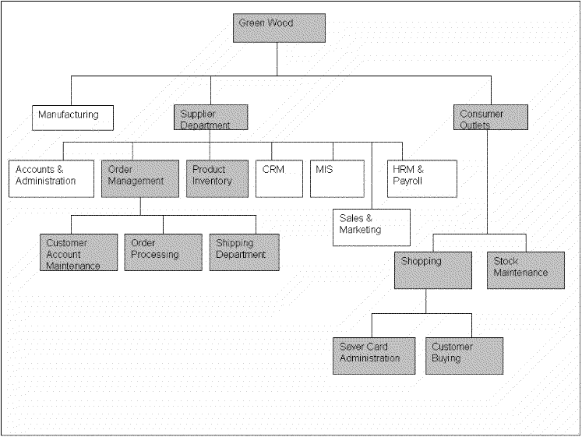

1.8.4Scope of the System
The GW System is divided in to three phases.

1.8.4.1 Phase I
Phase I includes following business areas:
- Customer Account Maintenance
- Order Processing
- Product Inventory

1.8.4.2 Phase II
Phase II involves complete automation of the Supplier Department. Phase II includes following business areas:
- Accounts and Administration
- CRM
- MIS
- HRM and Payroll
- Sales and Marketing

1.8.4.3 Phase III
Phase III covers a complete solution for Green Wood. Phase III includes remaining business areas which are not developed in previous phases.
This document scope is limited to Phase I only.

1.8.5 Summary of Requirements:(Initial Requirements)
The purposed system must fulfill following requirements as follow:

1.8.5.1 Order Management

1. Only registered customer could place order for goods. So a customer must be able to register himself to the system by requesting for registration. There should have to be two types of registration process, normal and privileged. Customer should provide his personal, organizational, authorizer and payment details in the registration request process. All the requests are to be viewed by the customer account administrator (CA). CA could accept, reject and temporarily waive the requests on the basis of credentials provided. If admin accept the registration request, a login information (Password, Id & role) should be assigned and mailed to the corresponding customer. Similarly customer could also request for the updating of his record. He could request for different types of updating e.g. updating of his personal/shipping details, or upgrading of his status from registered to privileged customer, or updating of his payment methodology. Customer could also view his details for verification purposes and similarly CA could search any customer detail and could also view the whole list of currently registered customers.

2. Both registered and privileged customers could order for goods. Customer places an order by providing his ID and other order related details A complete order must contain personal details of the customer, shipping information, product list along with product quantity and payment details. Customer could make payment either through cash or through a credit card. Accordingly invoice should be generated, and user should be given the option to finally place the order and in the end confirmation receipt must be given to the customer. Invoice contains the list of complete product along with their pricing details. It also contains discounts, sales tax and total pricing details. User could also view the status of their orders by providing the Order Number. Privileged customers could also place the request for the updating of their orders if the orders are not shipped. They could place request for the updating of shipping address and product quantity only. Similarly the privileged customer could also place the request for the cancellation of the order. But all these updating and cancellation requests are to be viewed by the Order Administrator in order to accept, reject, or waive them.

3.Action List mechanism should be adopted for better notification/messaging services, business interaction and control. An action event should be generated for a corresponding administrator when a request is placed for updating of orders or customer details etc. These actions could be generated by the Order Operator or through the updating process. Similarly on the other hand corresponding administrator could view his Action List containing different actions, and correspondingly process these pending actions. Similarly when the action processing is completed or if the action is just a notification message then administrator could delete these actions from the action list. Actions List configuration should be done by System Admin, who could add new action events and delete any current event from the system.

4. Shipping Department ships the corresponding orders.

1.8.5.2 Product Inventory

Deals with addition, searching, updating of products and their stocks. Whenever a product stock arrives, the Inventory Administrator updates the stocks of the products. He could add new product in the inventory. He could also view, search and modify the product details. The Admin could view the whole product list and their product summaries.

1.8.5.3 Consumer Dealing Department Requirements
Deals with front office customer dealing related to goods sales and marketing.

1.8.5.4 Shopping Centre
- Deals with customer registration and saver card administration
- Also deals with customer buying and returning of goods

1.8.5.5 Product Stock Maintenance
Deals with addition, searching, updating of products and their stocks.

1.8.6 Identifying External Entities or Actors
The identification of the external entities will be based on the information contained in your Abstract. This identification is done after two phases. We will map the “Green wood” case study to make things more comprehensible.
- An external entity (person or machine) that interacts with or uses the system
- Things that the project cannot control
- An actor is external to a system, interacts with the system, may be a human user or another system, and has goals and responsibilities to satisfy in interacting with the system. Actors address the question of who and what interacts with a system. In the UML, an actor is shown as a "stick figure" icon.

The Identification of External Entities or Actors is done in two phases.

1.8.7Over Specify Entities from Abstract
On the basis of the Abstract, one might identify the following entities from the Green Wood case study.

- Customer
- Order
- Order Product
- Shipment
- Invoice
- Product
- Payment
- Account
- Credit Card
- Cheque
- Request

1.8.8 Perform Refinement
After over specifying the entities, you have to refine them on the basis of your Business Logic. For example, in this example we found the following entities more related to our Business Logic;

- Customer
- Inventory
- Shipment
- Account

1.8.9 Capture "shall" Statements and the external entities (Actors)

Para # | External Entity | Initial Requirements
1.0 | customer | A customer “shall” place order for goods
1.0 | customer | A customer “shall” register himself to the system
1.0 | System | The system “shall” provide two types of registration process, normal and privileged
1.0 | CA | CA “shall” accept, reject and temporarily waive the requests on the basis of credentials provided.
1.0 | customer | A customer “shall” login to the system and can change his password
1.0 |  | System “shall” update the customers Request
1.0 |  | System “shall” process different types of updating e.g. updating of his personal/shipping details, or upgrading of his status from registered to privileged customer, or updating of his payment methodology
1.0 | customer | A customer “shall” view his details for verification purposes
1.0 |  | CA “shall”accept, reject and temporarily waive the requests on the basis of credentials provided.
1.0 |  | System “shall” search any customer details
2.0 |  | Both registered and privileged customers “will”order for goods.
2.0 | customer | Customer “shall” make payment; either through cash or through a credit card
2.0 |  | System “shall” generate invoice, confirmation receipt and finally will place order
2.0 |  | User “shall” view the status of their orders by providing the Order Number
2.0 |  | Privileged customers “shall”place the request for the updating of their orders if the orders are not shipped.
2.0 | Privileged customer | Privileged customer “shall” place the request for the cancellation of the order. But all these updating and cancellation requests are to be viewed by the Order Administrator in order to accept, reject, or waive them.
3.0 | administrator | An action event "shall" be generated for a corresponding administrator when a request is placed for updating of orders or customer details etc
3.0 | administrator | Corresponding administrator "shall" view his Action List containing different actions, and correspondingly process these pending actions
3.0 |  | When the action processing is completed or if the action is just a notification message then administrator "shall" delete these actions from the action list

1.8.10 Allocate Requirements

Para # | Initial Requirements | Use Case Name
1.0 | A customer “will” place order for goods | UC_Place_Order
1.0 | A customer “shall” register himself to the system | UC_Registration_Request
1.0 | The system “shall” provide two types of registration process, normal and privileged | UC_Place_Order_Request
1.0 | CA “shall”accept, reject and temporarily waive the requests on the basis of credentials provided. | UC_Process_Customer_Request
1.0 | A customer “shall” login to the system and can change his password | UC_Login
1.0 | System “shall” update the customers Request | UC_Update_Request
1.0 | System “shall” process different types of updating e.g. updating of his personal/shipping details, or upgrading of his status from registered to privileged customer, or updating of his payment methodology | UC_Change_Status
1.0 | A customer “shall” view his details for verification purposes | UC_View_Customer_Details
1.0 | System “shall” search any customer details | UC_Search_Customer
1.0 | CA “shall”accept, reject and temporarily waive the requests on the basis of credentials provided. | UC_Accept_Customer_Request  UC_Reject_Customer_Request  UC_View_Customer_Request
2.0 | Both registered and privileged customers “will”order for goods. | UC_Place_Order_Privleged
2.0 | Customer “will” make payment; either through cash or through a credit card | UC_Pay_For_Order
2.0 | System “will” generate invoice, confirmation receipt and finally will place order | UC_Invoice_Generation,
2.0 | User “shall” view the status of their orders by providing the Order Number | UC_Serach_Orders
2.0 | Privileged customers “shall”place the request for the updating of their orders if the orders are not shipped. | UC_Update_Request
2.0 | Privileged customer “shall” place the request for the cancellation of the order. But all these updating and cancellation requests are to be viewed by the Order Administrator in order to accept, reject, or waive them. | UC_Change_Payment_Details,  UC_Change_Status,  UC_Change_Personal_Details
3.0 | The System “shall” generate an action event for a corresponding administrator when a request is placed for updating of orders or customer details etc | UC_Create_Action,
3.0 | Corresponding administrator “shall ” view his Action List containing different actions, and correspondingly process these pending actions | UC_View_Action,

1.8.11 Priorities Requirements

Para # | Rank | Initial Requirements | Use Case ID | Use Case Name
1.0 | Highest | A customer “will” place order for goods | UC_1 | UC_PlaceOrder
1.0 | Highest | A customer “shall” register himself to the system | UC_2 | UC_Registration_Request
2.0 | Highest | Customer “will” make payment either through cash or through a credit card | UC_3 | UC_Pay_For_Order
2.0 | Highest | System “will” generate invoice, confirmation receipt and finally will place order | UC_4 | UC_Invoice_Generation,
2.0 | Medium | Both registered and privileged customers “will”order for goods. | UC_5 | UC_Place_Order_Privleged
1.0 | Medium | The system “shall” provide two types of registration process, normal and privileged | UC_6 | UC_Place_Order_Request
3.0 | Medium | The System “shall” generate an action event for a corresponding administrator when a request is placed for updating of orders or customer details etc | UC_7 | UC_Create_Action
1.0 | Medium | CA “shall”accept, reject and temporarily waive the requests on the basis of credentials provided. | UC_8  UC_9  UC_10 | UC_Accept_Customer_Request  UC_Reject_Customer_Request  UC_View_Customer_Request
1.0 | Medium | System “shall” update the customers Request | UC_11 | UC_Update_Request
1.0 | Medium | System “shall” process different types of updating e.g. updating of his personal/shipping details, or upgrading of his status from registered to privileged customer, or updating of his payment methodology | UC_12  UC_13  UC_14 | UC_Change_Payment_Details,  UC_Change_Status,  UC_Change_Personal_Details
1.0 | Medium | A customer “shall” view his details for verification purposes | UC_15 | UC_View_Customer_Details
1.0 | Medium | System “shall” search any customer details | UC_16 | UC_Search_Customer
2.0 | Medium | User “shall” view the status of their orders by providing the Order Number | UC_17 | UC_Serach_Orders
2.0 | Medium | Privileged customers “shall”place the request for the updating of their orders if the orders are not shipped. | UC_18 | UC_Update_Request
2.0 | Medium | Privileged customer “shall” place the request for the cancellation of the order. But all these updating and cancellation requests are to be viewed by the Order Administrator in order to accept, reject, or waive them. | UC_19  UC_20  UC_21 | UC_View_All_Orders  UC_Manage_Order
1.0 | Lowest | A customer “shall” login to the system and can change his password | UC_22  UC_23 | UC_Login,
3.0 | Lowest | Corresponding administrator “shall ” view his Action List containing different actions, and correspondingly process these pending actions | UC_24 | UC_View_Action,
3.0 | Lowest | When the action processing is completed or if the action is just a notification message then administrator “shall” delete these actions from the action list | UC_25 | UC_Delete_Action

1.8.12 Requirements Traceability Matrix

Sr# | Para # | System Specification Text | Build | Use Case Name | Category
1 | 1.0 | A customer “will” place order for goods | B1 | UC_Place_Order | Business
2 | 1.0 | A customer “shall” register himself to the system | B1 | UC_Registration_Request | Business
3 | 1.0 | The system “shall” provide two types of registration process, normal and privileged | B1 | UC_PlaceOrderRequest,  UC_PlaceCustomerRequest | Business
4 | 1.0 | CA “shall”accept, reject and temporarily waive the requests on the basis of credentials provided. | B1 | UC_Accept_Customer_Request  UC_Reject_Customer_Request  UC_View_Customer_Request | Business
5 | 1.0 | A customer “shall” login to the system and can change his password | B1 | UC_Login, | Business
6 | 1.0 | System “shall” update the customers Request | B1 | UC_Update_Request | Business
7 | 1.0 | System “shall” process different types of updating e.g. updating of his personal/shipping details, or upgrading of his status from registered to privileged customer, or updating of his payment methodology | B1 | UC_Change_Payment_Details,  UC_Change_Status,  UC_Change_Personal_Details | Business
8 | 1.0 | A customer “shall” view his details for verification purposes | B1 | UC_View_Customer_Details | Business
9 | 1.0 | System “shall” search any customer details | B1 | UC_SearchCustomer | Business
10 | 2.0 | Both registered and privileged customers “will”order for goods. | B1 | UC_Place_Order_Privellged | Business
11 | 2.0 | Customer “will” make payment; either through cash or through a credit card | B1 | UC_Pay_For_Order | Business
12 | 2.0 | System “will” generate invoice, confirmation receipt and finally will place order | B1 | UC_Invoice_Generation | Business

1.9 High Level Usecase Diagram
A use case scenario is a visual description, typically written in structured English or point form, of a potential business situation that a system may or may not be able to handle.
A use case defines a goal-oriented set of interactions between external actors and the system under consideration.
A use case is initiated by a user with a particular goal in mind, and completes successfully when that goal is satisfied. It describes the sequence of interactions between actors and the system necessary to deliver the service that satisfies the goal. It also includes possible variants of this sequence, e.g., alternative sequences that may also satisfy the goal, as well as sequences that may lead to failure to complete the service because of exceptional behavior, error handling, etc. The system is treated as a “black box”, and the interactions with system, including system responses, are as perceived from outside the system.
Thus, use cases capture who (actor) does what (interaction) with the system, for what purpose (goal), without dealing with system internals. A complete set of use cases specifies all the different ways to use the system, and therefore defines all behavior required of the system, bounding the scope of the system.
Generally, use case steps are written in an easy-to-understand structured narrative using the vocabulary of the domain. This is engaging for users who can easily follow and validate the use cases, and the accessibility encourages users to be actively involved in defining the requirements.

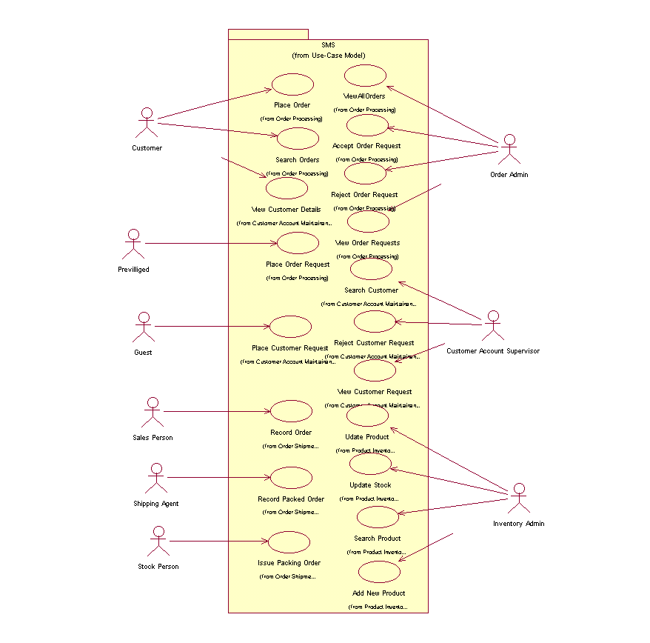
Example

