DEPARTMENT COURSE MANAGEMENT SYSTEM

GROUP MEMBERS

* MUHAMMAD AAMIR 16-NTU-1051
* SAIM ALI 16-NTU-1075
* MUSSARAT SHAH 16-NTU-1063

INTRODUCTION

The DEPARTMENT COURSE MANAGEMENT SYSTEM OR STUDENT COURSE REGISTRATION SYSTEM is Dot Net Application which contains several modules as per university, school or other institute required for student

• Student

• Faculty

• Department

• Course

OBJECTIVES

The main objective of this project is that to maximum reduce the manual work and manage the information about Students, Courses, Faculty and Departments. The Project is totally built at administrative end and thus only the administrator is guaranteed the access.

FUNCTIONALITIES

* Search Facilities (such as courses, teachers, registration etc.)
* It tracks all the information of students, faculty, courses and departments
* Show the description of the courses, teachers
* Manage the information of course
* Editing, Adding and Updating of records
* Manage the information of registrations

LOG IN FORM

If your User Name and Password exist then you enter into the text box otherwise go to the ADD NEW option to sign up yourself.

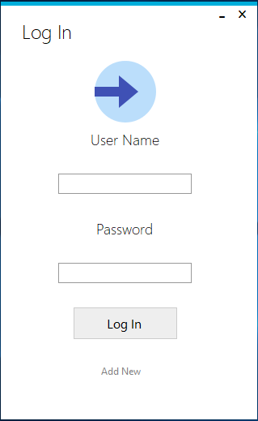

WRONG PASSWORD

When you entering the wrong password then it shows the message that your user name and password is not correct.

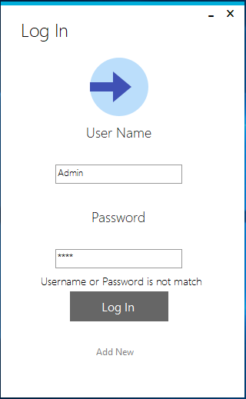

SIGN UP FORM FOR FACULTY

This is the signup form for the faculty. Enter the information and click the submit button. Then the message is show that you are successfully registered.

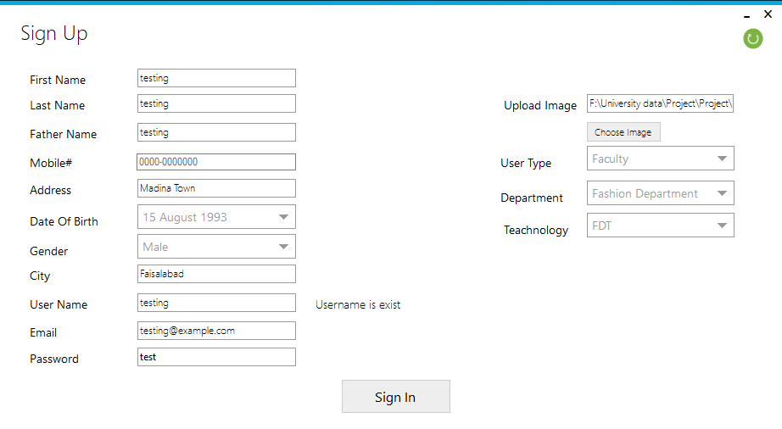

SIGN UP FORM FOR THE STUDENTS

The student carefully entre your information in the form and click the submit button then he is successfully registered.

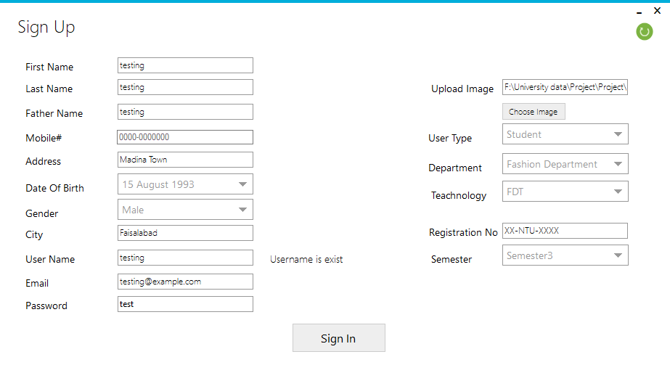

ADMIN MAIN MENU

The main menu of Admin contains the information of all students, teachers and courses. It also has a dropdown menu to logout or reset your password.

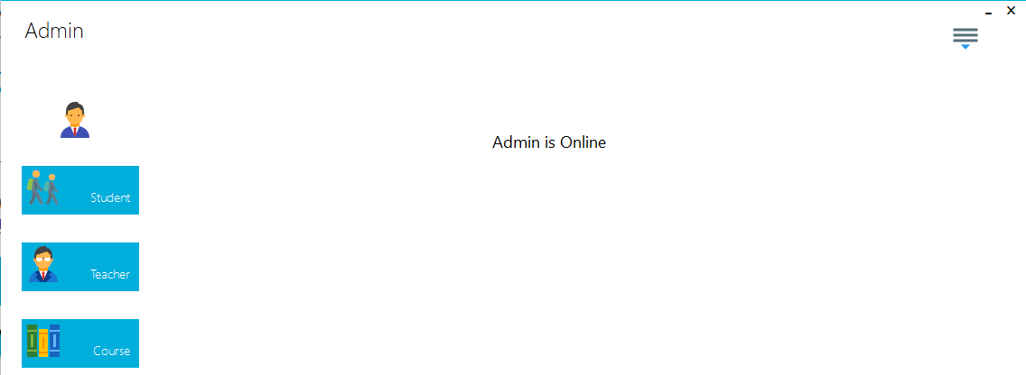

PASSWORD RESET

To reset the password first you open the Admin main menu. Click on the dropdown button and select the password reset. There you give your previous password and then enter your new password.

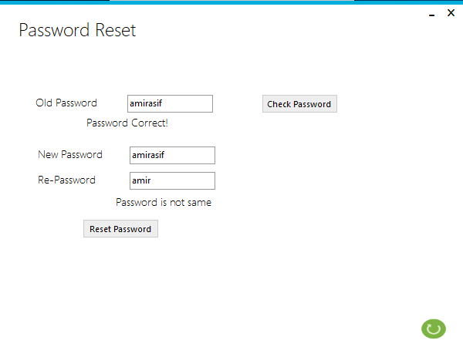

TEACHER DATA TABLE

When the teacher login then the teacher data table will open as given below.

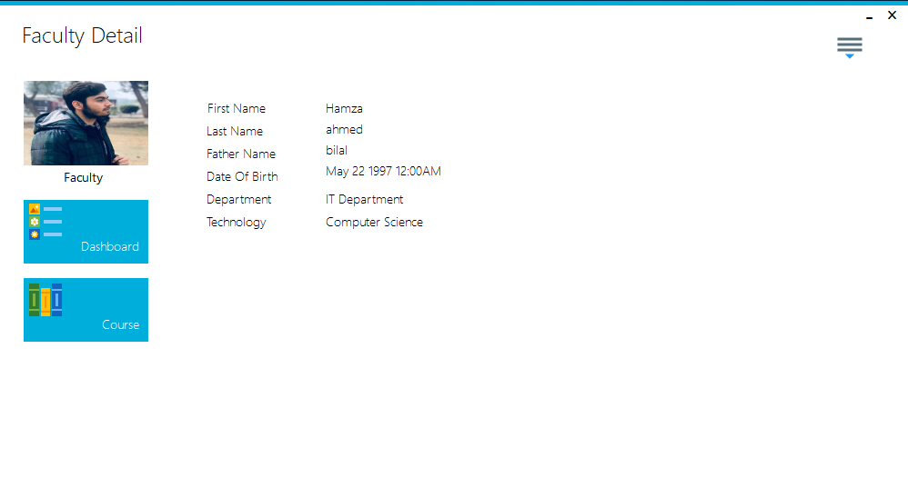

STUDENT DATA TABLE

When the Student log in then the Student data table will open as given below.

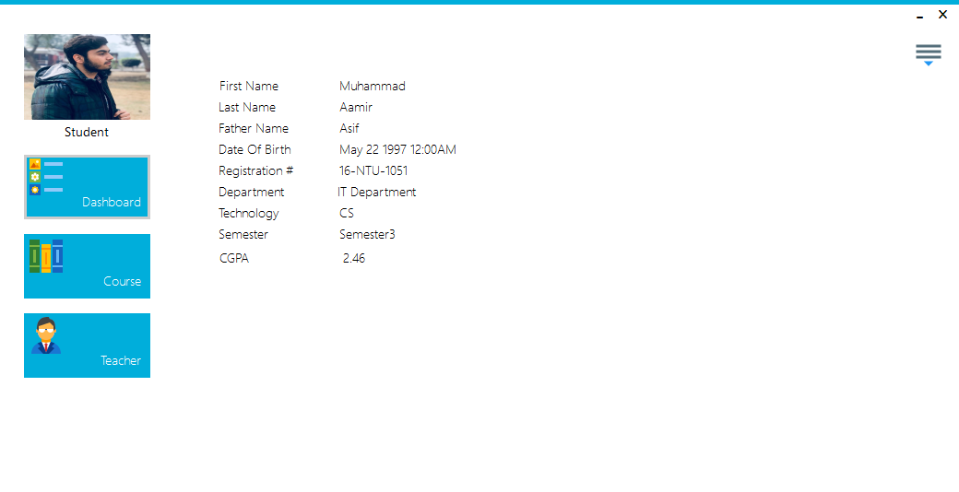

STUDENT COURSE DETAIL

In student data table when you enter on the course button then student courses detail will display on the screen as given below.

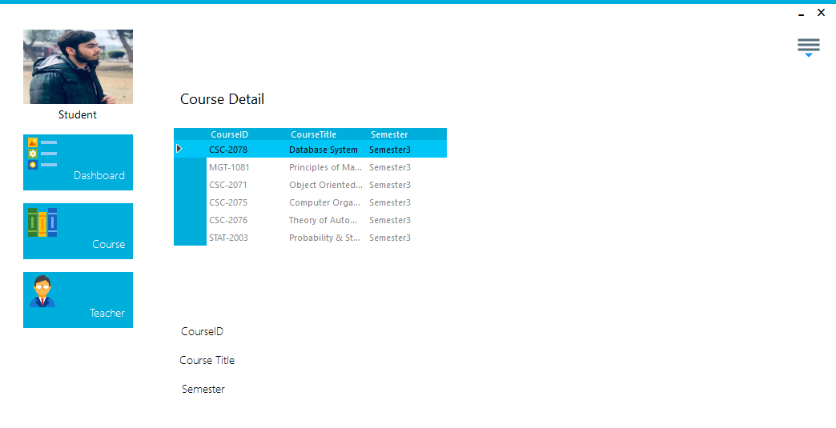

TEACHER COURSE DETAIL

In teacher data table when you enter on the course button then teacher courses detail will display on the screen as given below.

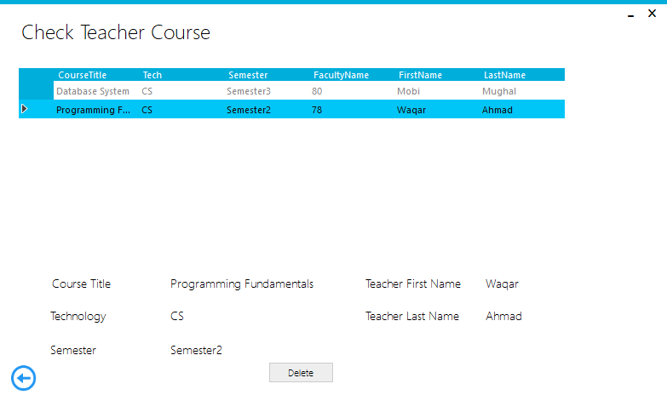

ADMIN STUDENT DATA

Admin has data of all students of different departments.

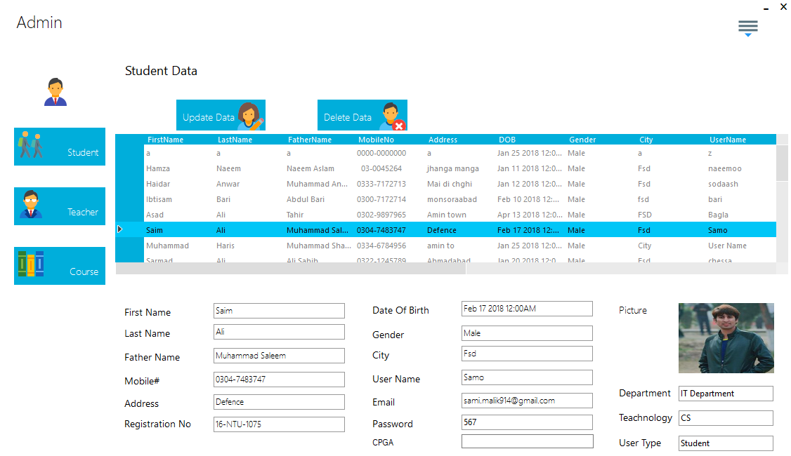

ADMIN TEACHER DATA

Admin has data of all teachers of different departments.

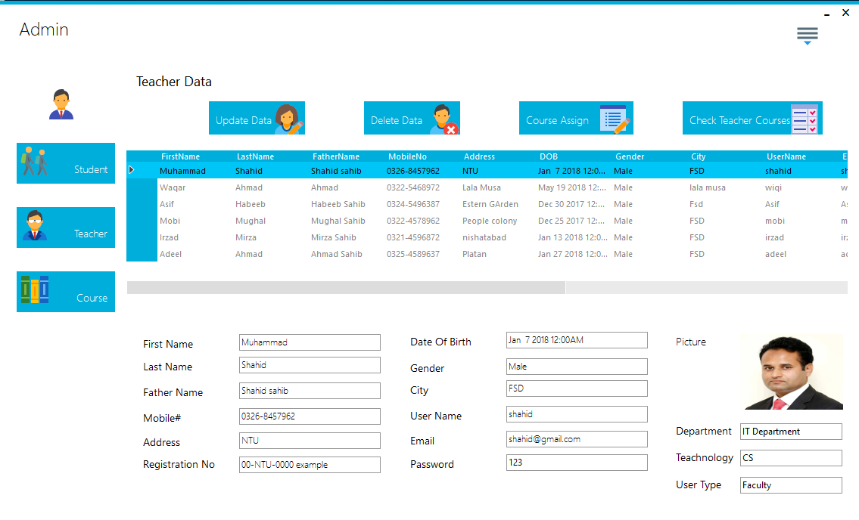

ADMIN COURSE DATA

Admin has data of all courses of different departments.

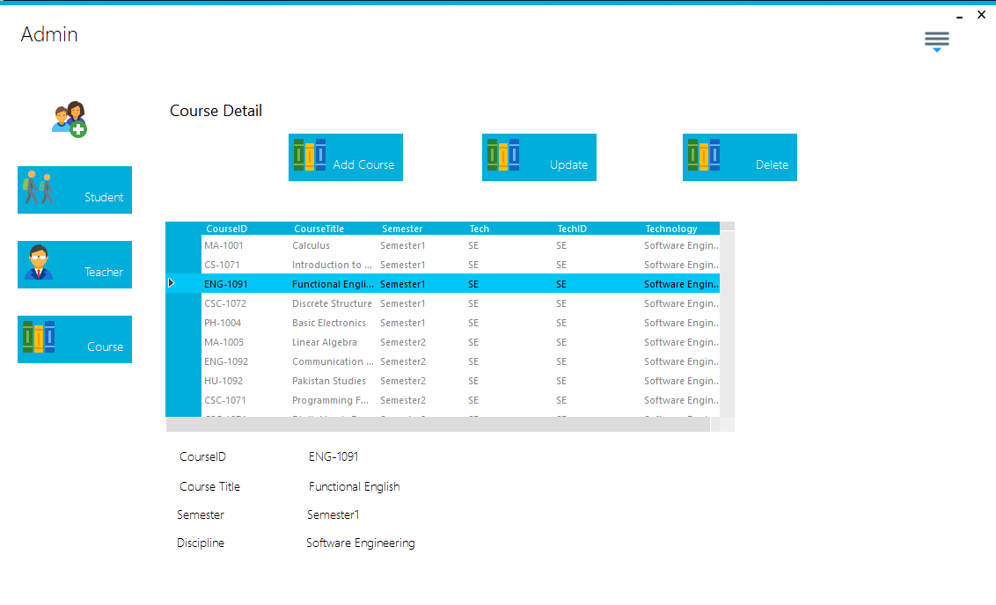

ADMIN ADDING NEW COURSE

Admin can add the new course. For adding the new course, the following info is required as given below in the form.

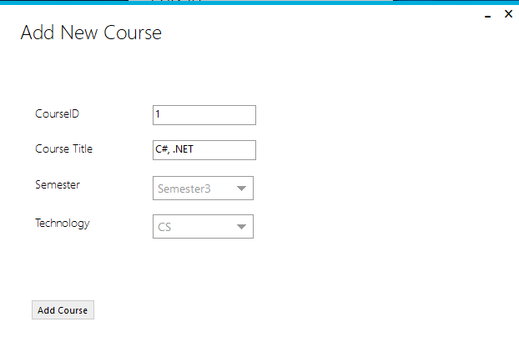

ADMIN ASSIGNING THE COURSE

Admin is assigning the course to all teachers of different departments as shown below.

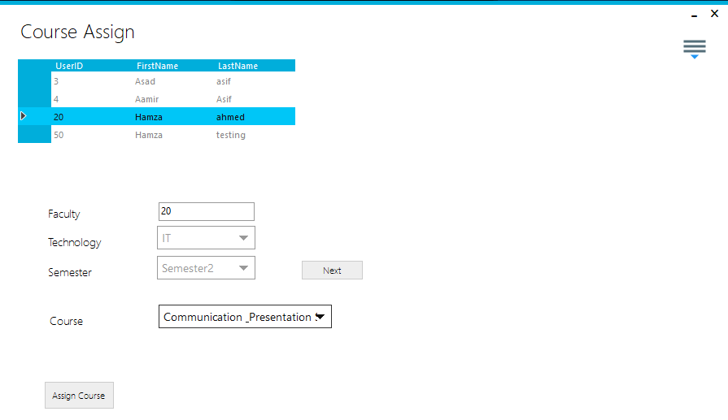

ADMIN DELETE STUDENT

If the Admin wants to delete any Student then in student menu he will enter the delete button and will give the info of that student. And press the delete button the student info will has been successfully deleted as shown below.

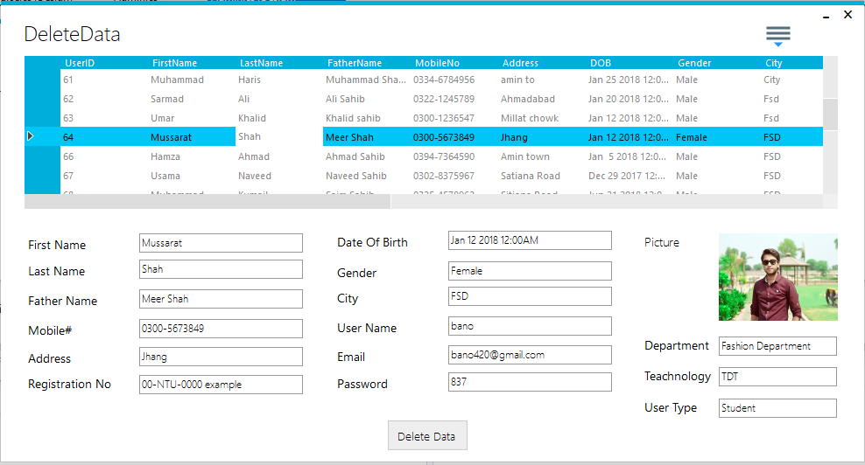

ADMIN DELETE TEACHER

If the Admin wants to delete any teacher info then in teacher menu he will enter the delete button and will give the info of that teacher. And press the delete button the teacher info will has been successfully deleted as shown below.

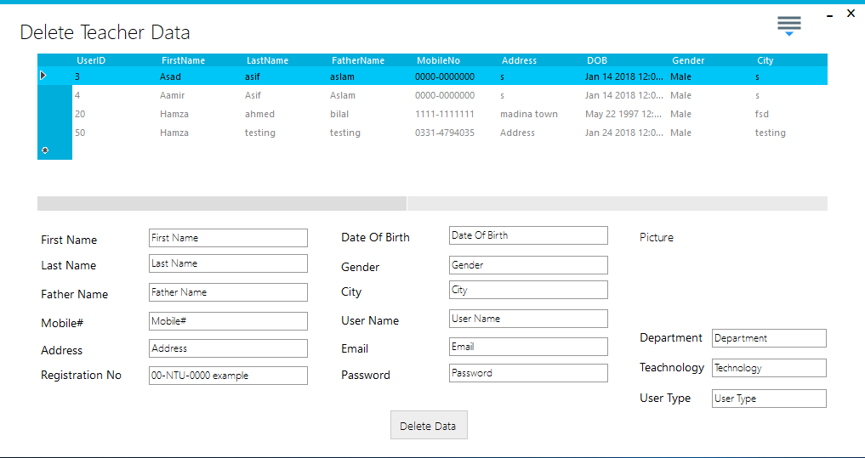

ADMIN DELETE COURSE

If the Admin wants to delete any course info then in course menu he will enter the delete button and will give the info of that course. And press the delete button the course info will has been successfully deleted as shown below.

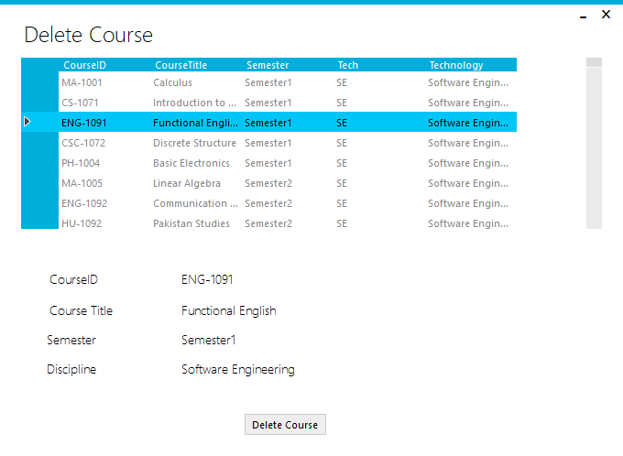

ADMIN UPDATE STUDENT

If the Admin wants to update any Student info then in student menu he will enter the update button and will give the info of that student. And press the update button the student info will has been successfully updated as shown below.

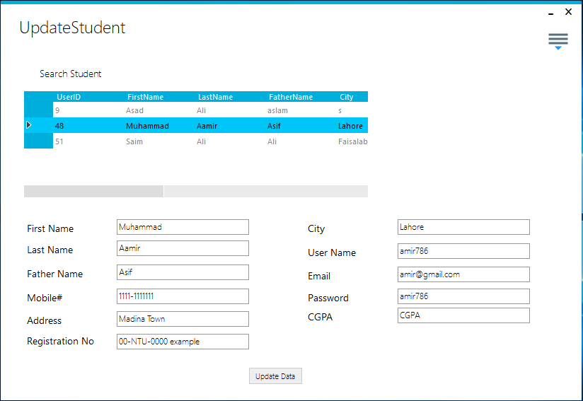

ADMIN UPDATE TEACHER

If the Admin wants to update any teacher info then in Teacher menu he will enter the update button and will give the info of that teacher. And press the update button the teacher info will has been successfully updated as shown below.

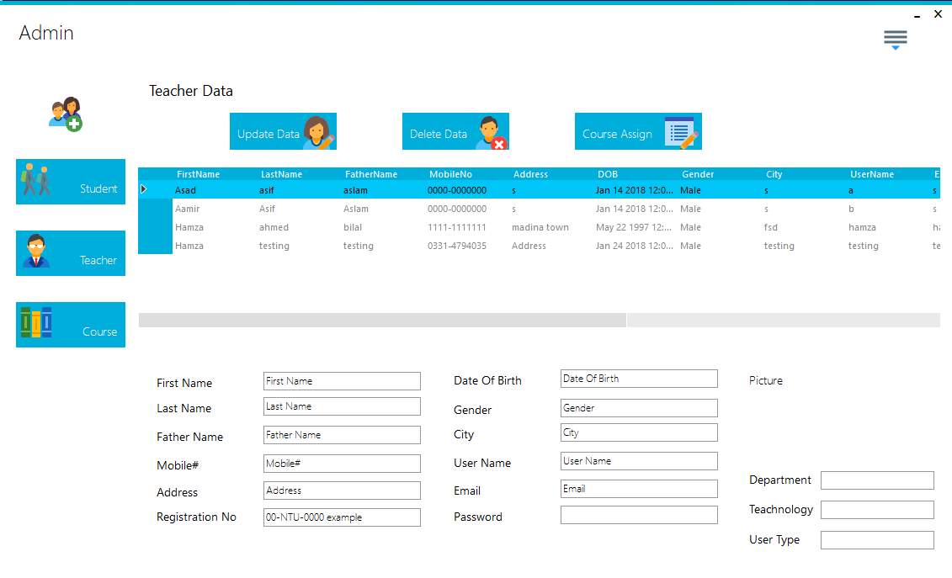

ADMIN UPDATE COURSE

If the Admin wants to update any course info then in course menu he will enter the update button and will give the info of that course. And press the update button the course info will has been successfully updated as shown below.

